Measured Evaluation of a
RAG Retrieval Benchmark
Dense retrieval, criteria decomposition, selective section policies,
Qwen reranking, and a Lucene custom TF–IDF comparator

Field | Value
Revision | Rebuilt from the corrected current result tree
Prepared | 2026-07-25
Current experiments | 8
Measured case results | 208
Common benchmark cases | 26
Primary cutoff | 10
Historical packages | Excluded from primary analysis (OLD)
Delivery directory | C:\edocument.repo\benchmark-rag\-REPORT-001

Evidence rule
Every numerical result in this report is traceable to a current aggregate-results.json, individual-results.csv, or measured aggregate run record. Warm-ups and OLD packages are excluded. No unavailable result is estimated or replaced.

Table of contents
Table of contents 2
List of figures 3
Abstract 4
1. Evidence scope and reconstruction method 5
1.1 Admission checks 5
1.2 Unit of analysis and uncertainty 5
2. Indexing, matching, and mathematical model 5
2.1 Lucene indexing and matching 5
2.2 Dense indexing and whole-description matching 6
2.3 Criteria-based retrieval 6
2.4 Section-aware Qwen reranking 6
2.5 Expected differences and admissible equations 7
2.6 End-to-end lifecycle and failure boundaries 7
3. Embedding and reranker model analysis 7
3.1 Jina v5 small retrieval embedding model 7
3.2 Qwen3 Reranker 4B 8
3.3 Model-role assessment 8
4. Experimental design 8
4.1 Evaluation mathematics 9
4.2 Comparison and uncertainty rule 9
5. Measured results 9
5.1 Overall quality 9
5.2 Reranking contrasts 10
5.3 RAG versus Lucene 10
5.4 Selective scope, weighting, and criteria representation 10
5.5 Group heterogeneity 11
5.6 Runtime and execution diagnostics 11
6. Alternative interpretations and threats to validity 11
6.1 What the current results do and do not establish 12
7. Figures 12
8. Discussion and conclusion 27
Appendix A. Current run inventory 27
Appendix B. Paired nDCG@10 comparisons 28
References 28

List of figures
Figure 1. RAG ingestion from source PDF to a provenance-controlled vector index
Figure 2. RAG semantic retrieval, document aggregation, and optional cross-encoder reranking
Figure 3. Lucene ingestion into language-specific lexical indexes
Figure 4. Lucene query compilation, custom scoring, and operational filtering
Figure 5. RAG and Lucene as controlled but non-identical retrieval mechanisms
Figure 6. Verified implementation matrix for Lucene and RAG
Figure 7. Configured candidate bounds in the two retrieval paths
Figure 8. Source-derived score construction for Lucene and RAG
Figure 9. Published model context versus locally served context
Figure 10. Configured vLLM GPU-memory-utilization targets
Figure 11. Evidence chain used for the rebuilt report
Figure 12. Verified Lucene and RAG implementation differences
Figure 13. Observed Precision@10 by current experiment
Figure 14. Observed Recall@10 by current experiment
Figure 15. Observed nDCG@10 by current experiment
Figure 16. Observed MRR by current experiment
Figure 17. Observed end-to-end mean latency
Figure 18. Observed macro-quality matrix
Figure 19. Observed quality–latency positions
Figure 20. Observed common-cutoff quality differences versus Lucene
Figure 21. Observed matched reranking differences
Figure 22. Observed matched reranking latency increment
Figure 23. Case-level nDCG@10 differences for the highest-macro-nDCG condition
Figure 24. Observed nDCG@10 by benchmark group
Figure 25. Observed Precision@10 by benchmark group
Figure 26. Observed mean stage-time composition
Figure 27. Observed relevant-document coverage at each final-list depth
Figure 28. Observed selected-section exclusions
Figure 29. Observed quality curves across reported cutoffs
Figure 30. Observed rerank-status audit
Figure 31. Current result-evidence validation

Abstract
Objective. To evaluate the corrected current RAG benchmark artifacts without inferring results from folder names or system architecture. Method. Eight current experiment packages were reconciled by manifest, authored and resolved configuration hashes, 26 common benchmark cases, aggregate JSON, individual CSV, and runtime diagnostics. OLD packages and warm-ups were excluded. Results. All 208 measured case runs succeeded. RAG Standard Criteria + rerank produced the highest macro nDCG@10 (0.6968), with P@10=0.5769 and R@10=0.4455; its mean latency was 14469 ms. Lucene produced nDCG@10=0.6186, P@10=0.5231, R@10=0.4069, and mean latency=197 ms. Every reranked RAG condition had higher macro P@10, R@10, nDCG@10, and MRR than Lucene; every non-reranked RAG condition had lower macro means on those four metrics. Conclusion. The current evidence supports the RAG architecture only with the qualification that reranking accounts for the observed quality separation and imposes a large measured latency cost. Selective section weighting is not uniformly beneficial, and one measured repetition cannot establish runtime reliability.
Keywords: retrieval-augmented generation; dense retrieval; Lucene; reranking; precision; recall; nDCG; MRR; latency; benchmark validity.

1. Evidence scope and reconstruction method
The primary evidence is the corrected current tree under retrieval-benchmarl-results. The analysis discovers batch directories through manifest.json, excludes the OLD subtree, and requires the authored input, resolved experiment, aggregate JSON/CSV, individual CSV, group summary, and generated report for every admitted experiment.

1.1 Admission checks
Check | Observed | Criterion | Passed
Current batch count | 8 | 8 required | True
Common case set | 26 | Identical across experiments | True
Manifest status | 8 SUCCEEDED | No failed batch | True
Measured rows | 208 SUCCEEDED | 26 per experiment | True
Warm-ups | 208 | 26 per experiment; excluded | True
Hash chain | Authored, packaged, input, resolved | All match | True
Judgment resolution | 100% | All experiments | True
CSV/JSON reconciliation | Macro means agree | Tolerance 1e-7 | True

1.2 Unit of analysis and uncertainty
Each experiment contains one measured repetition for each of the same 26 cases. Primary means are therefore case-first macro averages. Paired differences compare the same case under two conditions. The report calculates a fixed-seed 20,000-resample percentile bootstrap over case-level differences. This interval describes variation across this benchmark case set; it does not estimate run-to-run, service, GPU, cache, or network variability.
Non-invention boundary
The report does not use the OLD subtree, folder labels, model expectations, or architectural plausibility as substitutes for measurements. Performance statements are limited to the current measured artifacts.

2. Indexing, matching, and mathematical model
RAG is not treated here as one opaque model. It is a sequence of transformations whose assumptions can fail independently: extraction, structured representation, embedding, candidate retrieval, aggregation, optional reranking, and evaluation. Lucene is likewise evaluated as its complete configured path rather than as an abstract keyword-search label. An observed rank difference cannot be assigned to 'semantics' or 'lexical matching' until the intermediate mechanisms and their failure states are examined.

2.1 Lucene indexing and matching
The Lucene comparator indexes normalized text and metadata into language-specific indexes. Search execution uses case-authored syntax over content and keywords, runtime field boosts, analyzers, bounded fuzzy and multilingual expansion, Boolean and phrase logic, operational filters, a 100-hit bound, permission filtering, and the custom SquareSimilarity. It is therefore a deliberately strong and inspectable lexical comparator, not BM25 and not an unconfigured keyword baseline.
Implemented SquareSimilarity components
tf(f)=√f
idf(t)=ln((N+1)/(df(t)+1))+1
lengthNorm(d)=|d|^(-1/4)
Repeated terms receive diminishing returns, rare terms receive greater weight, and longer fields are penalized by a fourth-root norm. These components do not reconstruct the full runtime score because clauses, fields, phrases, boosts, expansions, and filters also contribute.
Explanatory lexical score
S_L(q,d) ∝ Σ_t b_t · √f(t,d) · idf(t)^2 · |d|^(-1/4)
This abstraction exposes the implemented components and query boosts. It is not asserted as an exact Lucene runtime score and must not be compared numerically with cosine or reranker scores.
The lexical path has plausible strengths for exact titles, technologies, identifiers, rare terms, and authored phrases. It may be weaker for paraphrase, distributed evidence, and cross-language concepts without shared terms. Fuzzy and multilingual expansion can reduce that weakness but can also create query drift. These are competing mechanistic expectations, not accepted explanations of measured rankings.

2.2 Dense indexing and whole-description matching
The RAG ingestion path parses source documents, writes UTF-8 Markdown, produces schema-validated structured JSON, plans row- and section-aware chunks, and persists vectors with metadata and embedding provenance. The resolved runtime uses 1024-dimensional jina-embeddings-v5-text-small-retrieval embeddings, 600-token chunks with 60-token overlap, initial chunk K=1000, and a 60-document candidate limit.
Embedding and similarity contract
e_q=f_θ(prefix_q ⊕ q), e_c=f_θ(prefix_c ⊕ c)
s(q,c)=(e_q·e_c)/(||e_q||·||e_c||)
if ||e_q||=||e_c||=1, then s(q,c)=e_q·e_c
Model identity, role prefix, dimension, pooling, normalization, and chunking jointly define the index geometry. A corpus/query mismatch can change nearest-neighbour ordering even when the application code is otherwise correct.
Implemented row/section aggregation
A_j(d)=0.7·max(s_j)+0.3·mean(top 3 s_j)
S_standard(d)=Σ_j w_j A_j(d)
S_selective(d)=Σ_{j∈J}w_jA_j(d) / Σ_{j∈J}w_j
Only the best chunk per document/section/source-row tuple survives before aggregation. The maximum preserves one strong passage while the top-three mean rewards repeated evidence. The coefficients are implementation choices, not statistically estimated optima; chunk overlap and section availability can alter the resulting score.

2.3 Criteria-based retrieval
Criteria mode uses frozen JobCriterion objects instead of embedding the job description as one undifferentiated query. Separate candidate pools are configured for must-have, should-have, and nice-to-have criteria (300, 300, and 200). The best eligible section evidence is scored for each criterion and document.
Implemented criteria score
S_criteria(d)=Σ_i [w_i · v_i · s_i(d)] / Σ_{i∈scoring} w_i
w_i is the criterion's effective weight, v_i the resolved section multiplier, and s_i(d) the best eligible chunk similarity. Frozen-criteria quality, section mapping, skipped criteria, and pool allocation remain alternative explanations of outcomes.
Causal limitation of selective weighting
SELECTIVE_WEIGHTED changes section eligibility and weights together. Whole-description selective mode may also exclude documents missing a selected section. Its measured difference is a combined evidence-scope policy, not an isolated estimate of weighting.

2.4 Section-aware Qwen reranking
The reranker jointly processes the query and candidate section text, allowing token-level interaction that a precomputed bi-encoder vector cannot perform. This is computationally expensive, so the source limits it to 60 documents. Section planning uses 2000-token chunks, a 3000-token maximum atomic section, and an 8000-token application sequence budget.
Implemented section-aware rerank aggregation
u_m=p_m·importance_m
r_d=0.7·max(u_m)+0.3·mean(top 3 u_m)
p_m is the returned query–evidence score. It is used for ordering and is not assumed to be a calibrated probability. Template, tokenization, splitting, skipped sections, service failure, and fallback can change rank.
Candidate survival bound
Rel(final top k) ⊆ Rel(first-stage top 60)
R@k_final ≤ R@60_first-stage
Reranking can reorder only surviving documents. Candidate recall and rerank coverage are therefore required to interpret a second-stage gain.

2.5 Expected differences and admissible equations
The mechanisms motivate hypotheses but do not determine a winner. Dense retrieval may help with paraphrase or multilingual equivalence; Lucene may help when rare exact terminology and authored phrases are decisive; reranking may improve top positions if relevant documents survive. Contrary explanations—semantic drift, lexical expansion drift, candidate truncation, or reranker mis-scoring—must be tested rather than assumed.
Case-paired quality difference
ΔM_c=M_c(RAG)−M_c(Lucene)
mean(ΔM)=(1/n)Σ_cΔM_c
The benchmark case is the paired unit. A positive mean is a bounded benchmark observation, not a universal model property. Case bootstrap intervals do not estimate run-to-run uncertainty.
Exact graded-ranking difference at common cutoff k
ΔnDCG@k_c=[1/IDCG_c]·Σ_{i=1..k}[G(r_i)−G(l_i)]/log2(i+1)
The same case judgments supply the same IDCG. Gains can arise from promotion, replacement, or graded ordering; the equation alone does not establish which mechanism caused them.
End-to-end latency accounting
ΔT_c=(T_embed+T_vector+T_aggregate+I_rr·T_rerank+T_other)−T_Lucene
This is an accounting identity, not a hardware-independent complexity result. Batch date, cache, queueing, network topology, and a single measured repetition remain confounders.
Raw-score non-equivalence
SquareSimilarity, cosine similarity, aggregation scores, and reranker scores occupy different spaces. Only common rank metrics and paired judgments support a direct Lucene–RAG effectiveness comparison.

2.6 End-to-end lifecycle and failure boundaries
The restored process figures retain the PDF→Markdown→structured JSON→embedding→vector-index path, the query-time candidate and reranking funnel, and the corresponding Lucene paths. They enumerate alternatives that can masquerade as retrieval quality: parsing loss, invalid structure, profile mismatch, chunk-boundary loss, section exclusion, candidate truncation, reranker skip/fallback, expansion drift, and operational filtering.

3. Embedding and reranker model analysis

3.1 Jina v5 small retrieval embedding model
The resolved profile identifies jina-embeddings-v5-text-small-retrieval. Its primary model card reports 677M parameters, 1,024-dimensional output, last-token pooling, a 32,768-token published maximum, Matryoshka dimensions, and retrieval-specific training. These properties make it a plausible corpus-scale encoder; they do not establish suitability for this CV corpus and do not override the locally served 8,192-token limit [5–6].
Parameter | Verified local value | Rationale to test | Assumption / competing interpretation
Model/profile | jina-embeddings-v5-text-small-retrieval / jina-v5-small-vllm | Retrieval encoder matching the 1,024-D corpus contract. | Pin the exact local snapshot/hash; model-family identity is insufficient.
Runner/pooling | vLLM pooling; LAST | Matches the published serving example. | Changing pooling changes all vectors and requires reindexing.
Precision | float16 | Reduces memory and bandwidth. | Precision/backend effects on ties and latency were not ablated.
GPU memory target | 0.3 | Leaves nominal headroom for other services. | May constrain batching or create contention; it is configured, not proven optimal.
Context | startup 8,192; published 32,768 | The 600-token chunks remain below the served guardrail. | Local 8,192 is binding; published 32K cannot be assumed at runtime.
Dimension | 1024 | Matches resolved corpus/query evidence. | Any dimension or Matryoshka truncation change invalidates the index.
Normalization | resolved normalize=True; startup script does not state normalize | L2 normalization equates cosine and dot-product ordering. | Verify effective server/application normalization; a resolved flag is not server proof.
Query representation | Find the most suitable job applicants for these requirements: | Makes measured retrieval intent explicit. | Prefix sensitivity was not isolated from other treatments.
Chunking | 600 / 60 overlap | Localizes evidence and protects some boundaries. | Overlap creates correlated candidates and can amplify repeated text.

3.2 Qwen3 Reranker 4B
The resolved reranker is Qwen3-Reranker-4B in SECTION_AWARE mode. The primary Qwen model card reports a 4B reranking model, a 32K published context, more than 100 supported languages, and optional task instructions [7–8]. The local script fixes 8,192 tokens, Qwen3ForSequenceClassification, no/yes classifier tokens, and a specific Jinja template. Those deployment details are part of model identity.
Parameter | Verified local value | Rationale to test | Assumption / competing interpretation
Model/profile | Qwen3-Reranker-4B / qwen3-reranker-4b-vllm-no-instruction | Joint scoring is feasible after reducing to 60 documents. | A gain belongs to this checkpoint and pool, not reranking universally.
Architecture/template | sequence classification; no/yes; qwen3_reranker.jinja | Returns one query–evidence ordering signal. | Template/override changes are model changes; scores are not assumed calibrated.
Precision | bfloat16 | Wider exponent range than FP16 with less memory than FP32. | ROCm, vLLM, hardware, and precision versions may affect results.
GPU memory target | 0.5 | Provides more nominal headroom than the embedding service. | Plausible for 4B, but not experimentally optimized.
Context | startup 8,192; application 8,000; published 32K | Leaves a small margin under the service limit. | Tokenizer accounting and skipped long sections remain material.
Instruction | instructionPresent=False | Avoids prompt variability in this profile. | A recruitment instruction might help or bias ranking; test separately.
Candidate/output | 60 / top 25 | Bounds expensive joint scoring while retaining depth beyond k=20. | The startup smoke test top_n=20 is not the experiment's top-25 contract.
Section planner | 2,000 chunk; 3,000 atomic; 8,000 sequence | Represents long documents as bounded evidence items. | Splitting and importance weights confound pure checkpoint effects.

3.3 Model-role assessment
The architecture assigns a smaller bi-encoder to reusable corpus-scale representations and a larger cross-encoder to a bounded candidate set. That division is computationally coherent, but coherence is not proof of optimality. Alternative configurations include another embedding checkpoint, pooling or normalization, a larger first-stage pool, a different reranker, an explicit instruction, or a lexical–dense hybrid. The current benchmark supports this deployment only to the extent demonstrated by component ablations and diagnostics.
Model evidence boundary
Published parameter counts, context lengths, and language support describe model capability. Local scripts and resolved runtime records describe the measured deployment. Neither layer substitutes for benchmark results.

4. Experimental design
Code | Experiment | Engine | Representation | Scope/weights | Rerank | Cases
LUC | lucene-manual-syntax-fuzzy-multilingual-01 | LUCENE | WHOLE_DESCRIPTION | STANDARD | off | 26
STD-WHOLE-RR | selective-weighting-ablation-standard-01 | VECTOR | WHOLE_DESCRIPTION | STANDARD | on | 26
STD-CRIT-NO-RR | standard-weight-criteria-reranking-disabled-01 | VECTOR | CRITERIA | STANDARD | off | 26
STD-CRIT-RR | standard-weight-criteria-reranking-01 | VECTOR | CRITERIA | STANDARD | on | 26
SEL-WHOLE-NO-RR | selective-weight-whole-description-reranking-disabled-01 | VECTOR | WHOLE_DESCRIPTION | SELECTIVE_WEIGHTED | off | 26
SEL-WHOLE-RR | selective-weight-whole-description-reranking-01 | VECTOR | WHOLE_DESCRIPTION | SELECTIVE_WEIGHTED | on | 26
SEL-CRIT-NO-RR | selective-weight-criteria-reranking-disabled-01 | VECTOR | CRITERIA | SELECTIVE_WEIGHTED | off | 26
SEL-CRIT-RR | selective-weight-criteria-reranking-01 | VECTOR | CRITERIA | SELECTIVE_WEIGHTED | on | 26

The design contains three matched rerank-on/off pairs: standard criteria, selective criteria, and selective whole description. It also supports selective-versus-standard criteria comparisons and criteria-versus-whole comparisons under selective scope. There is no standard whole-description no-rerank condition, so that specific interaction cannot be estimated.

4.1 Evaluation mathematics
Binary ranking metrics
P@k=|Rel∩Top_k|/k
R@k=|Rel∩Top_k|/|Rel|
MRR=1/rank(first relevant)
The implemented relevance rule is grade > case cutoff.
Graded ranking
DCG@k=Σ_i G(d_i)/log2(i+1)
nDCG@k=DCG@k/IDCG@k
G is the raw positive grade for documents strictly above the case cutoff.

4.2 Comparison and uncertainty rule
Paired case difference
ΔM_c=M_c(treatment)−M_c(control)
mean ΔM=(1/26)Σ_c ΔM_c
Positive quality deltas favor the treatment. Positive latency deltas mean the treatment is slower.

5. Measured results
All eight current manifests report SUCCEEDED, and all 208 measured case rows report SUCCEEDED. No current numerical field is replaced with a prediction. The following table reproduces the ALL macro aggregate.
Condition | P@10 | R@10 | nDCG@10 | MRR | Mean ms | p95 ms
LUC | 0.5230769230769231 | 0.40685862832623965 | 0.6186331466900233 | 0.837051282051282 | 197.30769230769232 | 386.0
STD-WHOLE-RR | 0.55 | 0.40934051722007186 | 0.6655389457805131 | 0.9423076923076923 | 14290.538461538461 | 17576.0
STD-CRIT-NO-RR | 0.4538461538461539 | 0.363356777051109 | 0.5476328089551907 | 0.7993589743589743 | 1931.5384615384614 | 2141.0
STD-CRIT-RR | 0.5769230769230769 | 0.445546138521847 | 0.6967984185411958 | 0.9423076923076923 | 14469.115384615385 | 19823.0
SEL-WHOLE-NO-RR | 0.49615384615384617 | 0.38095516775172644 | 0.5679727405782733 | 0.7875457875457875 | 1667.0 | 1824.0
SEL-WHOLE-RR | 0.5653846153846154 | 0.4286734278991364 | 0.6809653325309124 | 0.9615384615384616 | 14092.5 | 18719.0
SEL-CRIT-NO-RR | 0.4653846153846154 | 0.354975845679287 | 0.5270276355729193 | 0.7701923076923076 | 1775.576923076923 | 2162.0
SEL-CRIT-RR | 0.573076923076923 | 0.4369526380052696 | 0.6891078750969292 | 0.9230769230769231 | 14288.923076923076 | 20243.0

5.1 Overall quality
RAG Standard Criteria + rerank has the highest observed macro P@10 (0.5769), R@10 (0.4455), and nDCG@10 (0.6968). RAG Selective Whole + rerank has the highest observed MRR (0.9615). These are metric-specific maxima in the current eight-condition set, not universal model rankings.
Lucene records P@10=0.5231, R@10=0.4069, nDCG@10=0.6186, and MRR=0.8371. All four reranked RAG conditions have higher macro means than Lucene on all four metrics. All three non-reranked RAG conditions have lower macro means than Lucene on all four metrics.

5.2 Reranking contrasts
Matched pair | ΔP@10 | ΔR@10 | ΔnDCG@10 | ΔMRR | Δms | nDCG case-bootstrap 95% CI | nDCG W/T/L
standard criteria | 0.12307692307692308 | 0.08218936115384616 | 0.14916561 | 0.14294871807692308 | 12537.576923076924 | [0.0557, 0.2526] | 16/2/8
selective criteria | 0.10769230769230768 | 0.08197679307692307 | 0.16208023846153846 | 0.152884615 | 12513.346153846154 | [0.0707, 0.2599] | 18/1/7
selective whole | 0.06923076923076922 | 0.04771826038461538 | 0.11299259269230769 | 0.17399267423076922 | 12425.5 | [0.0508, 0.1782] | 19/1/6

Every matched rerank-on condition has higher observed macro P@10, R@10, nDCG@10, and MRR than its rerank-off counterpart. The mean end-to-end latency increment is approximately 12.4–12.5 seconds. This identifies reranking as the dominant treatment difference in the current quality results, while the single repetition limits claims about stable runtime cost.

5.3 RAG versus Lucene
RAG condition | ΔP@10 | ΔR@10 | ΔnDCG@10 | ΔMRR | Δms | nDCG case-bootstrap 95% CI | nDCG W/T/L
STD-WHOLE-RR | 0.026923076923076925 | 0.0024818892307692337 | 0.04690579923076923 | 0.10525641076923077 | 14093.23076923077 | [-0.0239, 0.1178] | 14/1/11
STD-CRIT-RR | 0.05384615384615385 | 0.03868751038461539 | 0.07816527153846153 | 0.10525641076923077 | 14271.807692307691 | [-0.0007, 0.1557] | 14/1/11
SEL-WHOLE-RR | 0.0423076923076923 | 0.021814800000000002 | 0.06233218576923077 | 0.12448718 | 13895.192307692309 | [-0.0069, 0.1311] | 16/1/9
SEL-CRIT-RR | 0.049999999999999996 | 0.03009401 | 0.0704747273076923 | 0.08602564153846154 | 14091.615384615385 | [-0.0059, 0.1460] | 15/1/10
STD-CRIT-NO-RR | -0.06923076923076923 | -0.04350185076923077 | -0.07100033846153847 | -0.03769230730769231 | 1734.2307692307693 | [-0.1614, 0.0171] | 8/1/17
SEL-WHOLE-NO-RR | -0.02692307692307692 | -0.025903460384615377 | -0.050660406923076926 | -0.04950549423076923 | 1469.6923076923076 | [-0.1516, 0.0486] | 12/1/13
SEL-CRIT-NO-RR | -0.057692307692307696 | -0.051882783076923074 | -0.09160551115384614 | -0.06685897346153846 | 1578.2692307692307 | [-0.1839, -0.0009] | 7/1/18

At the common cutoff k=10, the current macro means support a conditional statement: RAG exceeds Lucene on the reported quality metrics when the Qwen reranker is enabled, but not when the reranker is disabled. Lucene is far faster in the current batches. This conclusion is bounded to the current corpus, authored queries, deployment, and one measured repetition.

5.4 Selective scope, weighting, and criteria representation
Contrast | ΔP@10 | ΔR@10 | ΔnDCG@10 | ΔMRR
Scope/weight effect: criteria + rerank | -0.0038461538461538516 | -0.008593500384615389 | -0.007690544230769235 | -0.019230769230769232
Scope/weight effect: criteria no rerank | 0.011538461538461534 | -0.008380932307692303 | -0.02060517269230768 | -0.029166666153846155
Criteria vs whole: selective + rerank | 0.007692307692307693 | 0.008279209999999999 | 0.008142541538461535 | -0.038461538461538464
Criteria vs whole: selective no rerank | -0.03076923076923077 | -0.025979322692307693 | -0.040945104230769226 | -0.017353479230769228
Criteria vs whole: standard + rerank | 0.026923076923076925 | 0.03620562115384616 | 0.031259472307692306 | 0.0

The selective policy does not produce a uniform improvement. Selective criteria with reranking is slightly below standard criteria with reranking on all four macro quality metrics. Without reranking, selective criteria improves P@10 slightly but lowers R@10, nDCG@10, and MRR. Selective whole-description retrieval excludes 32 relevant document-case instances because one or more selected sections are absent; this exclusion is a mechanism-level explanation that must be considered alongside any quality difference.

5.5 Group heterogeneity
Condition | SHORT | LONG | LONG_MANY_RELEVANT | LONG_ALL_CVS
LUC | 0.6848981755555555 | 0.522593953076923 | 0.86456199 | 0.53297088
STD-WHOLE-RR | 0.69977974 | 0.5835836238461538 | 0.93034975 | 0.62835858
STD-CRIT-NO-RR | 0.5385604788888889 | 0.5137301146153846 | 0.7268409933333333 | 0.53239424
STD-CRIT-RR | 0.7428904377777777 | 0.6269907 | 0.91721938 | 0.5282077
SEL-WHOLE-NO-RR | 0.55551944 | 0.5262561269230769 | 0.77959754 | 0.58749401
SEL-WHOLE-RR | 0.7252337033333334 | 0.5961120538461538 | 0.8950995566666666 | 0.74323995
SEL-CRIT-NO-RR | 0.4583484466666667 | 0.5315135676923077 | 0.7879538266666667 | 0.30404465
SEL-CRIT-RR | 0.7324695077777778 | 0.6120075023076923 | 0.9192983166666666 | 0.61058668

The group results are heterogeneous. LONG_ALL_CVS contains one case and cannot support a stable subgroup claim. LONG_MANY_RELEVANT contains three cases with many positives, so P@10 can remain high while recall is structurally limited by k. Group-level conclusions should therefore be read with their case counts.

5.6 Runtime and execution diagnostics
Condition | Mean total | Lucene | Vector search | Aggregation | Rerank | Document statuses
LUC | 197.30769230769232 | 126.8076923076923 | 0 | 0 | 0 | {"NOT_APPLICABLE": 2516}
STD-WHOLE-RR | 14290.538461538461 | 0 | 336.1923076923077 | 106.8076923076923 | 12557.692307692309 | {"RERANKED": 650}
STD-CRIT-NO-RR | 1931.5384615384614 | 0 | 170.57692307692307 | 297.03846153846155 | 0 | {"NOT_REQUESTED": 1560}
STD-CRIT-RR | 14469.115384615385 | 0 | 167.69230769230768 | 292.6923076923077 | 12486.26923076923 | {"RERANKED": 650}
SEL-WHOLE-NO-RR | 1667.0 | 0 | 310.0769230769231 | 78.42307692307692 | 0 | {"NOT_REQUESTED": 1558}
SEL-WHOLE-RR | 14092.5 | 0 | 317.2692307692308 | 71.5 | 12461.192307692309 | {"RERANKED": 650}
SEL-CRIT-NO-RR | 1775.576923076923 | 0 | 148.07692307692307 | 241.1153846153846 | 0 | {"NOT_REQUESTED": 1560}
SEL-CRIT-RR | 14288.923076923076 | 0 | 150.65384615384616 | 240.65384615384616 | 12501.384615384615 | {"RERANKED": 650}

The runtime records permit stage-level interpretation rather than attributing all latency to vector search. Reranked conditions spend the largest named share in the rerank stage. Non-reranked vector conditions remain substantially slower than Lucene in these batches, but cross-date infrastructure differences and one repetition prevent a hardware-independent throughput claim.

6. Alternative interpretations and threats to validity
Observed pattern or issue | Alternative interpretation | Required follow-up
Reranked RAG quality lead | May reflect the Qwen model, candidate composition, section formatting, or top-25 policy rather than dense retrieval alone. | Use pre-rerank rankings and candidate recall; preserve rerank score audits.
Lucene latency lead | May combine algorithmic efficiency with date-specific cache, host, database, or service conditions. | Repeat interleaved runs on controlled infrastructure.
Selective-policy differences | Scope exclusion and weights change together; whole mode also requires every selected section. | Add scope-only and weight-only conditions.
Criteria differences | Frozen criteria quality and skipped out-of-scope criteria affect the treatment. | Report criteria coverage and compare the same query representation without scope changes.
Final relevant coverage | Final depths are 100, 60, or 25, so raw returned-relevant totals are not quality-comparable. | Use common-k metrics for engine comparison.
Group differences | Groups have 9, 13, 3, and 1 case. | Report case-level distributions and avoid stable claims for the one-case group.
Bootstrap interval | Resamples cases, not repeated executions. | Run multiple measured repetitions to estimate operational variance.
Corpus composition | Vector runs expose 5,274 searchable document-case instances versus 5,276 for Lucene. | Identify and reconcile the two missing vector-searchable instances.

6.1 What the current results do and do not establish
- They establish reproducible values for the eight current batch artifacts and the 26 common cases.
- They establish that matched rerank-on macro means exceed rerank-off macro means in the current runs.
- They establish that reranked RAG macro quality exceeds Lucene while non-reranked RAG macro quality does not, at k=10 in this benchmark.
- They do not establish general superiority outside this corpus, query set, model deployment, or relevance policy.
- They do not estimate run-to-run reliability because measuredRepetitions=1.
- They do not isolate selective section scope from section weights.

7. Figures
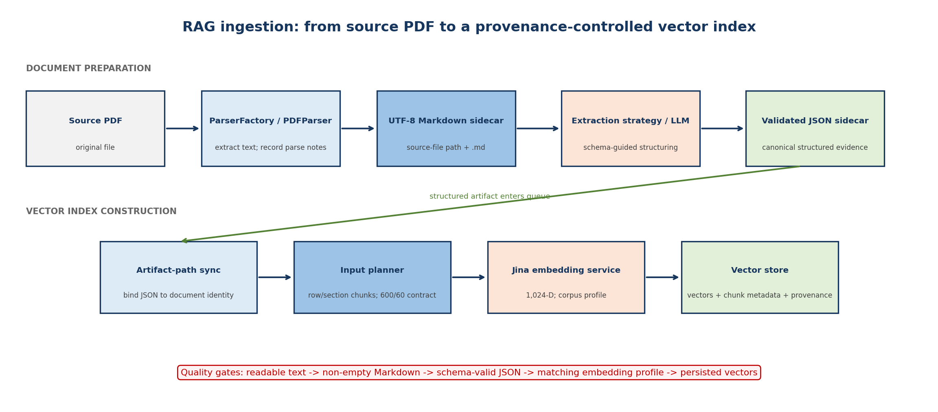
Figure 1. RAG ingestion from source PDF to a provenance-controlled vector index
The diagram identifies assumptions upstream of retrieval: parse fidelity, Markdown completeness, schema validity, chunk identity, embedding-profile consistency, and successful vector persistence. A downstream ranking cannot distinguish these failure sources without the corresponding diagnostics.
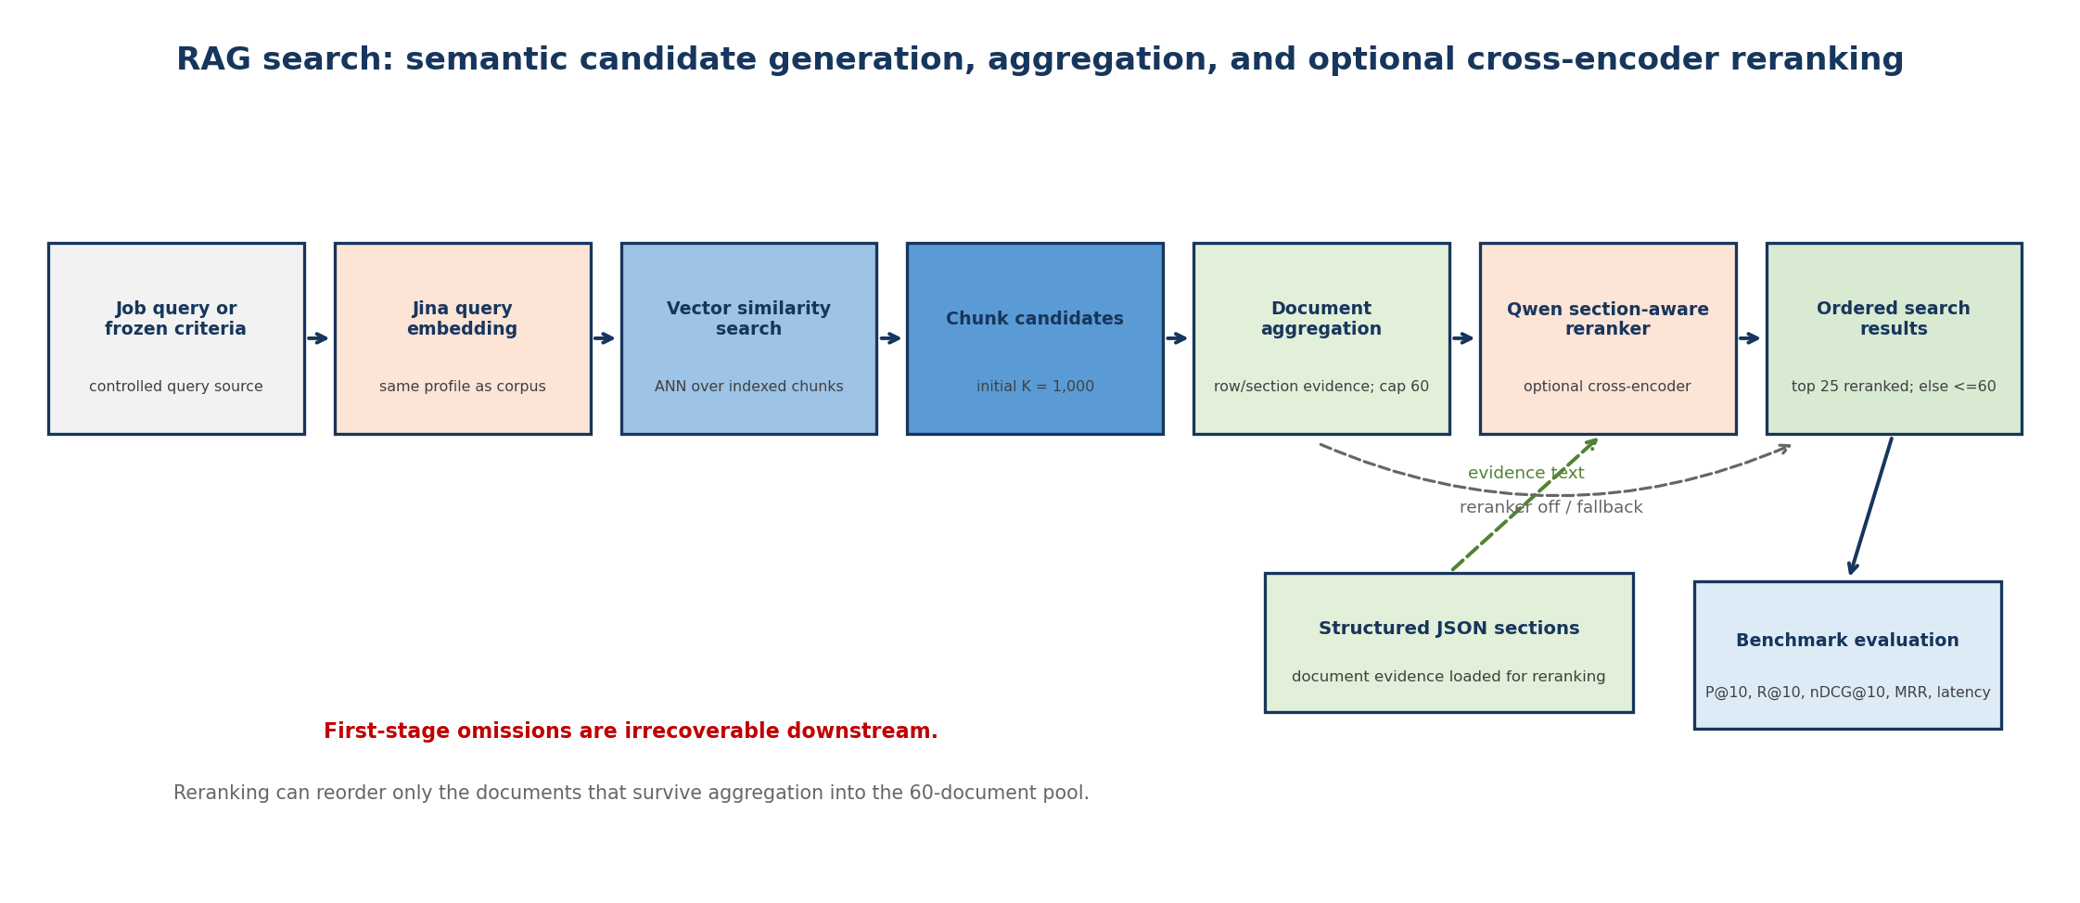
Figure 2. RAG semantic retrieval, document aggregation, and optional cross-encoder reranking
The funnel separates the bi-encoder candidate stage from the Qwen reranker. The 60-document boundary is analytically important because reranking cannot recover a relevant document omitted by first-stage aggregation.
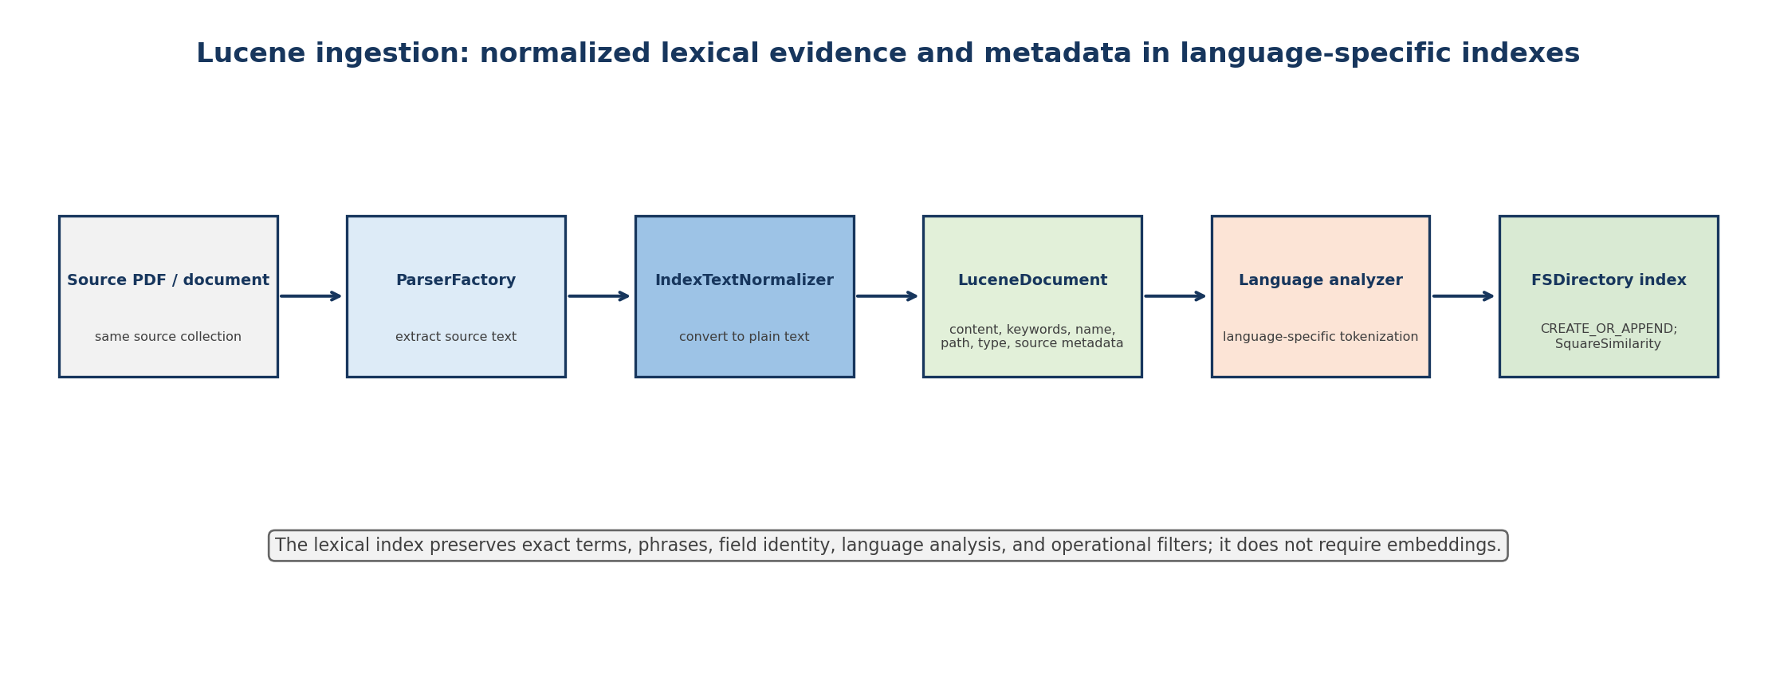
Figure 3. Lucene ingestion into language-specific lexical indexes
Lucene shares document extraction with RAG but indexes normalized text and metadata rather than vectors. This gives the benchmark a mechanistically different comparator instead of a weaker copy of the neural pipeline.
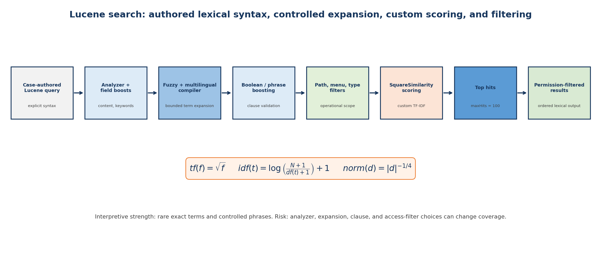
Figure 4. Lucene query compilation, custom scoring, and operational filtering
Authored syntax, analyzers, boosts, fuzzy and multilingual expansion, filters, and SquareSimilarity all affect the lexical result. A Lucene outcome therefore tests the complete configured baseline, not TF–IDF in isolation.
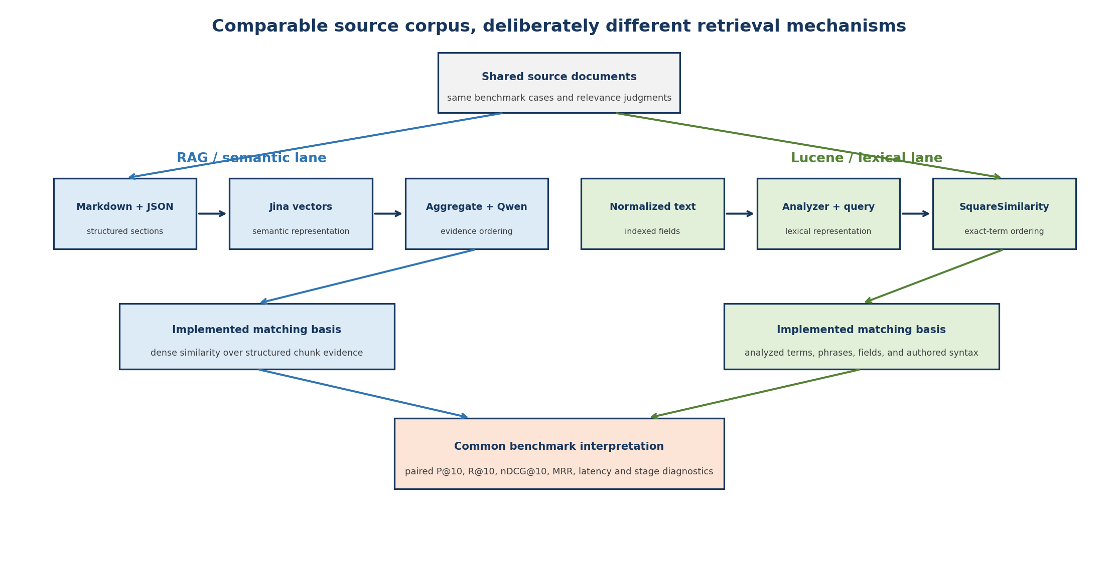
Figure 5. RAG and Lucene as controlled but non-identical retrieval mechanisms
The corpus, cases, and judgments are shared, while representation and matching differ by design. Common rank metrics are admissible; raw Lucene and vector scores are not commensurable.
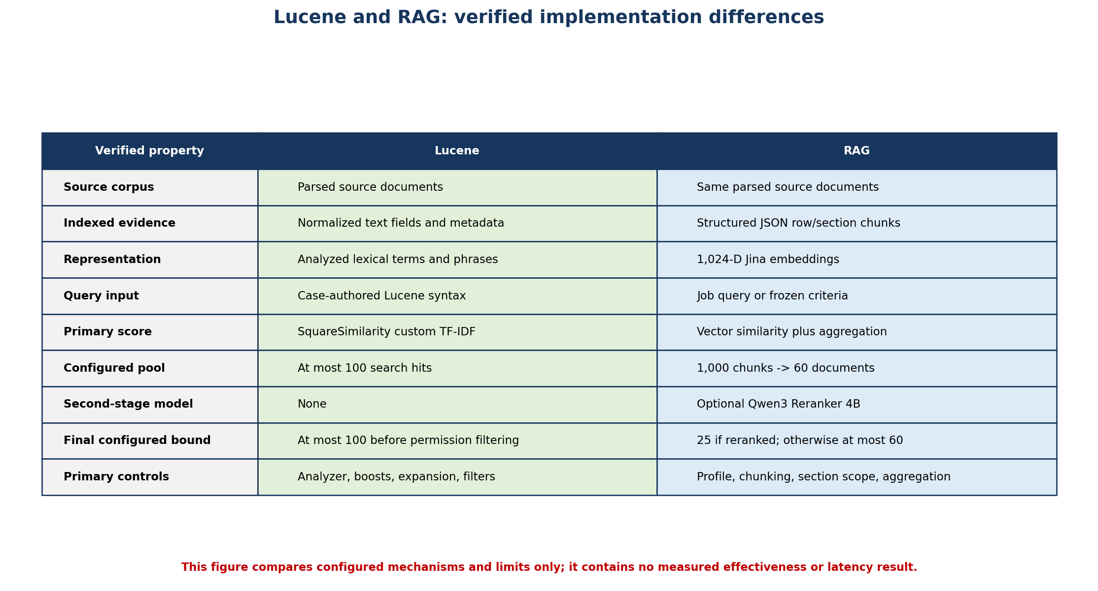
Figure 6. Verified implementation matrix for Lucene and RAG
The table records audited mechanisms and bounds only. It must not be read as an effectiveness result or as proof that one representation is intrinsically superior.
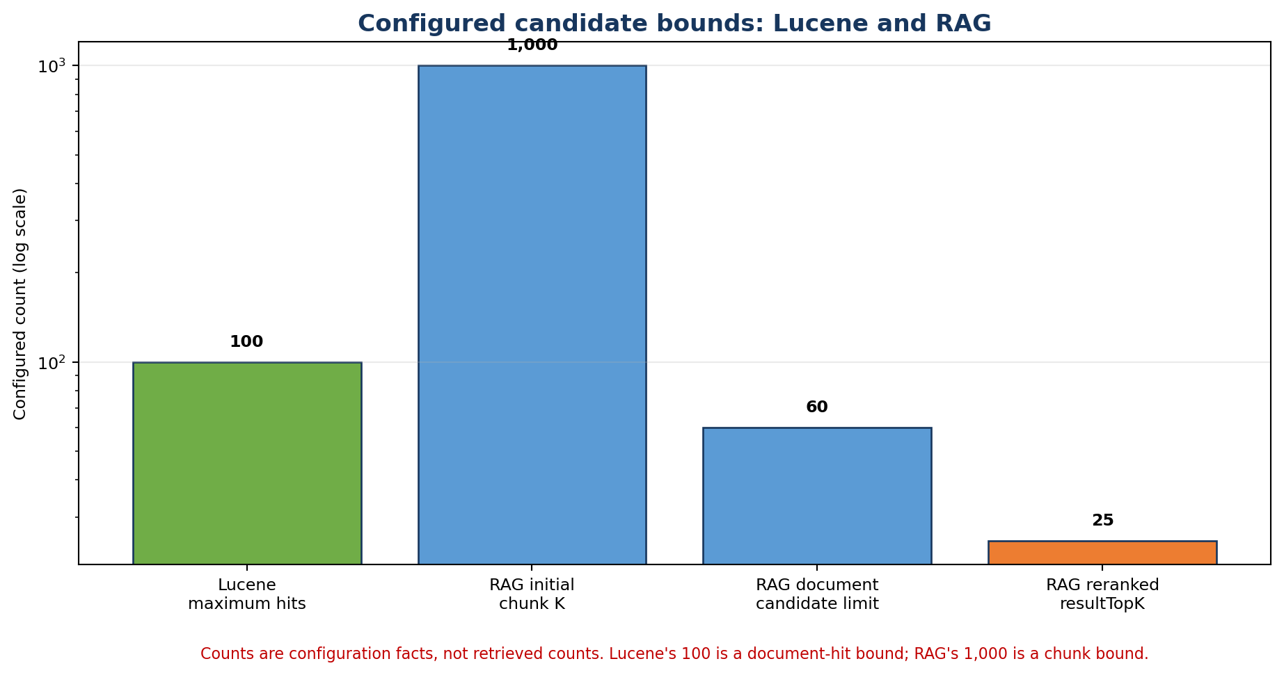
Figure 7. Configured candidate bounds in the two retrieval paths
The units differ: Lucene returns at most 100 document hits, whereas RAG begins with 1,000 chunk hits, aggregates to 60 documents, and returns 25 after successful reranking. Candidate depth is therefore both a compute choice and a recall constraint.
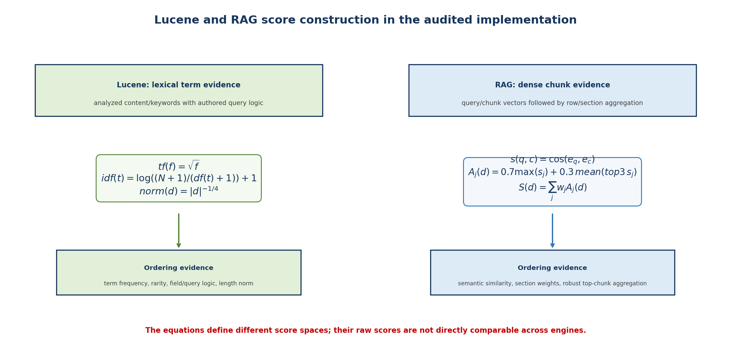
Figure 8. Source-derived score construction for Lucene and RAG
The equations expose incompatible score spaces. The academically valid comparison is through common judgments and rank metrics, not by comparing raw lexical, cosine, aggregation, or reranker values.
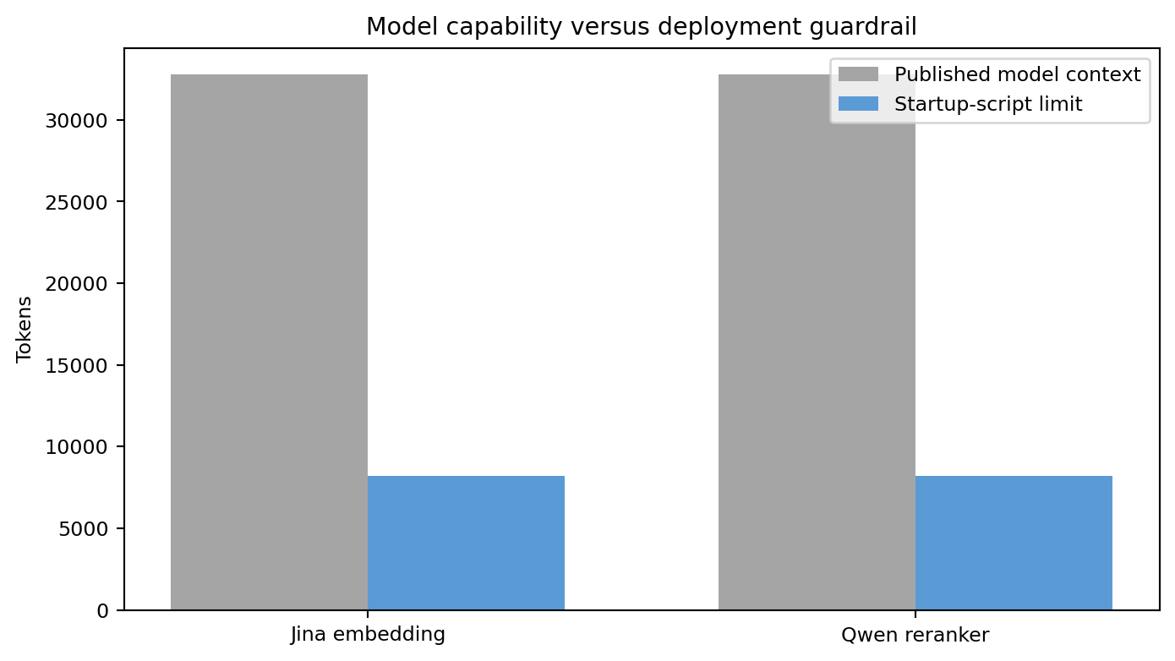
Figure 9. Published model context versus locally served context
Both model cards describe a 32K capability, while the startup scripts impose 8,192 tokens. The local limit is operationally binding; published capacity cannot be assumed during interpretation of skips or truncation.
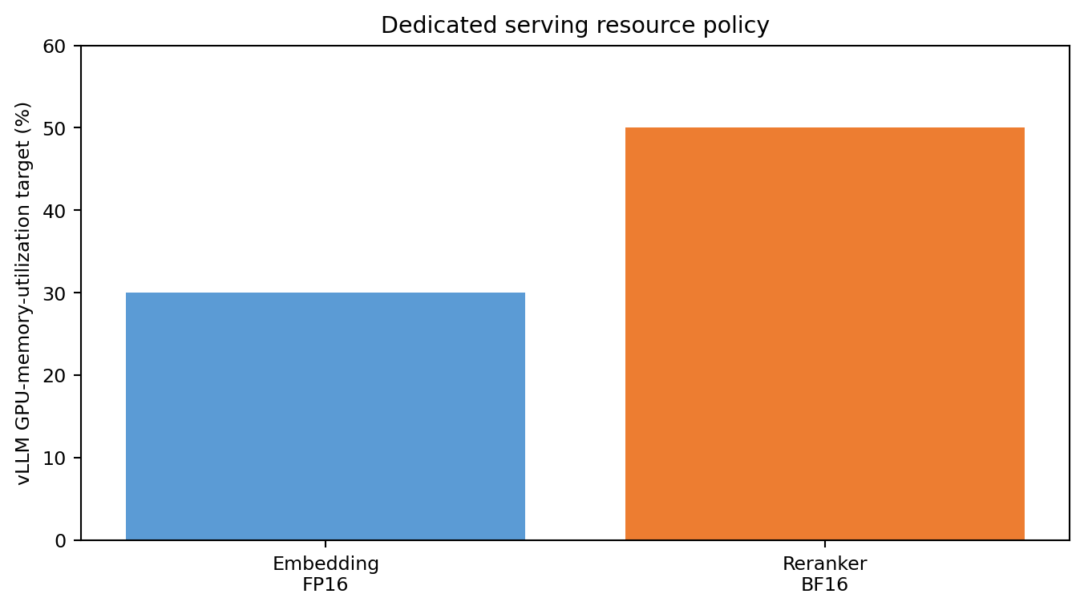
Figure 10. Configured vLLM GPU-memory-utilization targets
The 0.3 and 0.5 settings are observed deployment choices, not experimentally proven optima. They plausibly reflect different model sizes but may also influence batching, contention, throughput, and latency.
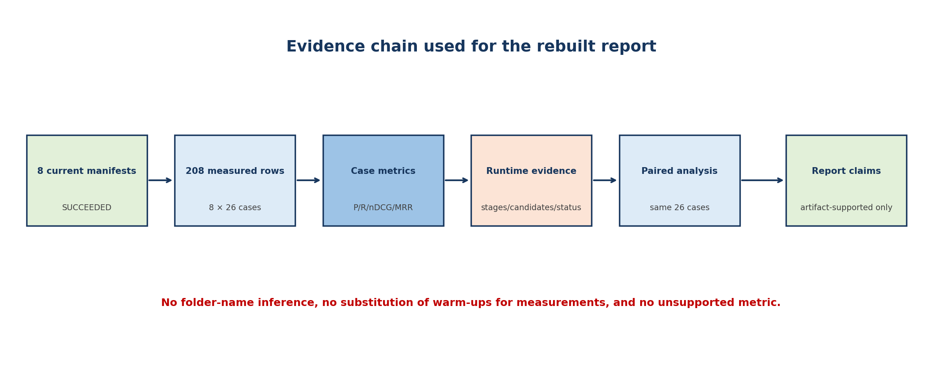
Figure 11. Evidence chain used for the rebuilt report
The primary evidence moves from eight successful current manifests through 208 measured case rows to paired analysis. The red boundary states the report's claim discipline.
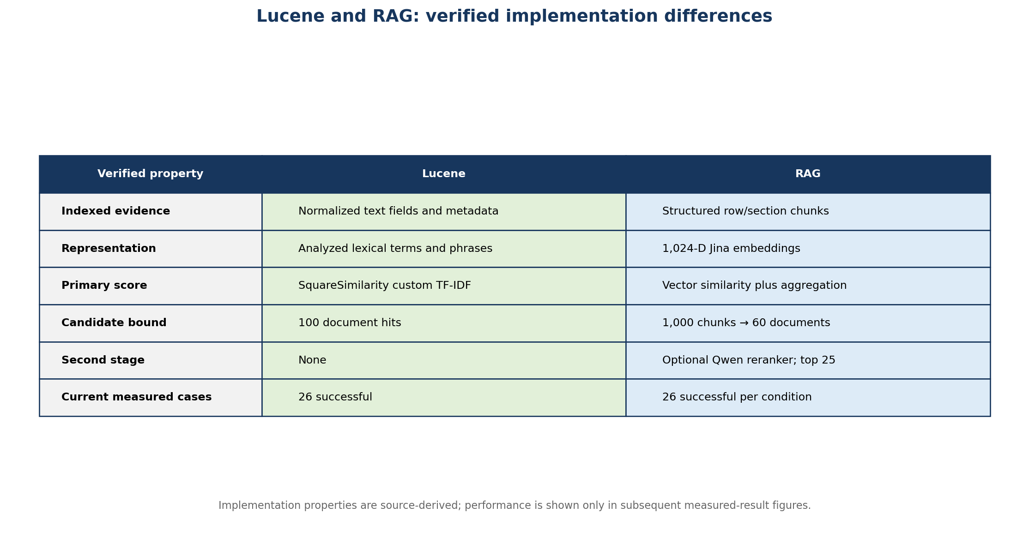
Figure 12. Verified Lucene and RAG implementation differences
This is an implementation comparison, not a performance claim. It identifies the evidence representation, score construction, and candidate bounds actually used.
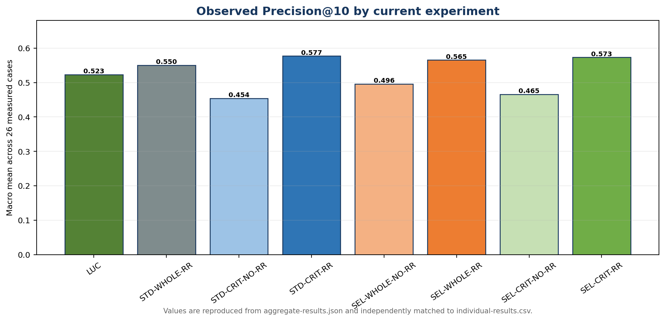
Figure 13. Observed Precision@10 by current experiment
Case-first macro means across the same 26 measured cases.
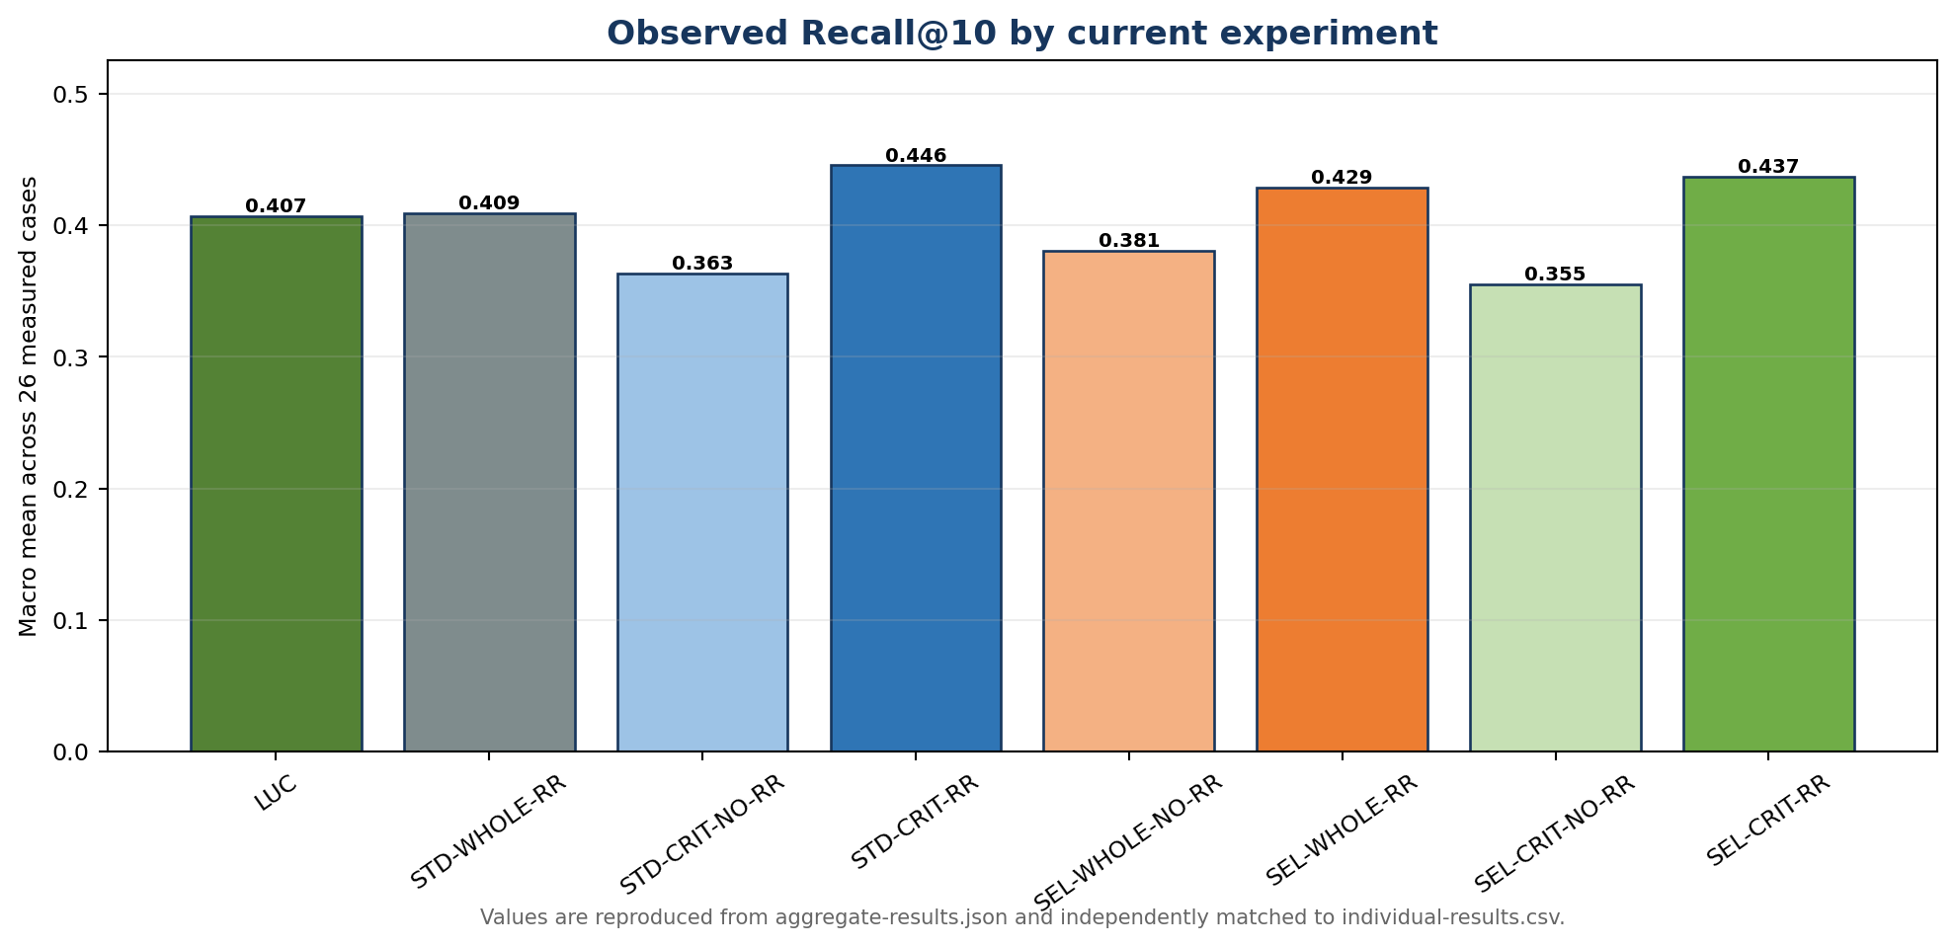
Figure 14. Observed Recall@10 by current experiment
Recall uses 478 strict-positive document-case judgments across the corpus.
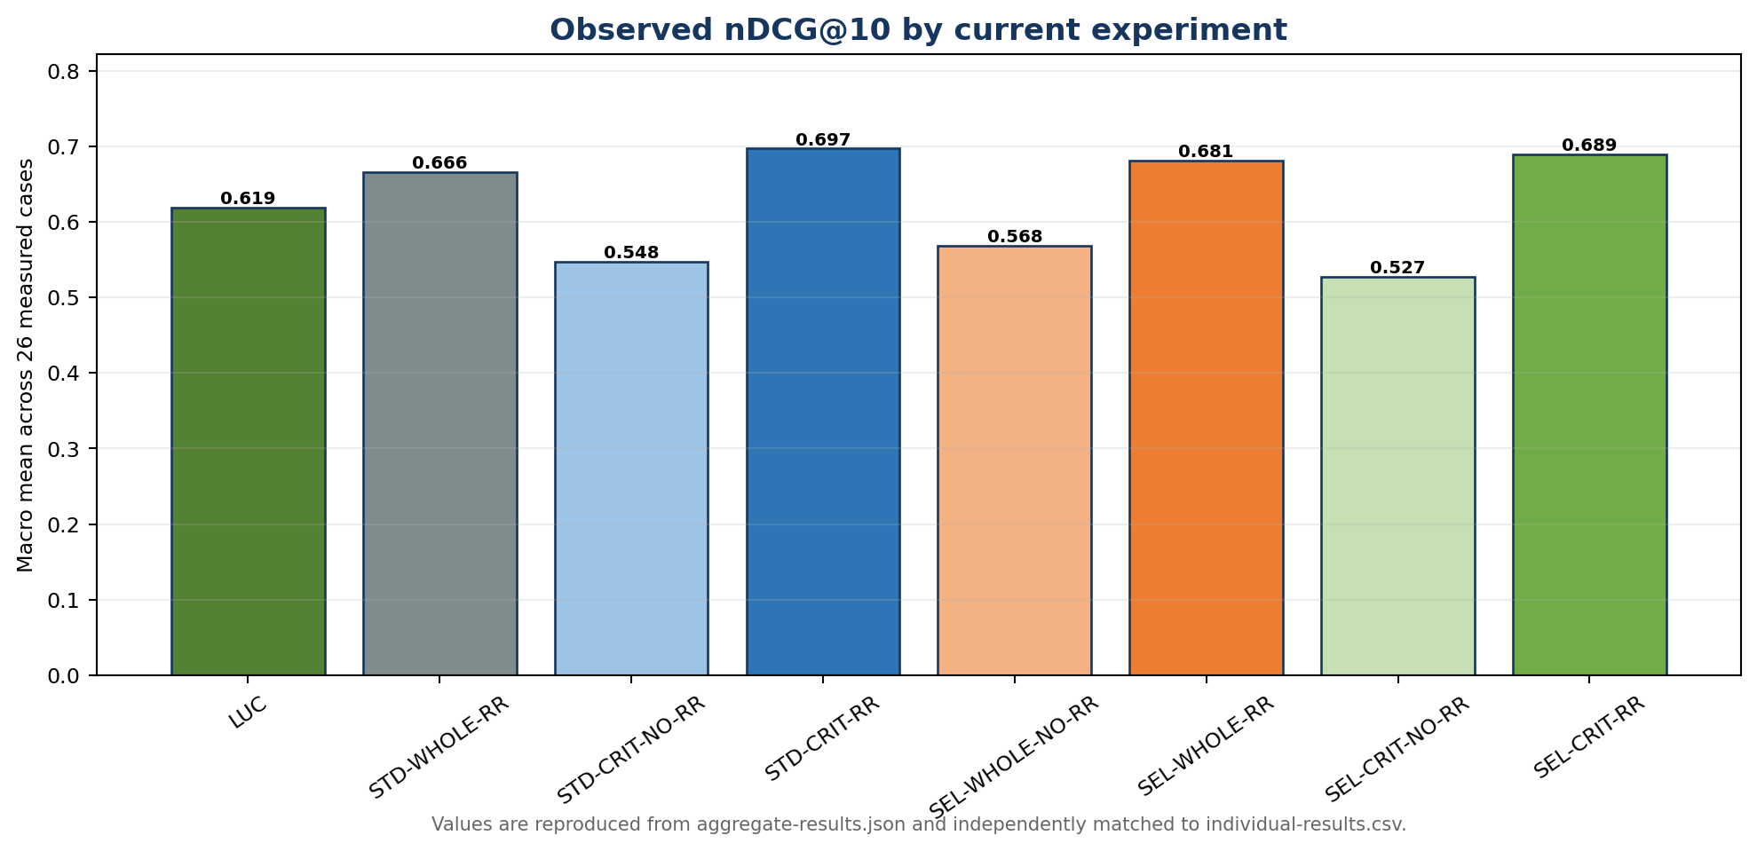
Figure 15. Observed nDCG@10 by current experiment
The evaluator uses raw positive relevance grades in DCG.
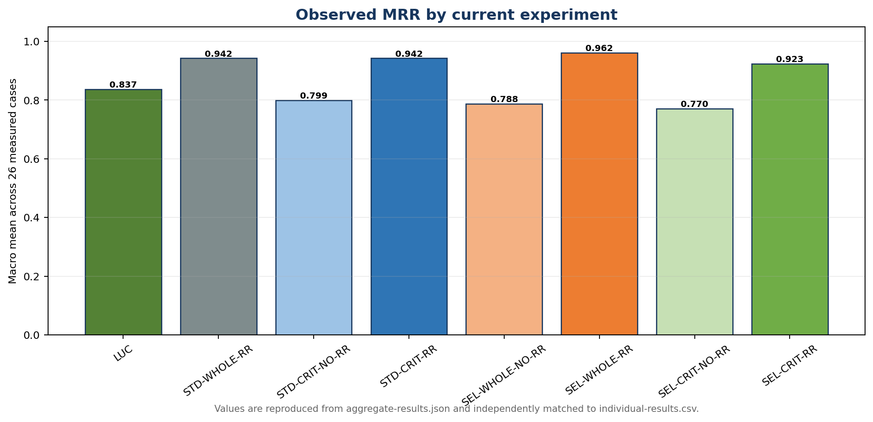
Figure 16. Observed MRR by current experiment
MRR records the position of the first relevant document and does not evaluate later relevant results.
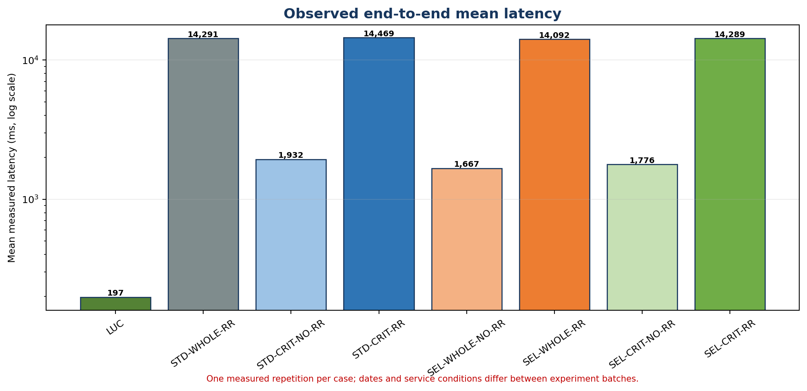
Figure 17. Observed end-to-end mean latency
The logarithmic axis accommodates the large difference between Lucene, non-reranked vector search, and reranked vector search.
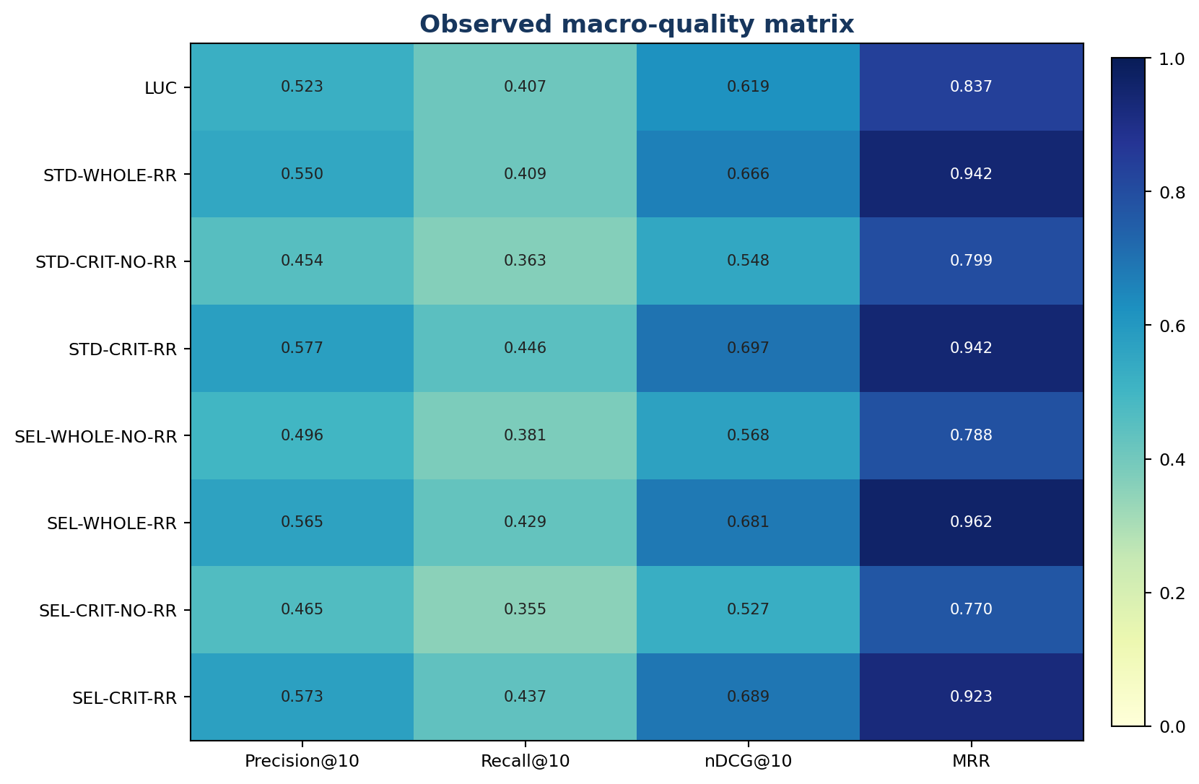
Figure 18. Observed macro-quality matrix
All displayed values are reproduced from current aggregate artifacts and independently matched to case CSV rows.
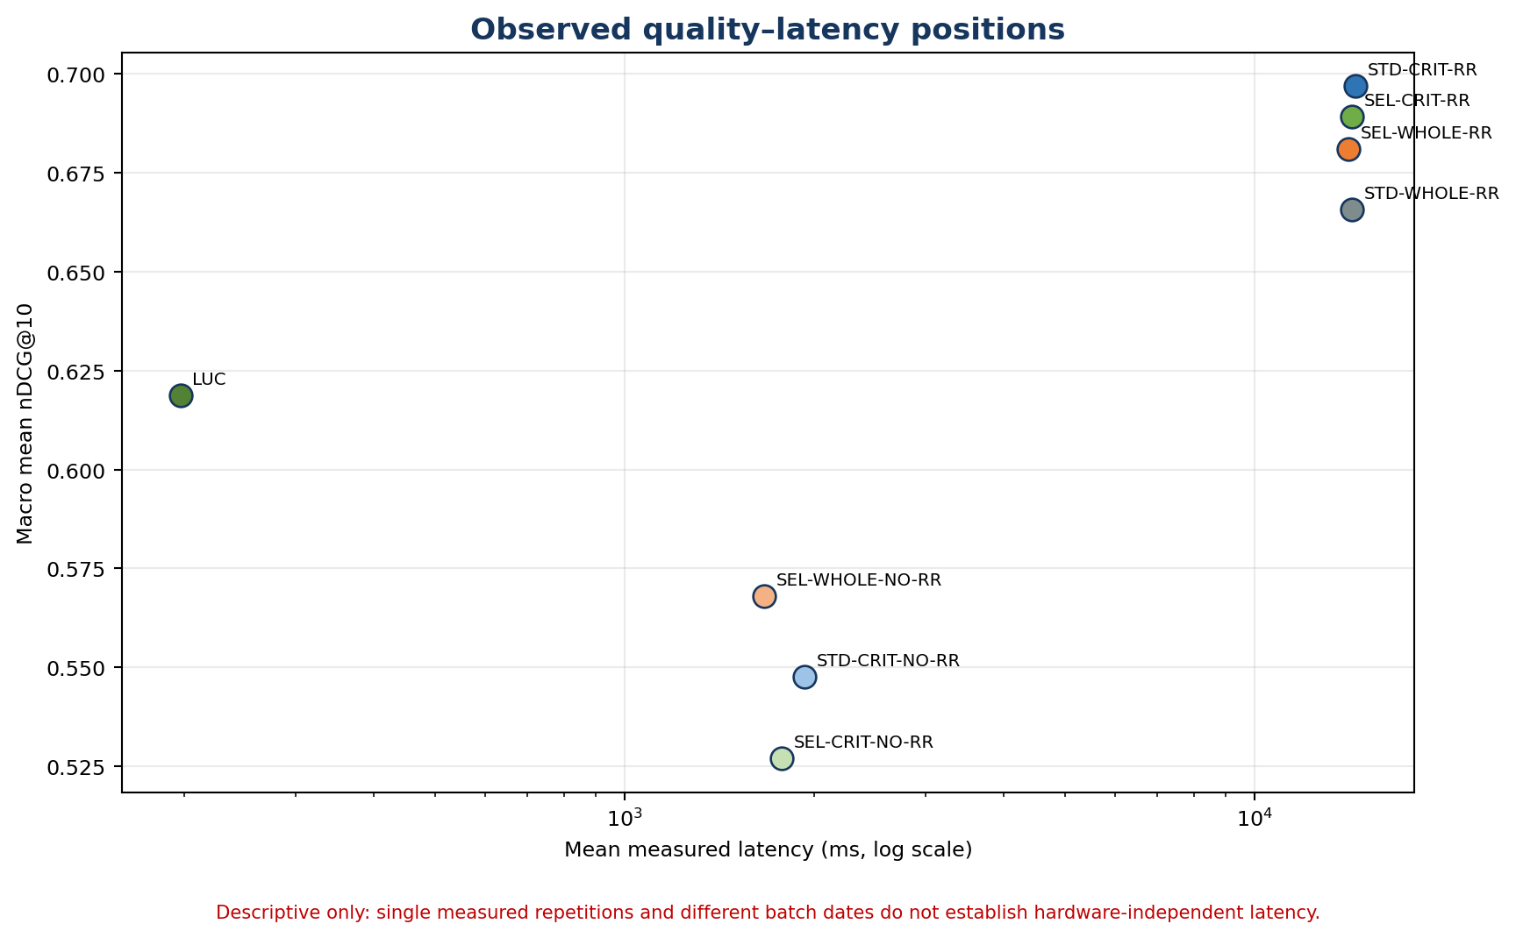
Figure 19. Observed quality–latency positions
This is descriptive because each case has one measured repetition and the batches ran on different dates.
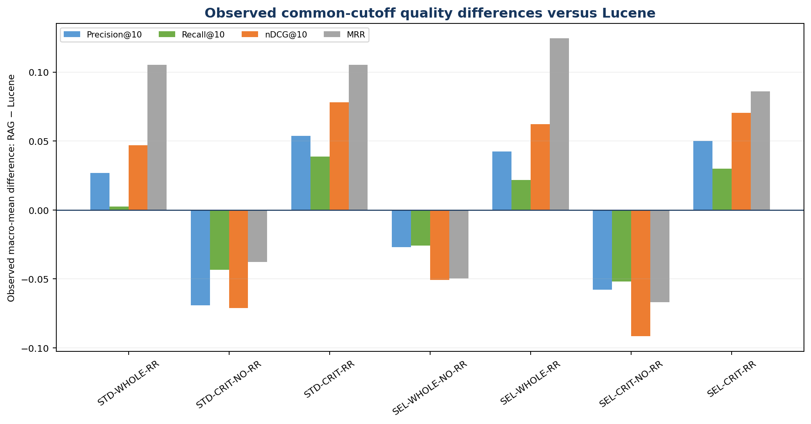
Figure 20. Observed common-cutoff quality differences versus Lucene
Positive bars mean the RAG condition has a higher macro mean than Lucene; negative bars mean the opposite.
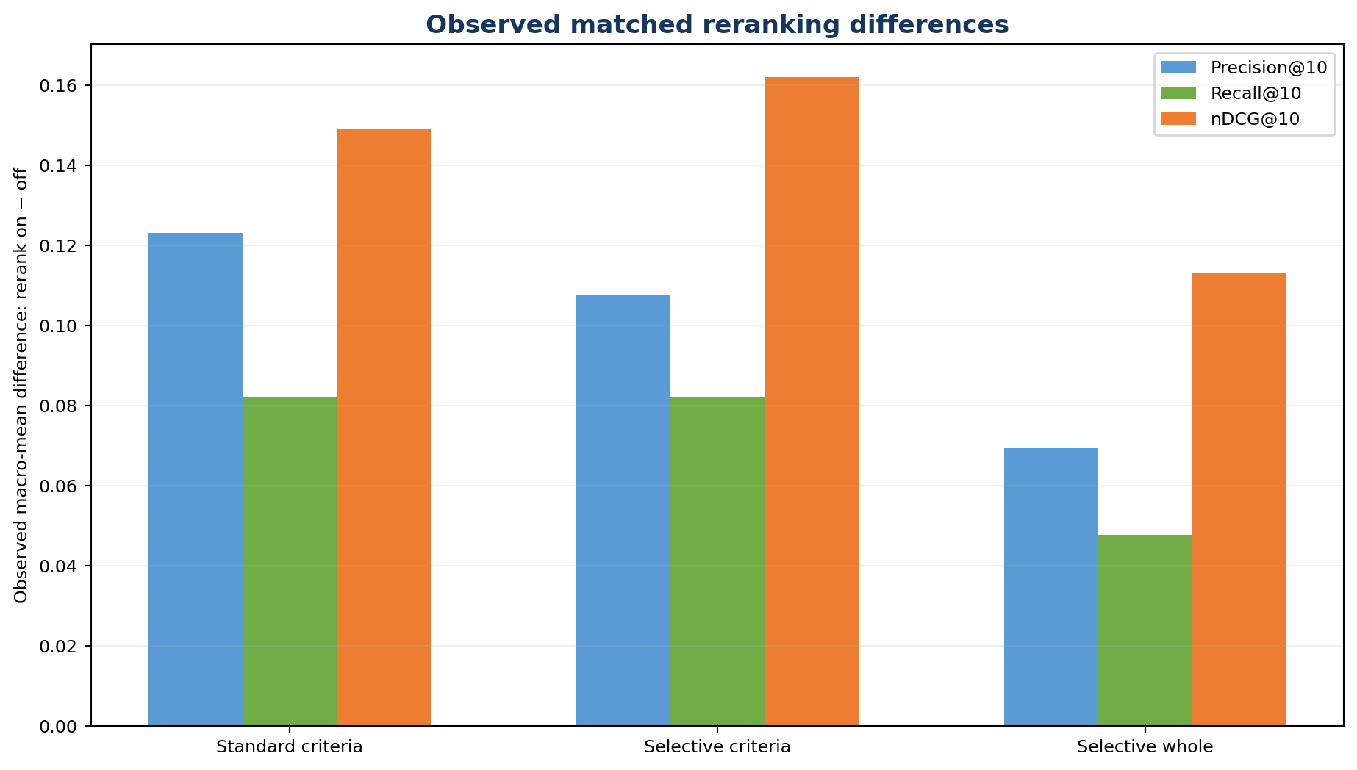
Figure 21. Observed matched reranking differences
Each bar compares rerank-on and rerank-off treatments with the same retrieval representation and section policy.
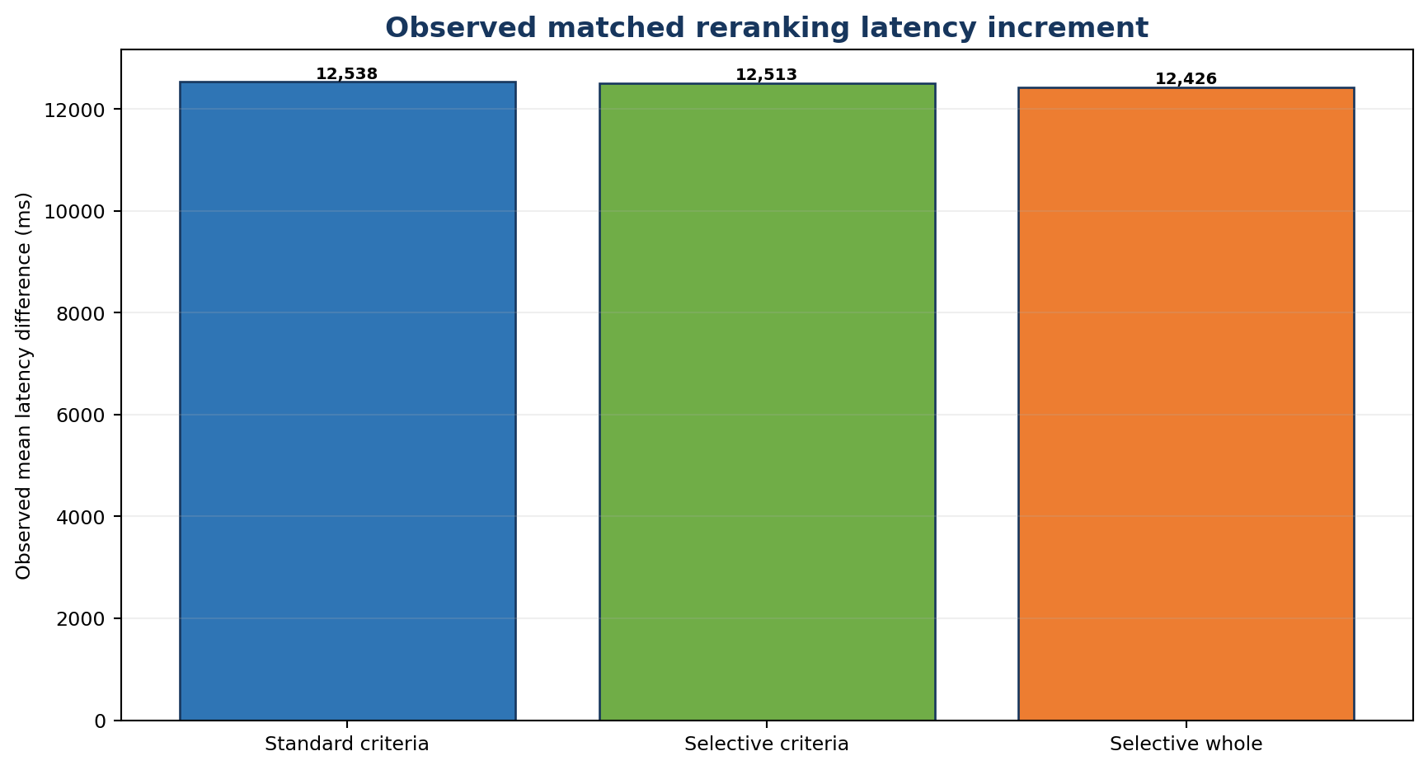
Figure 22. Observed matched reranking latency increment
The increment uses mean end-to-end case latency and therefore includes orchestration as well as reranker service time.
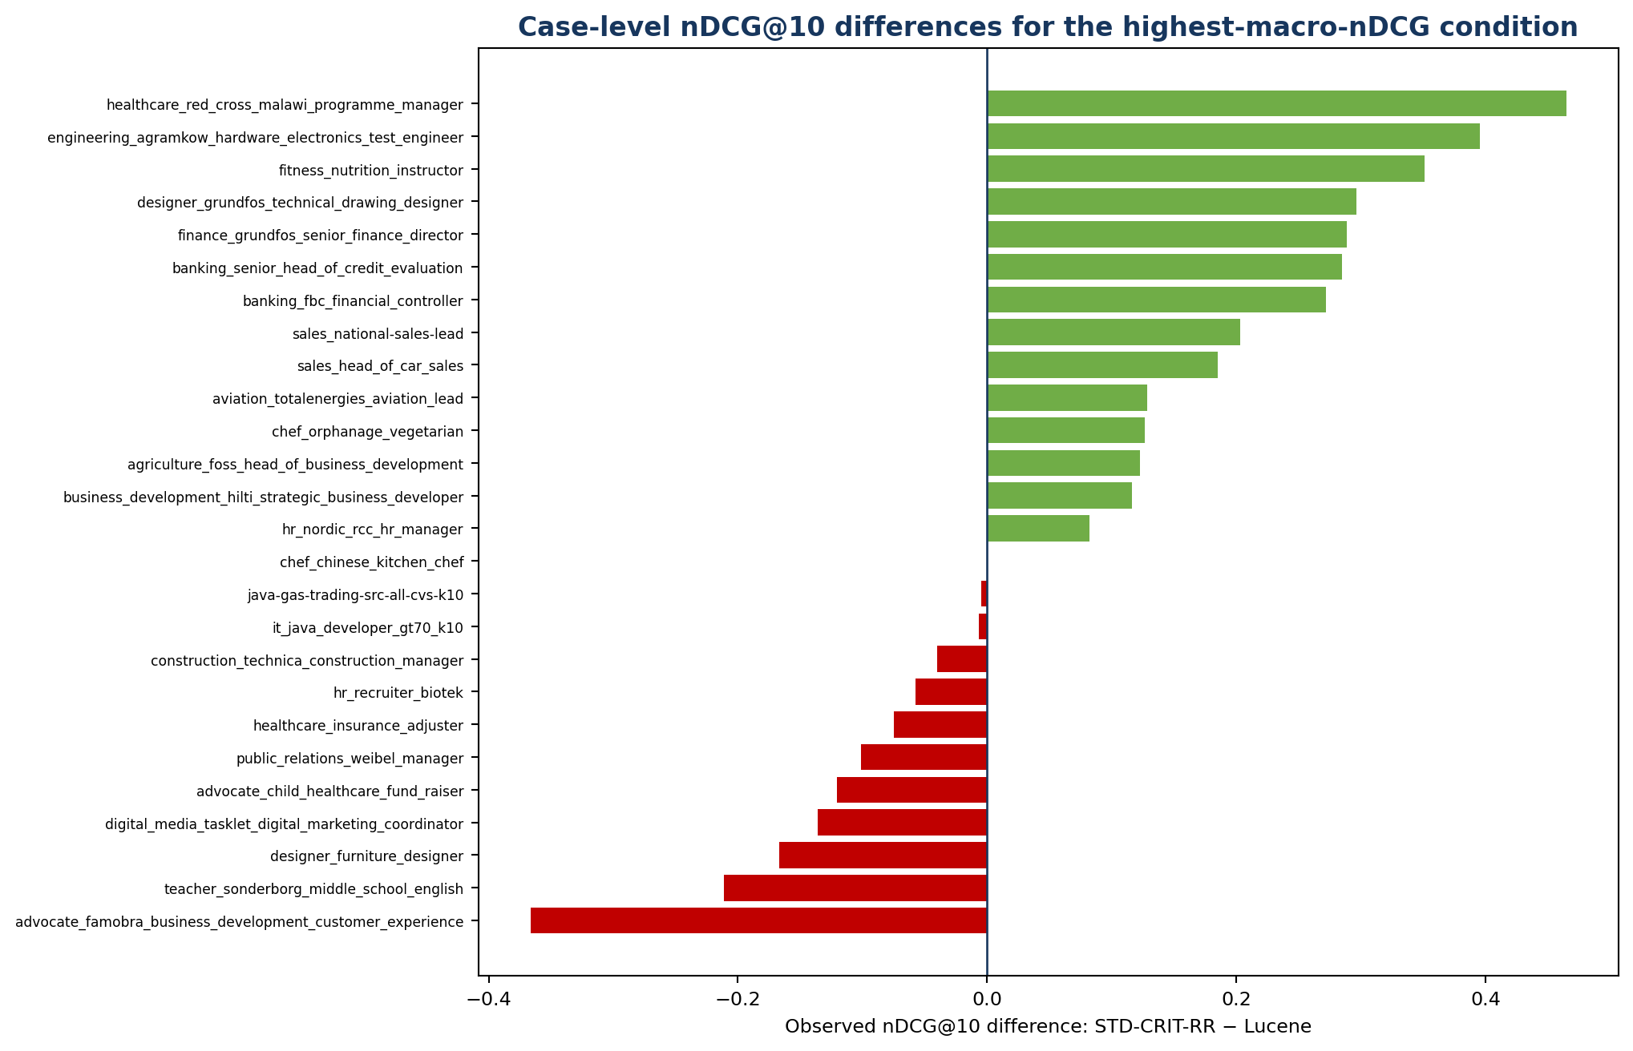
Figure 23. Case-level nDCG@10 differences for the highest-macro-nDCG condition
The distribution prevents the macro mean from hiding cases where Lucene ranked better.
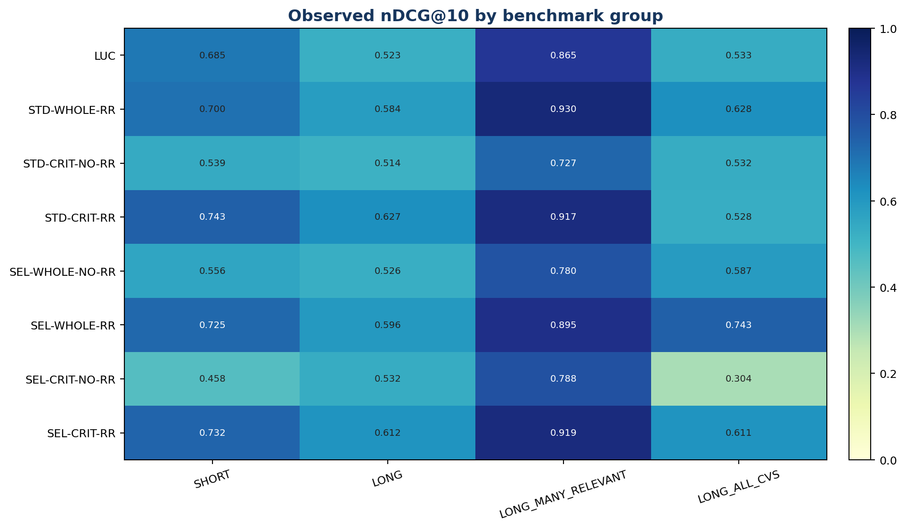
Figure 24. Observed nDCG@10 by benchmark group
LONG_ALL_CVS contains one case and should not be interpreted as a stable subgroup estimate.
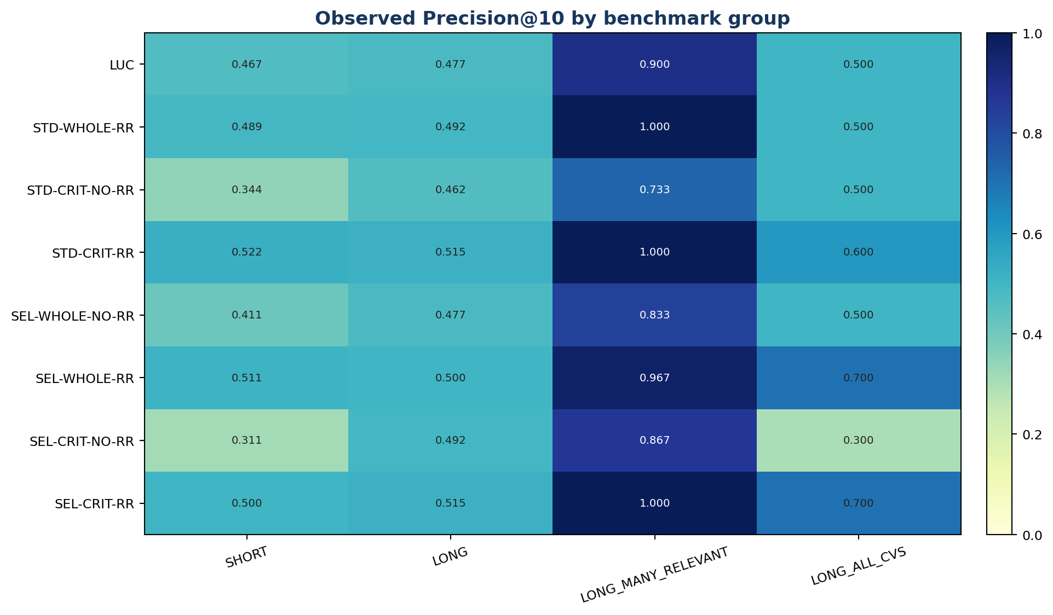
Figure 25. Observed Precision@10 by benchmark group
The heatmap exposes heterogeneous behavior across the four preregistered result groups.
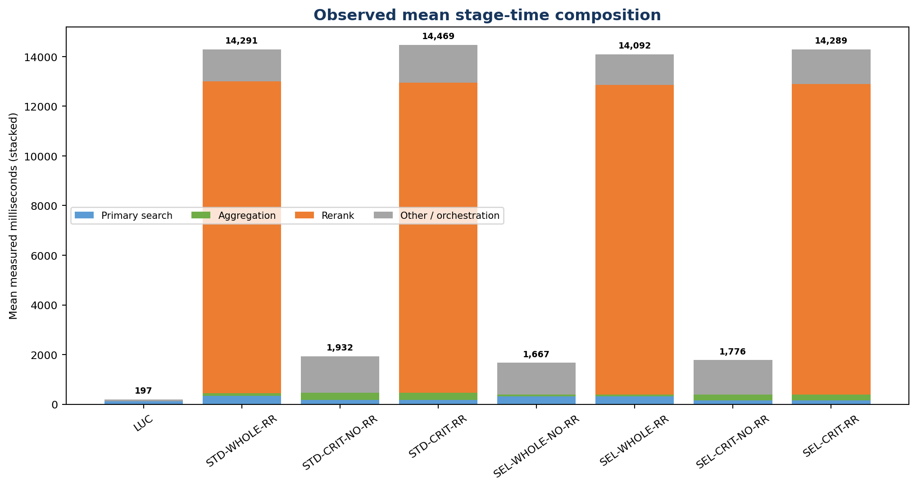
Figure 26. Observed mean stage-time composition
Components are read from stageDurationsMs; 'other/orchestration' is the measured total minus named stages.
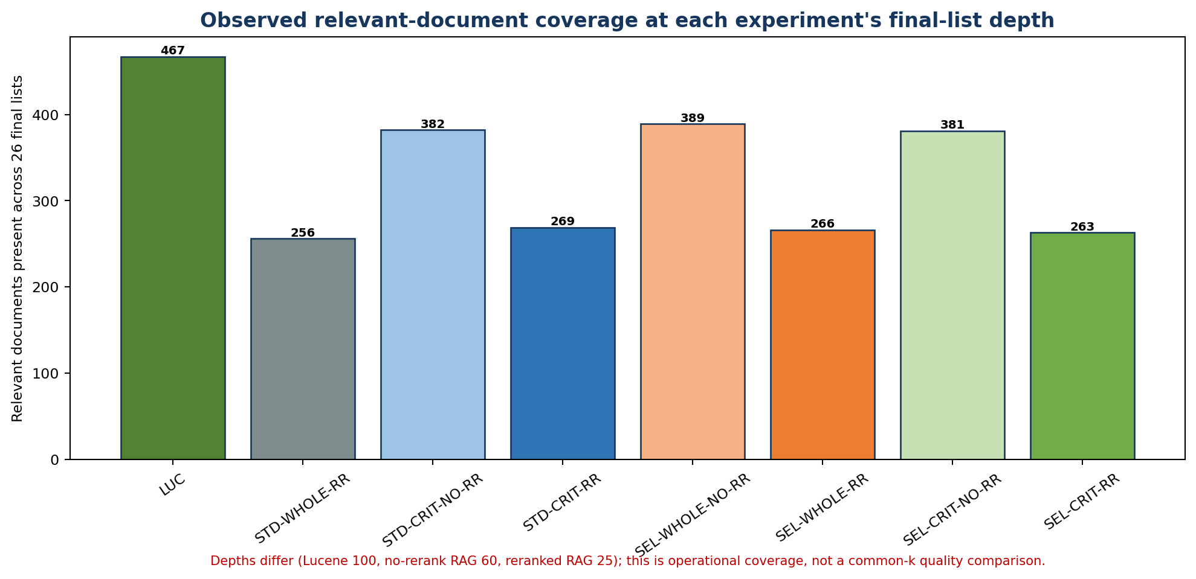
Figure 27. Observed relevant-document coverage at each final-list depth
Final depths differ and therefore this operational coverage figure is not a common-k quality comparison.
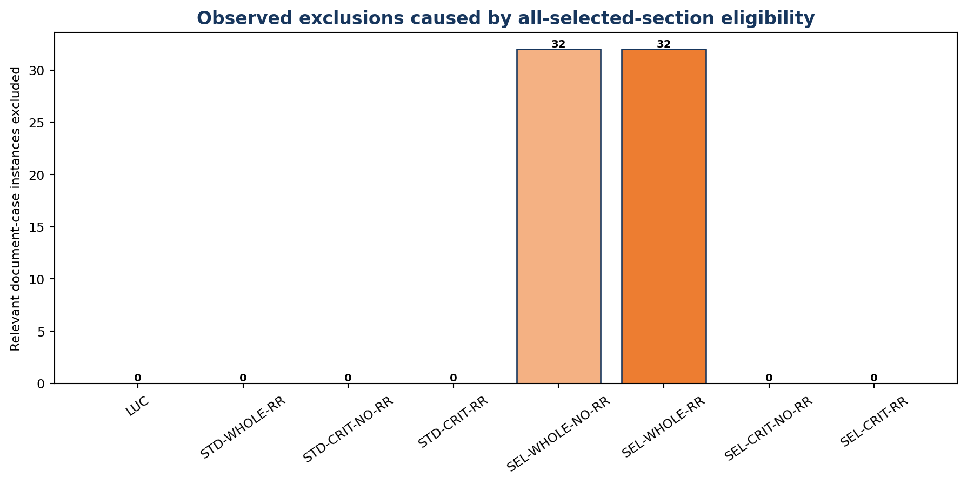
Figure 28. Observed selected-section exclusions
Only selective whole-description retrieval applies all-selected-section document eligibility.
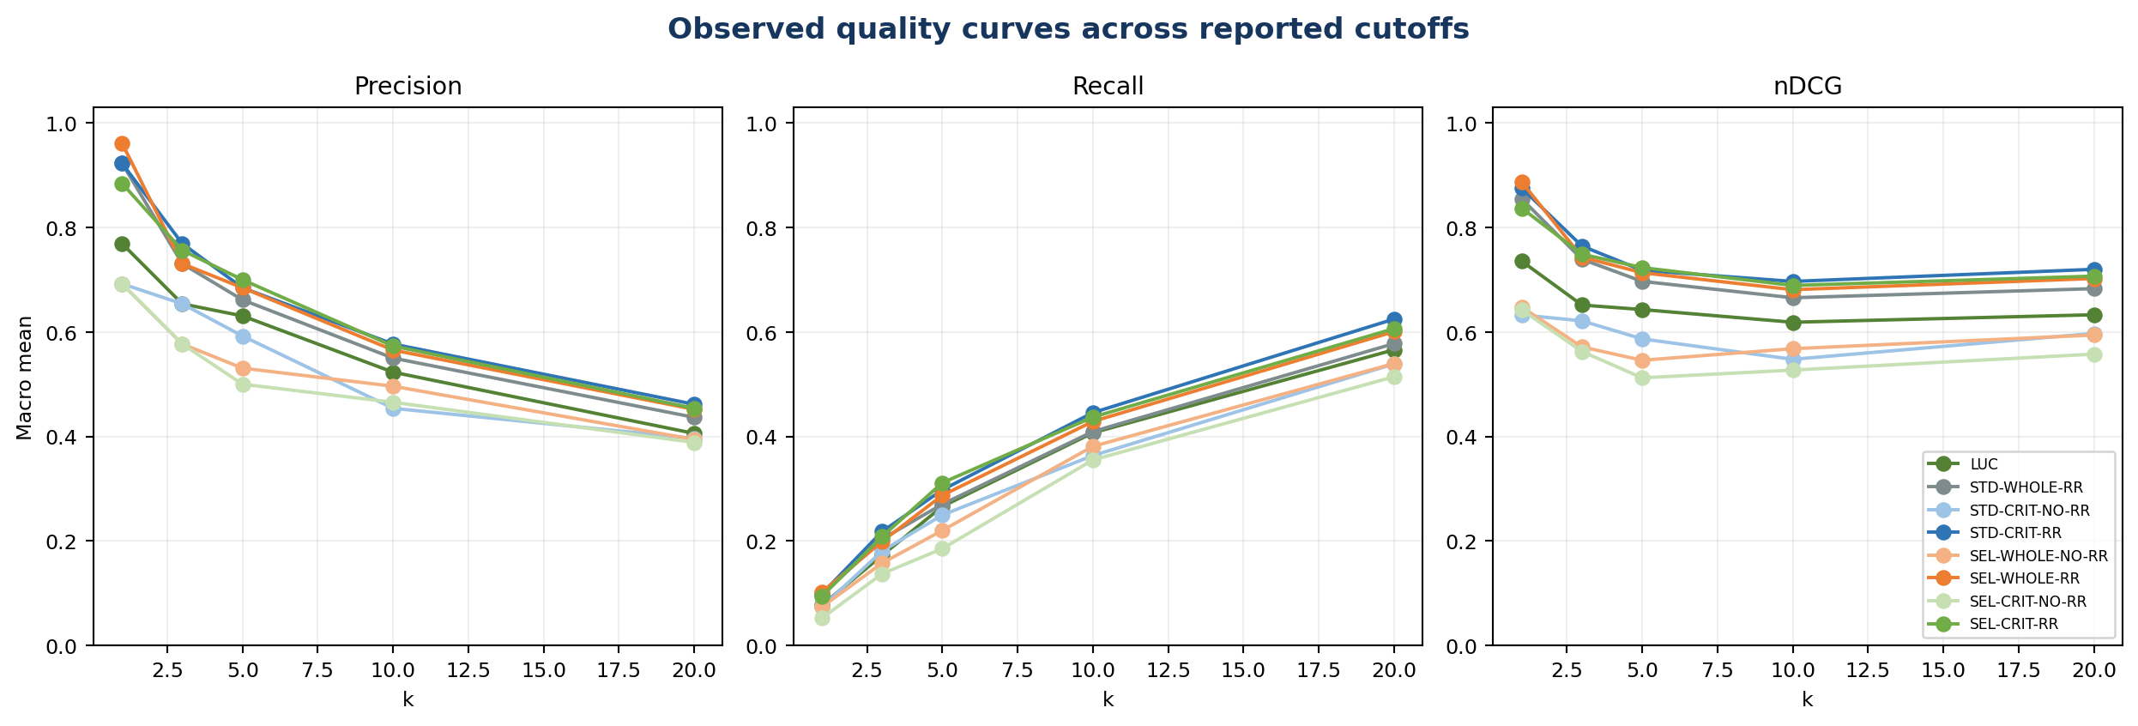
Figure 29. Observed quality curves across reported cutoffs
Curves use the five cutoffs stored in the current aggregate results.
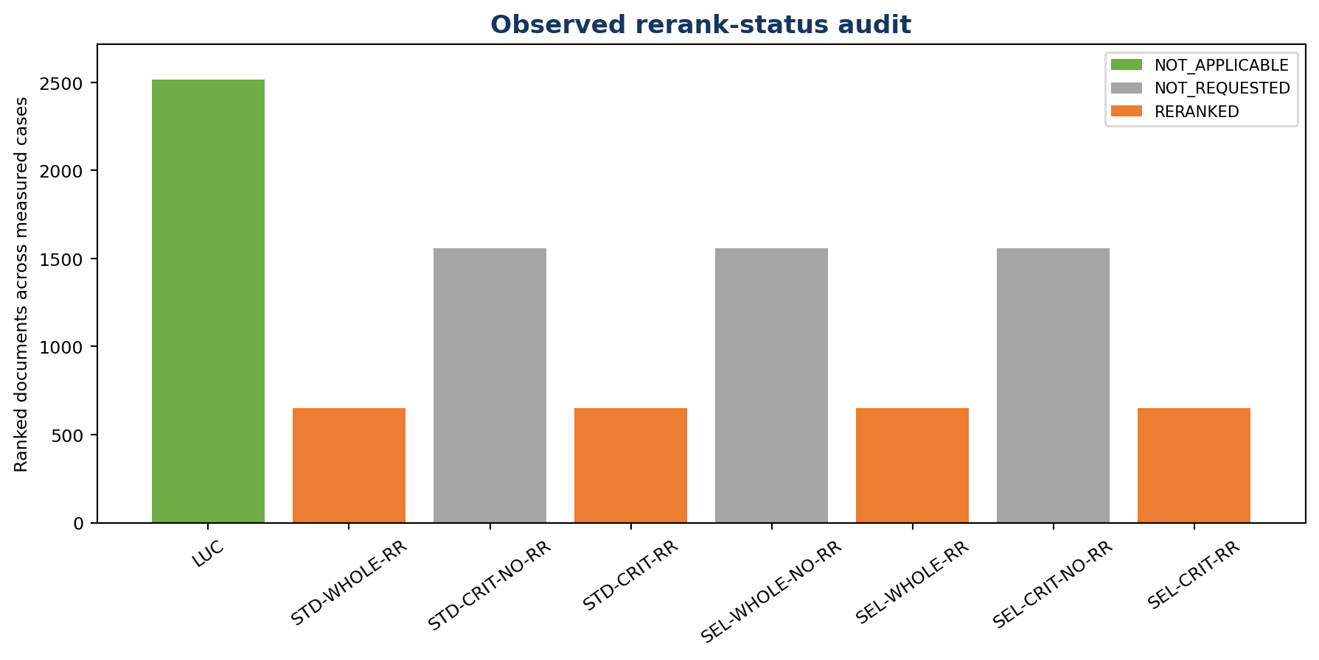
Figure 30. Observed rerank-status audit
The status counts come from every ranked document in the measured rankingComparison records.
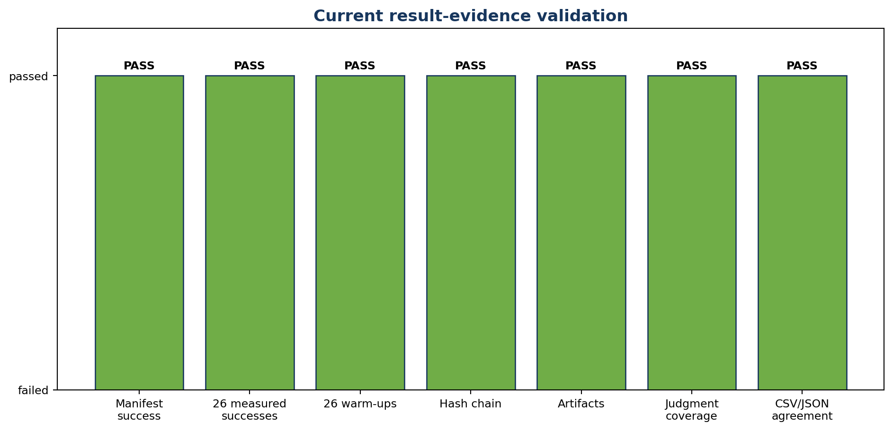
Figure 31. Current result-evidence validation
Every displayed check must pass before numerical conclusions are admitted into the report.

8. Discussion and conclusion
This benchmarsk substantiates setup as a credible RAG design. The corrected result tree now supplies the missing empirical evidence: eight successful conditions, 208 successful measured case results, complete configuration hash chains, resolved runtime parameters, case metrics, rankings, candidate counts, and stage timings.
The strongest current macro nDCG@10 is 0.6968 for RAG Standard Criteria + rerank; Lucene records 0.6186. The result supports the use of a bounded cross-encoder after dense candidate generation: all reranked RAG conditions exceed Lucene on the four reported macro quality measures, while every non-reranked RAG condition falls below Lucene. The same evidence also shows that the quality separation is purchased with a large latency increase and that selective weighting is not consistently beneficial.
The defensible recommendation is therefore to retain the RAG architecture and reranker as the quality-oriented path, retain Lucene as the low-latency lexical path and comparator, and avoid claiming that dense retrieval alone outperforms Lucene. Before production or general scientific claims, repeat the experiments, interleave conditions, reconcile the two vector-searchable document-case gaps, separate scope from weighting, and report repeated-run uncertainty in addition to case-bootstrap uncertainty.
Final claim boundary
The conclusion applies to the eight current runs, their 26 common benchmark cases, the strict relevance rule, the resolved Jina/Qwen/Lucene configurations, and the measured batch environments. It is not a universal ranking of Lucene, embeddings, or rerankers.

Appendix A. Current run inventory
Code | Batch | Status | Warm-ups | Measured | Path
LUC | 20260723-135511-9cd3de68 | SUCCEEDED | 26 | 26 | C:\edocument.repo\benchmark-rag\retrieval-benchmarl-results\23-07-2026\Lucene-working\20260723-135511-9cd3de68
STD-WHOLE-RR | 20260720-131949-08f0c1b7 | SUCCEEDED | 26 | 26 | C:\edocument.repo\benchmark-rag\retrieval-benchmarl-results\20-07-2026\Standard-weights-whole-mode-rerank-standard-params\20260720-131949-08f0c1b7
STD-CRIT-NO-RR | 20260722-095549-eb23b551 | SUCCEEDED | 26 | 26 | C:\edocument.repo\benchmark-rag\retrieval-benchmarl-results\22-07-2026\Standard-weights-criteria-no-rerank-standard-params\20260722-095549-eb23b551
STD-CRIT-RR | 20260720-170236-8d7baeed | SUCCEEDED | 26 | 26 | C:\edocument.repo\benchmark-rag\retrieval-benchmarl-results\20-07-2026\Standard-weights-criteria-rerank-standard-params\20260720-170236-8d7baeed
SEL-WHOLE-NO-RR | 20260722-145931-aca849af | SUCCEEDED | 26 | 26 | C:\edocument.repo\benchmark-rag\retrieval-benchmarl-results\22-07-2026\Selective-weights-whole-description-no-rerank-standard-params\20260722-145931-aca849af
SEL-WHOLE-RR | 20260722-080546-3e6f67df | SUCCEEDED | 26 | 26 | C:\edocument.repo\benchmark-rag\retrieval-benchmarl-results\21-07-2026\Selective-weights-whole-description-rerank-standard-params\20260722-080546-3e6f67df
SEL-CRIT-NO-RR | 20260722-142120-947cf272 | SUCCEEDED | 26 | 26 | C:\edocument.repo\benchmark-rag\retrieval-benchmarl-results\22-07-2026\Selective-weights-criteria-no-rerank-standard-params\20260722-142120-947cf272
SEL-CRIT-RR | 20260722-074644-b85ccb96 | SUCCEEDED | 26 | 26 | C:\edocument.repo\benchmark-rag\retrieval-benchmarl-results\21-07-2026\Selective-weights-criteria-rerank-standard-params\20260722-074644-b85ccb96

Appendix B. Paired nDCG@10 comparisons
Contrast | Mean Δ | Median Δ | CI low | CI high | Wins | Ties | Losses
Rerank effect: standard criteria | 0.14916561 | 0.09437273999999995 | 0.0557262773269231 | 0.2526105202596154 | 16 | 2 | 8
Rerank effect: selective criteria | 0.16208023846153846 | 0.15000126999999996 | 0.07069455849999999 | 0.25993661780769217 | 18 | 1 | 7
Rerank effect: selective whole | 0.11299259269230769 | 0.10148556000000003 | 0.05082197463461537 | 0.17817748582692294 | 19 | 1 | 6
Scope/weight effect: criteria + rerank | -0.007690544230769235 | 0.0 | -0.030190746000000008 | 0.011903596894230711 | 8 | 10 | 8
Scope/weight effect: criteria no rerank | -0.02060517269230768 | 0.0 | -0.07273142970192309 | 0.02462582475000001 | 12 | 4 | 10
Criteria vs whole: selective + rerank | 0.008142541538461535 | 0.0 | -0.020756495076923072 | 0.03664056794230769 | 12 | 3 | 11
Criteria vs whole: selective no rerank | -0.040945104230769226 | -0.004536069999999989 | -0.137233207625 | 0.05121045257692305 | 11 | 1 | 14
Criteria vs whole: standard + rerank | 0.031259472307692306 | 0.0 | -0.0014401307788461685 | 0.0688748998653846 | 11 | 4 | 11
RAG Standard Whole + rerank versus Lucene | 0.04690579923076923 | 0.08180511000000001 | -0.02387125566346153 | 0.11778735099038455 | 14 | 1 | 11
RAG Standard Criteria no rerank versus Lucene | -0.07100033846153847 | -0.07778657500000002 | -0.1613629012980769 | 0.01707715596153841 | 8 | 1 | 17
RAG Standard Criteria + rerank versus Lucene | 0.07816527153846153 | 0.09913379 | -0.0007120110673076836 | 0.15568686126923048 | 14 | 1 | 11
RAG Selective Whole no rerank versus Lucene | -0.050660406923076926 | -0.0033164649999999907 | -0.15155929841346155 | 0.048553585846153824 | 12 | 1 | 13
RAG Selective Whole + rerank versus Lucene | 0.06233218576923077 | 0.08290953000000001 | -0.006866988278846157 | 0.1311369164807692 | 16 | 1 | 9
RAG Selective Criteria no rerank versus Lucene | -0.09160551115384614 | -0.062709975 | -0.18387735545192307 | -0.0008910616826923994 | 7 | 1 | 18
RAG Selective Criteria + rerank versus Lucene | 0.0704747273076923 | 0.06643835999999997 | -0.005921317009615399 | 0.14600829186538447 | 15 | 1 | 10

References
[1] Current benchmark artifacts under benchmark-rag/retrieval-benchmarl-results (OLD excluded).
[2] Experiment definitions under benchmark-rag/benchmark-experiments and packaged application resources.
[3] RetrievalBenchmarkEvaluationService and related vector, reranking, Lucene, and artifact-persistence source code under edoc-265.
[4] Local embedding and reranker startup scripts under benchmark-rag/*.sh.
[5] Jina AI. jina-embeddings-v5-text-small-retrieval model card. https://huggingface.co/jinaai/jina-embeddings-v5-text-small-retrieval
[6] Akram, M. K. et al. (2026). jina-embeddings-v5-text: Task-Targeted Embedding Distillation. https://arxiv.org/abs/2602.15547
[7] Qwen Team. Qwen3-Reranker-4B model card. https://huggingface.co/Qwen/Qwen3-Reranker-4B
[8] Zhang, Y. et al. (2025). Qwen3 Embedding: Advancing Text Embedding and Reranking Through Foundation Models. https://arxiv.org/abs/2506.05176
[9] Lewis, P. et al. (2020). Retrieval-Augmented Generation for Knowledge-Intensive NLP Tasks.
[10] Apache Lucene scoring and Similarity documentation.

