LLM MOE models for RAG search
A pooled, PDF-grounded analysis across 24 predefined occupational categories and 2,484 CVs

July 2026

Evaluated reports | 24 category-specific workbooks
Predefined occupational categories | 24
Original CV PDFs | 2,484
Evaluable matched records | 2,482
Extraction model | Gemma 4 26B A4B instruction model, QAT/GGUF quantization
Inference runtime | llama-server with Vulkan acceleration and four parallel slots
Evaluation basis | Original PDFs as primary evidence; reference JSON diagnostic only

Scope statement: The analysis covers one validated evaluation report for each of 24 predefined occupational categories and 2,484 source CV PDFs. CV_Local_LLM_Extraction_Evaluation(7).xlsx is outside the set and is excluded. The valid Advocate category is represented by ADVOCATE-CV_Local_LLM_Extraction_Evaluation.xlsx; the mislabeled detailed duplicate is not used in the aggregate.

Abstract
This study evaluates a locally hosted, quantized Gemma 4 26B A4B mixture-of-experts instruction model used to extract structured information from curriculum vitae (CV) documents for downstream retrieval-augmented generation (RAG). The corrected corpus contains 2,484 original CVs in PDF format distributed across 24 predefined occupational categories, with one validated evaluation report per category. The original PDFs are treated as the primary evidentiary source; a separate reference extraction is used only for diagnostic disagreement analysis. Performance is assessed at pipeline, document, segment, and atomic-fact levels using strict and partial-credit precision, recall, F1, completeness, unsupported-content rate, schema completeness, critical-claim rate, and operational document outcomes. The pooled weighted precision is 94.8%, weighted recall is 65.5%, weighted F1 is 77.4%, completeness is 68.2%, and unsupported content is 1.23%. The technical pipeline produced 2,482 evaluable matched records from 2,484 PDFs (99.92%). Only 201 documents (8.1%) satisfy the joint success thresholds; 1,989 are partially successful and 294 fail. The dominant failure mode is omission rather than hallucination. Experience and profile fields perform comparatively well, while category classification, normalized fields, seniority, and document metadata are unsuitable as authoritative retrieval filters. CV structure and information density vary substantially, and the semantic boundary between skills and experience is often non-exclusive; the same source statement may validly function as both demonstrated experience and skill evidence. The report formalizes the evaluation mathematics, analyzes the supplied inference configuration, examines the speed-quality trade-off associated with reasoning-disabled inference, and critiques the extraction and evaluation prompts. The principal deployment conclusion is that the extracted JSON can serve as a high-precision indexing layer and source of positive evidence, but it must be combined with raw-section fallback, field-compatible retrieval, evidence citation, quality-aware ranking, and human review. Missing structured values cannot safely be interpreted as absence in the source CV. The analysis explicitly separates source availability from extraction completeness: a missing structured value may mean either that the CV does not contain the information or that the information was present but omitted by the extractor.
Keywords: curriculum vitae; information extraction; retrieval-augmented generation; local language model; mixture of experts; precision-recall trade-off; multilingual retrieval; structured search; llama.cpp; prompt engineering
Data and materials. The empirical basis consists of 24 category-specific evaluation workbooks covering 2,484 source CV PDFs, prompt2(5), aiextract.sys.prompt, and aiextract.user.prompt. The original Advocate workbook is used for the Advocate category; the generic outside-scope workbook and the mislabeled detailed Advocate duplicate are excluded. The combined Excel workbook contains the numerical consolidation and visualizations used in this report.

Table of Contents
Abstract | 2
1. Introduction | 7
1.1 Retrieval-augmented generation for CV search | 7
1.2 The same-context requirement | 7
1.3 Research questions and contributions | 8
2. Materials, System Configuration, and Evaluation Setup | 9
2.1 Corpus and scope | 9
2.2 Data composition, information density, and document heterogeneity | 9
2.3 Local model and inference server | 9
2.4 Extraction prompt chain | 10
2.5 PDF-grounded evaluation protocol | 11
2.6 Reproducibility controls | 11
3. Mathematical Framework | 13
3.1 Atomic-fact notation | 13
3.2 Strict precision, recall, and F1 | 13
3.3 Partial-credit metrics | 13
3.4 Completeness, unsupported content, and schema quality | 14
3.5 Document outcomes and aggregation | 14
3.6 Field-aligned RAG scoring | 15
3.7 Latency, throughput, and memory model | 15
4. Results | 16
4.1 Pooled results | 16
4.2 Dataset-level variation | 18
4.3 Segment-level performance | 24
4.4 Error structure and severity | 28
4.5 Document-level variation | 31
5. Technical Analysis | 36
5.1 Principal strengths | 36
5.2 Principal weaknesses | 36
5.3 Ontological ambiguity between experience and skills | 36
5.4 Why high precision and low recall coexist | 37
5.6 Consequences for retrieval and ranking | 37
5.5 Schema completeness is not factual completeness | 37
5.7 Decomposing low coverage: source absence versus extraction failure | 38
6. The Need for Speed | 41
6.1 Offline extraction versus online search latency | 41
6.2 Runtime trade-offs in the supplied configuration | 41
6.3 Throughput engineering and measurement | 41
6.4 Recommended performance architecture | 42
7. Consequences of Running with Reasoning Disabled | 43
7.1 Operational meaning of reasoning off | 43
7.2 Advantages for extractive processing | 43
7.3 Risks for ambiguous and compositional extraction | 43
7.4 Interpretation of the present results | 43
7.5 Required on-versus-off experiment | 44
8. Discussion of the Prompting Strategy | 45
8.1 Strengths of the extraction prompt | 45
8.2 Prompt-induced failure modes | 45
8.3 Relationship between prompting and observed errors | 45
8.4 Recommended prompt redesign | 45
8.5 Constrained decoding and validation | 46
9. Alternative Local Models | 47
9.1 Candidate model families | 47
9.2 Multilingual capability as a selection constraint | 47
9.3 Model substitution must be empirically validated | 47
10. Integration into a RAG System for CV Search | 49
10.1 Recommended index architecture | 49
10.2 Query decomposition and field alignment | 49
10.3 Quality-aware retrieval policy | 49
10.4 Human oversight and auditability | 50
11. Threats to Validity and Limitations | 51
12. Conclusion | 52
Appendix A. Dataset-Level Results | 53
Appendix B. Report Comparability and Provenance Audit | 55
Appendix C. Prompt and Runtime Record | 58
C.1 Extraction system prompt summary | 58
C.2 Extraction user prompt summary | 58
C.3 Evaluation prompt summary | 58
Appendix D. References | 59

List of Figures
Figure 1. Field-aligned extraction and RAG architecture. | 8
Figure 2. Pooled document outcomes. | 17
Figure 3. Weighted F1 by occupational dataset. | 19
Figure 4. Dataset precision-recall profile. | 20
Figure 5. Completeness versus weighted F1. | 21
Figure 6. Schema completeness versus weighted F1. | 22
Figure 7. Critical unsupported-claim rate by dataset. | 23
Figure 8. Outcome composition by dataset. | 24
Figure 9. Segment-level weighted precision, recall, and F1. | 26
Figure 10. Segment-level fact composition. | 27
Figure 11. Dataset-by-segment weighted-F1 heatmap. | 28
Figure 12. Error Pareto distribution. | 30
Figure 13. Error severity distribution. | 31
Figure 14. Distribution of document-level weighted F1. | 32
Figure 15. Document-level completeness versus weighted F1. | 33
Figure 17. Dataset volume versus weighted F1. | 35
Figure 18. Source-information availability by CV segment. | 39
Figure 16. Multimetric dataset quality heatmap. | 34
Figure 19. Gemma extraction coverage conditional on source availability. | 40

List of Tables
Table 1. Research questions and corresponding evidence. | 8
Table 2. Supplied llama-server configuration and analytical interpretation. | 10
Table 3. Roles of the extraction and evaluation prompts. | 10
Table 4. Atomic-fact status definitions. | 11
Table 5. Operational document-outcome thresholds. | 14
Table 6. Pooled extraction results. | 16
Table 7. Cross-dataset distribution of weighted F1. | 18
Table 8. Highest- and lowest-performing datasets. | 18
Table 10. Most frequent error categories. | 28
Table 9. Segment-level extraction performance. | 24
Table 10A. Source availability and Gemma conditional extraction coverage for principal CV-information segments. | 38
Table 11. Speed and capacity metrics that should be measured. | 41
Table 12. Effects expected from reasoning-disabled inference. | 43
Table 13. Prompt failure modes and recommended controls. | 45
Table 14. Alternative local model families for the same extraction task. | 47
Table 15. Recommended field-specific RAG policy. | 49
Table A1. Dataset-level outcome and quality metrics. | 53
Table B1. In-scope report provenance and aggregation status. | 55
Table C1. Exact supplied runtime command. | 58

1. Introduction

1.1 Retrieval-augmented generation for CV search
Retrieval-augmented generation (RAG) couples an information-retrieval subsystem with a generative model so that answers and decisions can be conditioned on external evidence rather than only on model parameters [1]. In a CV-search system, the retrieved evidence is not general encyclopedic text; it is candidate-specific evidence such as employment history, skills, education, certifications, languages, and source passages. The operational objective is therefore not merely semantic similarity. It is evidence retrieval under a typed schema, followed by criterion-level explanation.
A defensible CV RAG system separates at least three computational stages. First, the source CV is converted into structured fields and source-aligned text spans. Second, the job description is decomposed into atomic criteria, for example a required programming language, minimum experience duration, degree level, location constraint, or certification. Third, each criterion is compared only with semantically corresponding CV evidence. The generative model may summarize or explain the retrieved evidence, but it should not replace the evidence or infer unobserved credentials.
The distinction between positive evidence and negative evidence is essential. A structured value that is present and supported can be used as positive evidence. A structured value that is absent cannot automatically be used as negative evidence because extraction recall is materially below precision. The original document remains authoritative and must remain retrievable.

1.2 The same-context requirement
The same-context requirement is the central design constraint for CV retrieval. A skill requirement in a job description should be matched against skill statements and professional-experience evidence, not against hobbies, personal interests, file metadata, or unrelated course titles. An education requirement should be matched against degree and institution evidence, not employer training unless the source explicitly establishes an equivalent credential. A language requirement should be matched against language proficiency evidence, not nationality, residence, or inferred name origin.
Formally, the retrieval process should preserve the evidentiary role of both the query criterion and candidate evidence. This does not require a rigid one-fact-one-field ontology: a technology named in an employment bullet can be valid evidence for both experience and skill, and a leadership accomplishment can support both responsibility and competency. Cross-field semantic similarity is acceptable when the source statement has a compatible evidentiary role, but unrelated contexts such as hobbies, metadata, or generic interests must carry a strong penalty and cannot by themselves satisfy mandatory criteria. This prevents semantic leakage while allowing multi-role evidence.

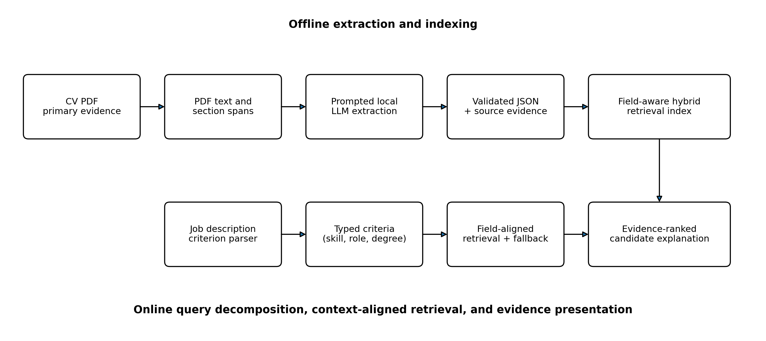
Figure 1. Field-aligned extraction and RAG architecture.
Source: pooled PDF-grounded evaluation workbooks; calculations in the combined analysis.
Interpretation. The architecture separates offline extraction from online retrieval. Both the job criterion and the CV evidence are typed before matching. Structured retrieval is supplemented by source-section fallback so that omitted JSON fields do not become false negatives.
Limitation. The diagram is a recommended architecture derived from the evaluation results; it is not a direct measurement of the supplied implementation.

1.3 Research questions and contributions
Table 1. Research questions and corresponding evidence.
ID | Research question | Evidence used
RQ1 | How accurately and completely does the local model reproduce PDF-supported CV facts? | Atomic-fact precision, recall, F1, completeness, and unsupported-content rate.
RQ2 | Which occupational datasets and CV segments are strongest or weakest? | Dataset and segment metrics, heatmaps, outcome distributions, and error logs.
RQ3 | Is the extracted JSON suitable for RAG-based CV search? | Field reliability, missingness risk, source fallback requirements, and ranking implications.
RQ4 | What are the performance implications of the supplied runtime and reasoning-disabled configuration? | Analytical latency model, concurrency settings, MoE/QAT characteristics, and reasoning-mode trade-offs.
RQ5 | How does the prompt design shape the observed precision-recall profile? | Prompt-contract analysis linked to omissions, segmentation errors, and normalization failures.
The report contributes a pooled empirical baseline across heterogeneous occupational datasets, a formal definition of the metrics used in the attached reports, a high-level systems analysis of the local inference configuration, and a deployment-oriented RAG design that explicitly accounts for extraction uncertainty.

2. Materials, System Configuration, and Evaluation Setup

2.1 Corpus and scope
The corrected scope contains one validated report for each of 24 predefined occupational categories and 2,484 source CV PDFs. The Advocate category is taken from ADVOCATE-CV_Local_LLM_Extraction_Evaluation.xlsx, which contains 118 Advocate CVs; the mislabeled detailed duplicate is not used. The generic workbook CV_Local_LLM_Extraction_Evaluation(7).xlsx was explicitly excluded and is absent from all calculations. Across the 2,484 PDFs, 2,482 records were matched and evaluable; the two non-evaluable cases occur in Banking and Business Development. The resulting pipeline-success rate is 99.92%.
The 24 predefined categories are Accountant, Advocate, Agriculture, Apparel, Arts, Automobile, Aviation, Banking, BPO, Business Development, Chef, Construction, Consultant, Designer, Digital Media, Engineering, Finance, Fitness, Healthcare, HR, Information Technology, Public Relations, Sales, and Teacher. The labels are corpus strata supplied before evaluation rather than occupational predictions produced by the extraction model. This breadth improves domain coverage but also makes pooled averages insufficient; category-level and document-level dispersion must be examined.

2.2 Data composition, information density, and document heterogeneity
The corpus contains 2,484 CVs in PDF format. Category size ranges from 22 CVs in BPO to 120 CVs in Business Development and Information Technology, with a mean of 103.5 and a median of 115 CVs per category. The category totals are descriptive sampling strata; they do not imply equal occupational prevalence, equal document complexity, or equal statistical precision. Micro-aggregated metrics therefore weight fact-rich categories and documents more heavily, while macro statistics give each category equal weight.
The CVs are structurally heterogeneous. Some are concise one-page documents containing little more than a profile, a short employment history, and a compact skills list. Others contain multiple pages of detailed responsibilities, projects, certifications, languages, publications, technical tools, and repeated role descriptions. Layouts include single-column prose, multi-column templates, tables, sidebars, graphical headings, and PDF text with imperfect reading order. Consequently, the number of applicable facts varies substantially between documents. A CV with fewer facts is not necessarily lower quality, and a high raw omission count can partly reflect a denser source document rather than a universally worse extraction mechanism.
The source documents also do not enforce a universally exclusive distinction between experience and skills. A skill may appear in a dedicated Skills section, inside a job-responsibility bullet, in a project description, or only through a concrete accomplishment. Conversely, an experience statement can contain an employer, role, date range, task, technology, domain skill, and outcome in a single sentence. Forcing every atomic fact into exactly one binary field can therefore create artificial disagreement between equally defensible classifications. The evaluation should treat such cases as multi-label or overlap-compatible evidence, retain the verbatim source span, and distinguish taxonomy ambiguity from factual extraction error.
These characteristics motivate four analytical choices used throughout the report: per-document applicability denominators, separate micro and macro summaries, document-level dispersion analysis, and RAG retrieval that accepts compatible multi-role evidence while rejecting semantically unrelated context. They also mean that an empty structured field can arise from true source absence, document-layout failure, taxonomy ambiguity, or model omission; those states must not be collapsed into a single negative value.

2.3 Local model and inference server
The extraction model was served locally with llama-server using the exact command supplied by the user. The model filename identifies the instruction-tuned Gemma 4 26B A4B checkpoint, a quantization-aware-trained variant converted to GGUF and quantized using a Q4_K_XL scheme. Gemma 4 26B A4B is a mixture-of-experts model with approximately 25.2 billion total parameters and 3.8 billion active parameters per token; the model family supports a context window up to 256K tokens and more than 140 languages [4,5]. The runtime explicitly limits context to 65,536 tokens.
Table 2. Supplied llama-server configuration and analytical interpretation.
Flag | Value | Technical interpretation
-m | gemma-4-26B-A4B-it-qat-UD-Q4_K_XL.gguf | Model checkpoint and quantization; exact converter/version should be recorded for reproducibility.
--device | Vulkan1 | Selects the Vulkan device used by the build.
--split-mode | layer | Distributes complete layers when more than one device is available; effect depends on detected devices.
-ngl | auto | Automatically selects the number of layers offloaded to acceleration hardware.
-c | 65536 | Sets the runtime context to 65,536 tokens, below the model maximum.
-ub | 64 | Sets the physical micro-batch size; this can affect prompt-processing speed and memory.
-fa | auto | Allows llama.cpp to select Flash Attention when supported.
--reasoning | off | Disables the model thinking/reasoning path in the chat template.
--host / --port | 127.0.0.1 / 8080 | Restricts the service to the local machine and exposes an HTTP endpoint.
-np | 4 | Creates four parallel server slots; throughput and effective KV-cache allocation must be benchmarked for the specific build.
Note. llama.cpp flags and defaults can change between builds. The exact llama.cpp commit or release, driver versions, hardware, and sampling parameters were not present in the supplied reports and should be captured in future runs [7].
llama-server.exe -m ..\models\gemma-4-26B-A4B-it-qat-UD-Q4_K_XL.gguf --device Vulkan1 --split-mode layer -ngl auto -c 65536 -ub 64 -fa auto --reasoning off --host 127.0.0.1 --port 8080 -np 4

2.4 Extraction prompt chain
The extraction chain contains a system prompt and a parameterized user prompt. The system prompt defines the model as a text-extraction engine and imposes a strict serialization contract: return exactly one XML <block> for each requested headline, preserve the requested order, copy only source text, and leave the block empty if no corresponding text exists. It explicitly forbids rewriting, summarization, invention, normalization, translation, or correction. The user prompt inserts the document text, requested headlines, headline definitions, and required block count.
Table 3. Roles of the extraction and evaluation prompts.
Artifact | Role | Principal controls
aiextract.sys.prompt | Primary extraction behavior | Verbatim copying, fixed block count, source order preservation, no normalization or translation.
aiextract.user.prompt | Per-document request template | Injects document text, ordered target headlines, definitions, and expected number of blocks.
prompt2(5) | Evaluation and report-generation protocol | Defines PDF-grounded adjudication, atomic statuses, metric formulae, thresholds, evidence requirements, workbook structure, and charts.
The extraction prompt and the evaluation prompt serve different functions. The former creates the model output under test. The latter specifies how that output is compared with the original PDF and how the resulting report is constructed. Conflating these two prompts would obscure the causal chain between extraction behavior and measured performance.

2.5 PDF-grounded evaluation protocol
The evaluation direction is fixed: original PDF to local extraction. The PDF is treated as the closest available approximation to ground truth. The reference JSON is explicitly secondary and cannot override PDF evidence. When local and reference outputs agree but conflict with the PDF, the local extraction is incorrect. When they disagree, the PDF adjudicates the disagreement. This is methodologically important because agreement between two extractors can reflect shared omission or shared hallucination rather than correctness.
Table 4. Atomic-fact status definitions.
Status | Operational definition
Correct | The extracted fact is explicitly or unambiguously supported by the PDF.
Partially correct | The fact contains a supported core plus an omission, imprecision, or unsupported modifier.
Unsupported | The extraction contains a fact that cannot be supported by the PDF.
Contradicted | The extracted value directly conflicts with the PDF.
Missing | A relevant fact is clearly present in the PDF but absent from the extraction.
Not applicable | The field is genuinely absent and should not have been extracted.
Unverifiable | PDF quality, ambiguity, language, or technical limitations prevent reliable adjudication.
The analysis occurs at four levels: pipeline/file, document, segment or field family, and atomic fact. Atomic decomposition is essential because a list or employment entry may contain both correct and missing elements. Scoring a whole segment as correct when only part of it is correct would inflate performance and conceal omissions.

2.6 Reproducibility controls
The reports contain file inventories, parameters, evidence tables, error logs, methodology, limitations, and data dictionaries. The common evaluation prompt fixes the partial-credit coefficient at 0.5 and applies identical outcome thresholds across datasets. Nevertheless, complete computational reproducibility requires additional runtime metadata: llama.cpp commit, GPU and driver details, sampling temperature and seed, parser version, PDF-to-text method, exact model hash, exact quantization hash, request concurrency, and measured context length per slot. These values should be added to a machine-readable experiment manifest.
The evaluation itself is deterministic only to the extent that evidence adjudication and report formulas are deterministic. Human or model-assisted atomic-fact judgments can introduce measurement variance. Future studies should include duplicate blind adjudication on a stratified sample and report inter-rater agreement.

3. Mathematical Framework
This section states the evaluation mathematics explicitly so that dataset comparisons, threshold decisions, and RAG policy recommendations can be reproduced without relying on spreadsheet implementation details.

3.1 Atomic-fact notation
For each atomic fact i, let $y_{i}∈\{C,P,U,X,M,N,V\}$, denoting Correct, Partially correct, Unsupported, Contradicted, Missing, Not applicable, and Unverifiable. The quantitative counts are defined as TP = number of correct facts, PARTIAL = number of partially correct facts, FP = unsupported plus contradicted extracted facts, and FN = missing PDF-supported facts. Unverifiable and not-applicable facts are reported separately and excluded from the main precision-recall denominators.
This definition treats extraction as a directed information-recovery problem. FP measures information introduced without support; FN measures supported source information not represented by the extraction. The direction matters because a missing fact and an unsupported fact have different consequences in RAG: the former creates false negative retrieval, while the latter creates false positive evidence.

3.2 Strict precision, recall, and F1
$$P_{s}=\frac{\text{TP}}{\text{TP}+\text{PARTIAL}+\text{FP}}$$ | (1)
Strict precision credits only fully correct facts while retaining partial facts in the predicted-fact denominator.
$$R_{s}=\frac{\text{TP}}{\text{TP}+\text{PARTIAL}+\text{FN}}$$ | (2)
Strict recall credits only fully correct facts and measures the fraction of relevant PDF facts recovered exactly.
$$F_{1,s}=\frac{2P_{s}R_{s}}{P_{s}+R_{s}}$$ | (3)
The harmonic mean penalizes systems that achieve a high value on only one of precision or recall.
The strict definitions are intentionally conservative. Partially correct facts contribute to neither strict true positives nor false positives alone; they remain in the denominators because the extractor produced an imperfect representation that cannot be counted as exact recovery.

3.3 Partial-credit metrics
The evaluation assigns a fixed partial-credit coefficient $α=0.5$. Let WTP denote weighted true positives.
$$\text{WTP}=\text{TP}+α⋅\text{PARTIAL},α=0.5$$ | (4)
$$P_{\text{w}}=\frac{\text{WTP}}{\text{TP}+\text{PARTIAL}+\text{FP}}$$ | (5)
$$R_{\text{w}}=\frac{\text{WTP}}{\text{TP}+\text{PARTIAL}+\text{FN}}$$ | (6)
$$F_{1,w}=\frac{2P_{\text{w}}R_{\text{w}}}{P_{\text{w}}+R_{\text{w}}}$$ | (7)
The coefficient alpha is an operational convention rather than an empirically calibrated utility value. It makes partial facts comparable across reports, but it does not imply that every partial fact is exactly half as useful as a correct fact. Sensitivity analysis with alternative alpha values would be appropriate when the downstream application assigns different costs to omitted dates, truncated responsibilities, or imprecise titles.

3.4 Completeness, unsupported content, and schema quality
$$C=\frac{\text{TP}+\text{PARTIAL}}{\text{TP}+\text{PARTIAL}+\text{FN}}$$ | (8)
Completeness asks whether relevant PDF facts were represented at least partially, irrespective of exactness.
$$U=\frac{\text{FP}}{\text{TP}+\text{PARTIAL}+\text{FP}}$$ | (9)
Unsupported rate measures the proportion of extracted facts that are not supported or are contradicted by the PDF.
$$A_{\text{exact}}=\frac{\text{TP}}{\text{TP}+\text{PARTIAL}+\text{FP}+\text{FN}}$$ | (10)
$$C_{\text{schema}}=\frac{N_{\text{pop,app}}}{N_{\text{app}}}$$ | (11)
Fields that are genuinely not applicable are excluded from the denominator.
$$S_{\text{pipeline}}=\frac{N_{\text{eval,match}}}{N_{\text{PDF}}}$$ | (12)
$$R_{\text{critical}}=\frac{N_{\text{critical}}}{N_{\text{eval}}}$$ | (13)
Schema completeness and factual completeness measure different constructs. A schema can be fully populated with incorrect or generic values, while a sparse schema can contain only correct facts. This distinction is empirically visible in the weak dataset-level correlation between schema completeness and weighted F1.

3.5 Document outcomes and aggregation
Table 5. Operational document-outcome thresholds.
Outcome | Operational rule
Successful | Evaluable; no critical unsupported/contradicted claim; weighted F1 >= 0.90; completeness >= 0.90; unsupported rate <= 0.05.
Partially successful | Evaluable and not successful; weighted F1 >= 0.60 or completeness >= 0.60.
Failed | Not evaluable, unmatched, weighted F1 < 0.60, major unsupported content, or critical schema/pipeline failure.
Note. These are fixed research thresholds from prompt2(5), not universal scientific or legal standards.
Pooled metrics are micro-aggregated from atomic-fact counts, so large datasets and fact-rich documents contribute more weight. Dataset summaries are also examined using macro statistics because micro-aggregation can conceal occupational heterogeneity. Let $m_{j}$ be a metric for dataset j and $J$ be the number of datasets.
$$\overline{m}=\frac{1}{J}\sum_{j=1}^{J}{m_{j}}$$ | (14)
No formal confidence intervals were included in the source reports. Because facts within a CV are not independent and documents are clustered by occupational dataset, naive binomial intervals would be inappropriate. A defensible uncertainty analysis should bootstrap at the document level within dataset and then aggregate across datasets.

3.6 Field-aligned RAG scoring
For a job criterion $q_{k}$, let $t\left(q_{k}\right)$ be its required evidentiary type. For candidate evidence $e_{i}$, let $T\left(e_{i}\right)$ be a set of compatible semantic roles rather than a single exclusive label. For example, a work-history sentence that explicitly names Python may have both experience and skill roles. A field-aligned score can combine lexical, embedding, cross-encoder, recency, evidence-quality, and source-verification terms while penalizing only genuinely incompatible evidence.
$$S\left(q_{k},e_{i}\right)=w_{l}L+w_{s}E+w_{r}R+w_{q}Q−λ1\left[t\left(q_{k}\right)∉T\left(e_{i}\right)\right)$$ | (15)
Here L is lexical matching, E is semantic similarity, R is a reranker score, Q is an evidence-quality or source-verification score, $1\left[⋅\right)$ is an indicator function, and $λ$ is a mismatch penalty. The penalty is activated when the criterion type is not a member of the evidence-role set. Mandatory criteria may therefore be supported by explicit skills or skill-bearing experience, but not by unrelated hobbies, metadata, or merely topically similar text.
$$S_{\text{cand}}\left(c\right)=\sum_{k}{β_{k}}\max_{e_{i}∈c}S\left(q_{k},e_{i}\right)−\sum_{k}{γ_{k}}U_{k}$$ | (16)
The term $U_{k}$ represents uncertainty, such as an empty structured field with no completed source fallback. The coefficients $β_{k}$ encode criterion importance; $γ_{k}$ prevents uncertainty from being silently interpreted as evidence of absence. The system should expose each max-scoring evidence item and its source excerpt.

3.7 Latency, throughput, and memory model
The source reports do not contain timing telemetry. Speed must therefore be discussed analytically and measured in a follow-up benchmark. End-to-end extraction time for one document can be decomposed as follows:
$$T_{\text{doc}}=T_{\text{pdf}}+T_{\text{prefill}}+T_{\text{decode}}+T_{\text{parse}}+T_{\text{validate}}+T_{\text{I/O}}$$ | (17)
$T_{\text{pdf}}$ is PDF decoding and text extraction; $T_{\text{prefill}}$ is prompt processing; $T_{\text{decode}}$ is model token generation; $T_{\text{parse}}$ is XML/JSON parsing; $T_{\text{validate}}$ is schema and evidence validation; and $T_{\text{I/O}}$ is storage and transport. Reasoning tokens increase $T_{\text{decode}}$ and can also increase memory pressure through longer sequences.
$$Θ_{\text{docs}}=\frac{N_{\text{completed}}}{T_{\text{wall}}}$$ | (18)
$$M_{\text{weights}}≈\frac{N_{\text{parameters}}b_{\text{w}}}{8}+M_{\text{quant}}$$ | (19)
$$M_{\text{KV}}≈\frac{2L_{\text{ctx}}n_{ℓ}n_{\text{KV}}d_{\text{h}}b_{\text{KV}}}{8}\text{per active sequence}$$ | (20)
The lower-bound raw storage for 25.2 billion parameters at 4 bits is approximately 12.6 GB before quantization metadata, tensors stored at higher precision, vision components, runtime buffers, and KV cache. In Equation (19), $N_{\text{parameters}}$ is the total parameter count and $b_{\text{w}}$ is the storage width in bits per parameter. In Equation (20), $L_{\text{ctx}}$ is sequence length, $n_{ℓ}$ is the number of layers, $n_{\text{KV}}$ is the number of key-value heads, $d_{\text{h}}$ is the head dimension, and $b_{\text{KV}}$ is the KV-cache storage width in bits. Although only approximately 3.8 billion parameters are active per token, all expert weights generally need to be resident for efficient routing [4].

4. Results

4.1 Pooled results
Table 6. Pooled extraction results.
Measure | Pooled result
Original PDF records | 2,484
Evaluable matched records | 2,482
Pipeline success | 99.92%
Correct atomic facts | 158,715
Partially correct facts | 13,961
Unsupported/contradicted facts | 2,158
Missing facts | 80,371
Unverifiable facts | 1,705
Strict precision / recall / F1 | 90.8% / 62.7% / 74.2%
Weighted precision / recall / F1 | 94.8% / 65.5% / 77.4%
Completeness | 68.2%
Unsupported-content rate | 1.23%
Critical unsupported-claim rate | 2.78%
Schema completeness | 72.4%
The principal result is a 29.3-percentage-point gap between weighted precision and weighted recall. The extraction is conservative: facts that appear in the output are usually supported, but a substantial fraction of source information is omitted. The pooled unsupported-content rate is low, yet low hallucination does not compensate for missing retrieval evidence when the system is used to search for candidates.
Under the common thresholds, 201 documents are successful, 1,989 are partially successful, and 294 fail. The pooled pipeline-success rate is 99.92%, not exactly 100%, because Banking and Business Development each report one unmatched or non-evaluable record. The outcome denominator is the full set of 2,484 source PDFs, whereas factual metrics are computed from the available atomic evidence.

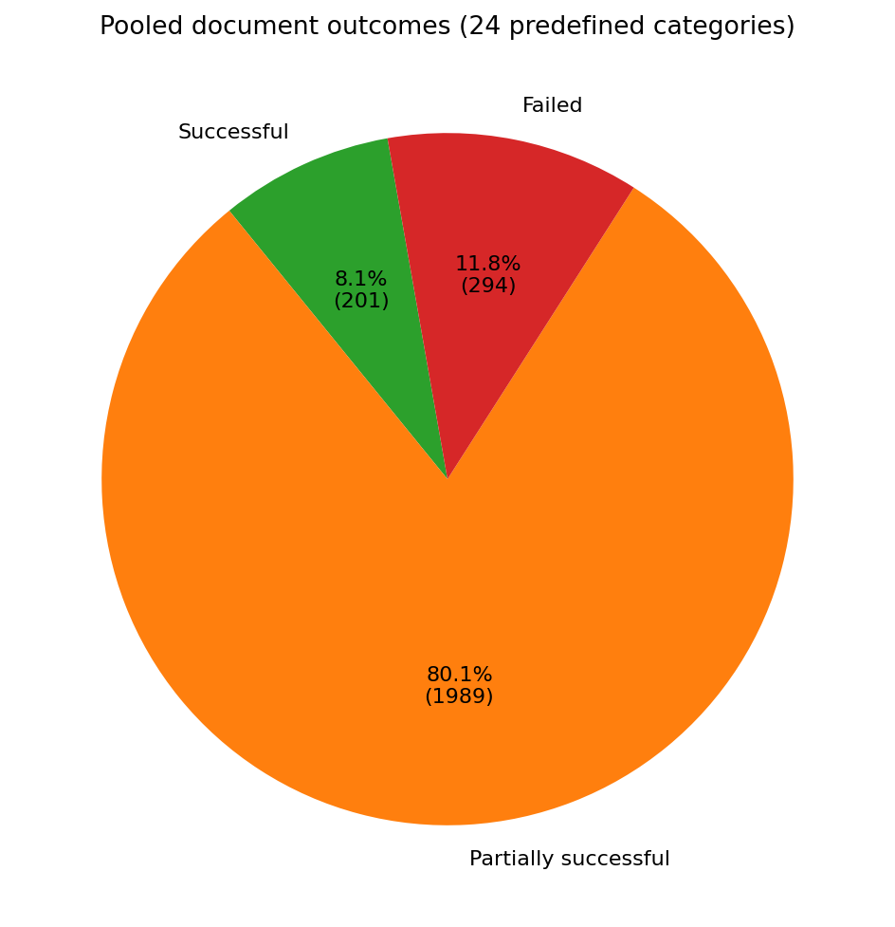
Figure 2. Pooled document outcomes.
Source: pooled PDF-grounded evaluation workbooks; calculations in the combined analysis.
Interpretation. Most documents are partially successful. The small fully successful fraction is caused by the joint threshold: a document must simultaneously achieve high F1, high completeness, low unsupported content, and no critical unsupported or contradicted claim.
Limitation. Outcome labels depend on the operational thresholds in prompt2(5); a different application could choose different cutoffs.

4.2 Dataset-level variation
Table 7. Cross-dataset distribution of weighted F1.
Statistic | Across 24 categories
Macro mean weighted F1 | 78.3%
Median weighted F1 | 82.3%
Standard deviation | 0.127
First quartile | 76.5%
Third quartile | 85.9%
Minimum / maximum | 43.5% / 90.9%
Macro mean weighted precision | 95.2%
Macro mean weighted recall | 67.9%
Table 8. Highest- and lowest-performing datasets.
Group | Dataset | CVs | W. precision | W. recall | W. F1 | Completeness | Failed
Highest | TEACHER | 102 | 97.8% | 84.9% | 90.9% | 85.6% | 1.0%
Highest | AUTOMOBILE | 36 | 100.0% | 81.6% | 89.8% | 81.6% | 0.0%
Highest | BUSINESS DEVELOPMENT | 120 | 98.5% | 82.5% | 89.8% | 83.7% | 1.7%
Highest | SALES | 116 | 99.8% | 79.0% | 88.2% | 79.0% | 1.7%
Highest | AGRICULTURE | 63 | 93.3% | 81.9% | 87.2% | 87.7% | 0.0%
Lowest | ACCOUNTANT | 118 | 89.5% | 28.7% | 43.5% | 32.1% | 89.8%
Lowest | BPO | 22 | 97.6% | 31.9% | 48.1% | 32.2% | 81.8%
Lowest | INFORMATION TECHNOLOGY | 120 | 75.9% | 38.6% | 51.1% | 50.8% | 46.7%
Lowest | HR | 110 | 89.4% | 57.8% | 70.2% | 64.5% | 16.4%
Lowest | CHEF | 118 | 96.8% | 61.8% | 75.5% | 62.8% | 9.3%
Teacher, Automobile, Business Development, Sales, and Agriculture form the highest-performing group by weighted F1. Accountant, BPO, Information Technology, HR, and Chef form the lowest-performing group. The ordering is driven primarily by recall and completeness rather than unsupported content. This pattern implies that layout, vocabulary, section conventions, and prompt-to-document alignment vary materially by occupation.

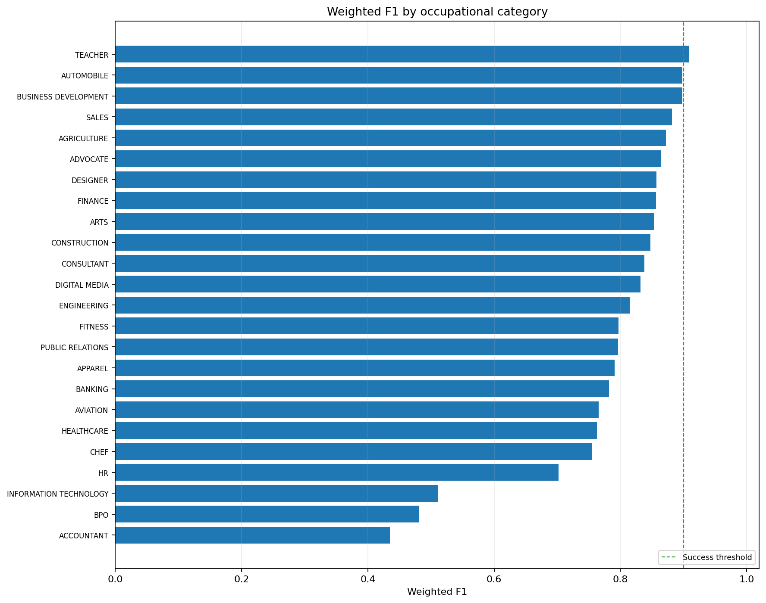
Figure 3. Weighted F1 by occupational dataset.
Source: pooled PDF-grounded evaluation workbooks; calculations in the combined analysis.
Interpretation. Weighted F1 varies widely across occupational datasets. A single pooled score therefore cannot be assumed to generalize uniformly to every CV domain.
Limitation. Dataset sizes differ, and weighted F1 alone does not identify whether a low score is caused by omission, unsupported content, or both.

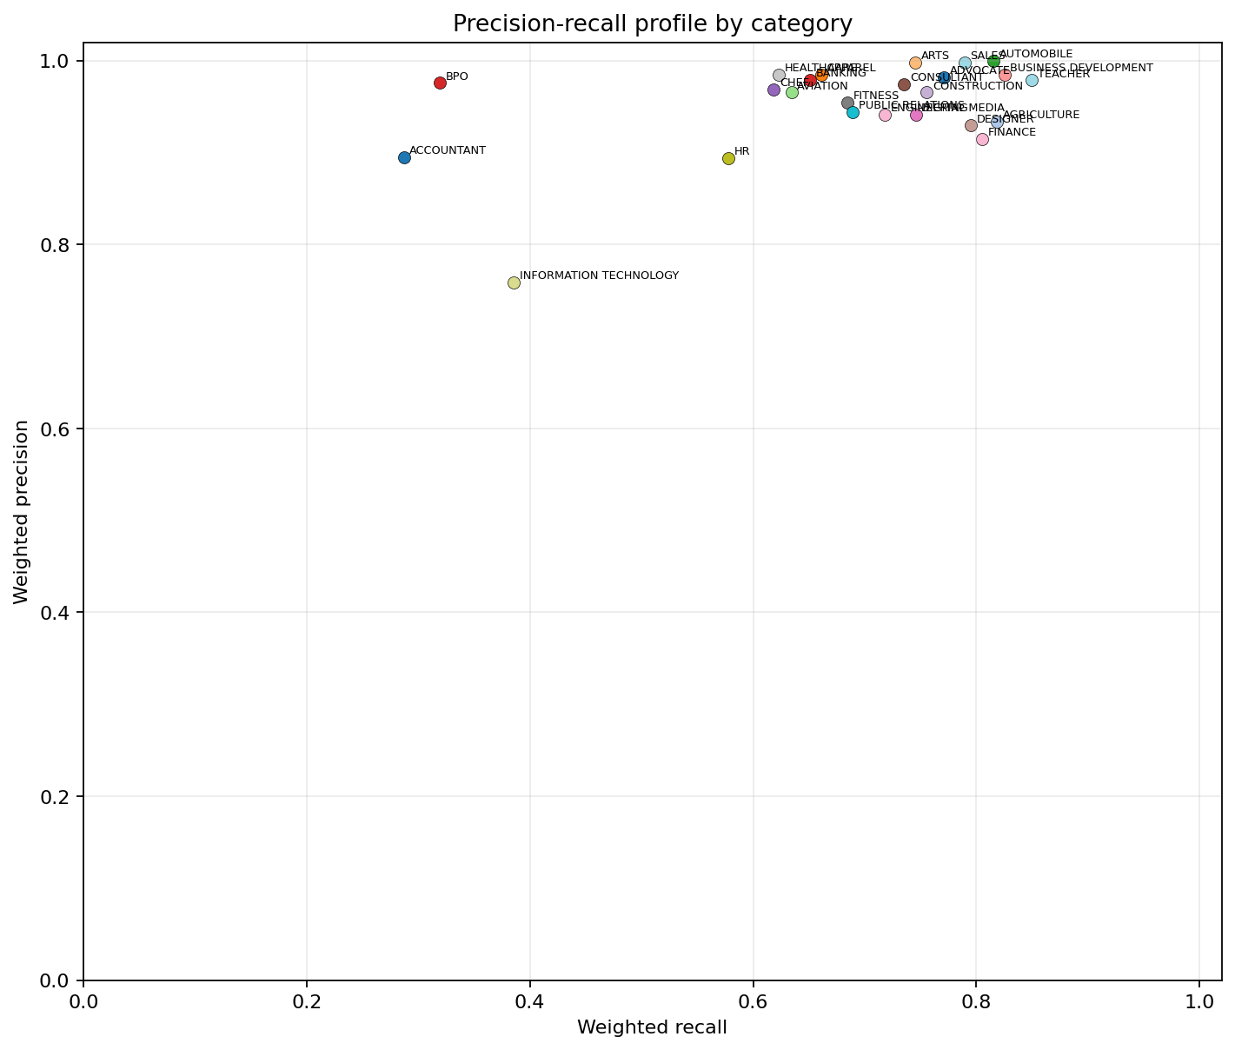
Figure 4. Dataset precision-recall profile.
Source: pooled PDF-grounded evaluation workbooks; calculations in the combined analysis.
Interpretation. Most datasets occupy a high-precision but lower-recall region. Accountant, BPO, and Information Technology are prominent low-recall outliers, supporting the interpretation of conservative extraction with substantial omission.
Limitation. Each point aggregates heterogeneous documents; confidence intervals and language-stratified results are unavailable.

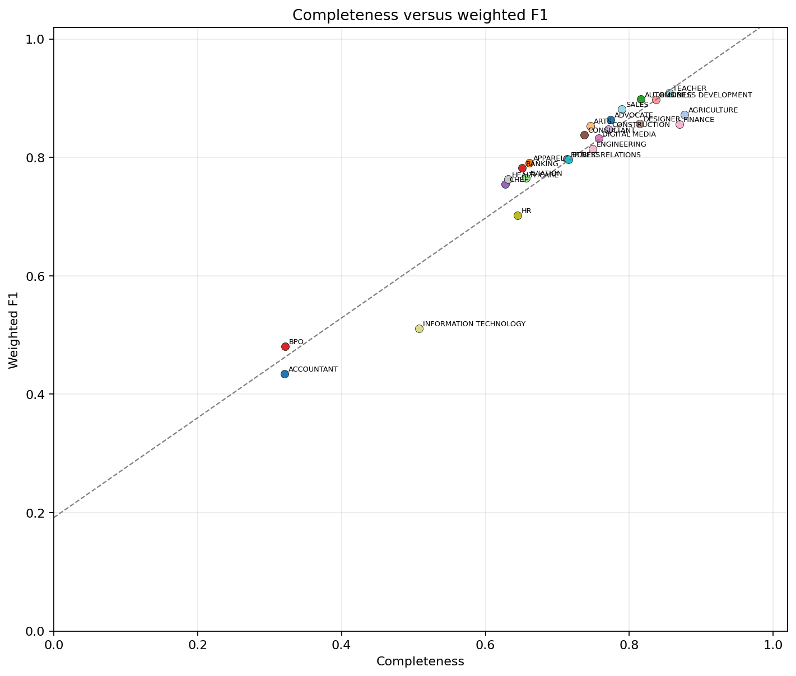
Figure 5. Completeness versus weighted F1.
Source: pooled PDF-grounded evaluation workbooks; calculations in the combined analysis.
Interpretation. Completeness and weighted F1 are strongly associated across the 24 categories (Pearson r = 0.958). Missing source facts are therefore a principal determinant of overall quality.
Limitation. Correlation does not establish that completeness alone causes F1; both measures share atomic-fact counts and are mathematically related.

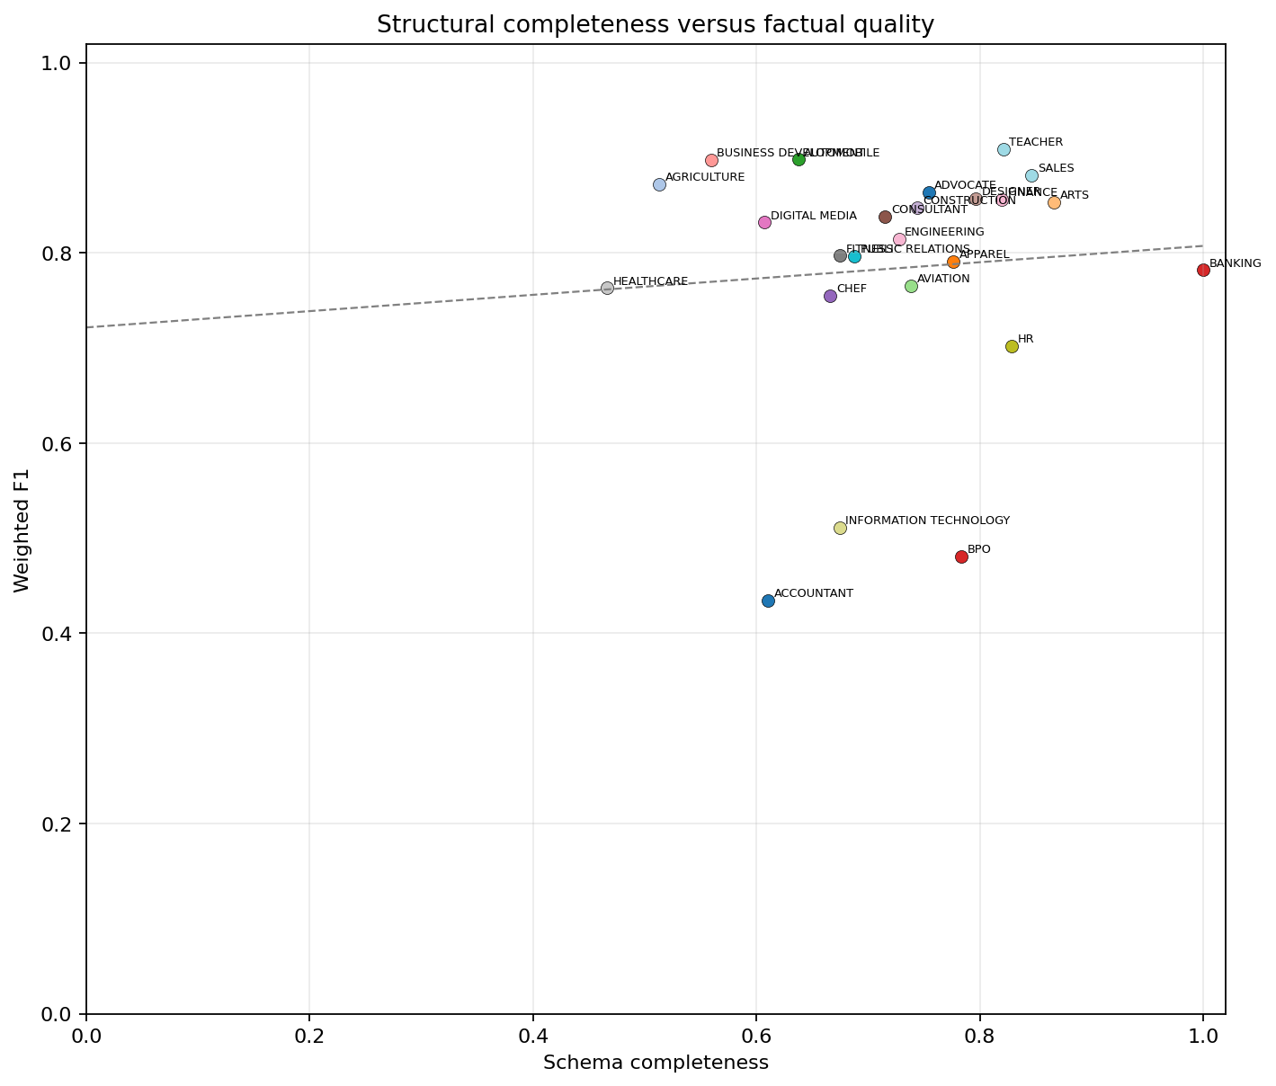
Figure 6. Schema completeness versus weighted F1.
Source: pooled PDF-grounded evaluation workbooks; calculations in the combined analysis.
Interpretation. Schema completeness has little category-level association with weighted F1 (r = 0.080). A populated JSON structure is not evidence that its values are correct or complete.
Limitation. Schema fields and factual facts are not equally numerous across datasets; the correlation is descriptive.

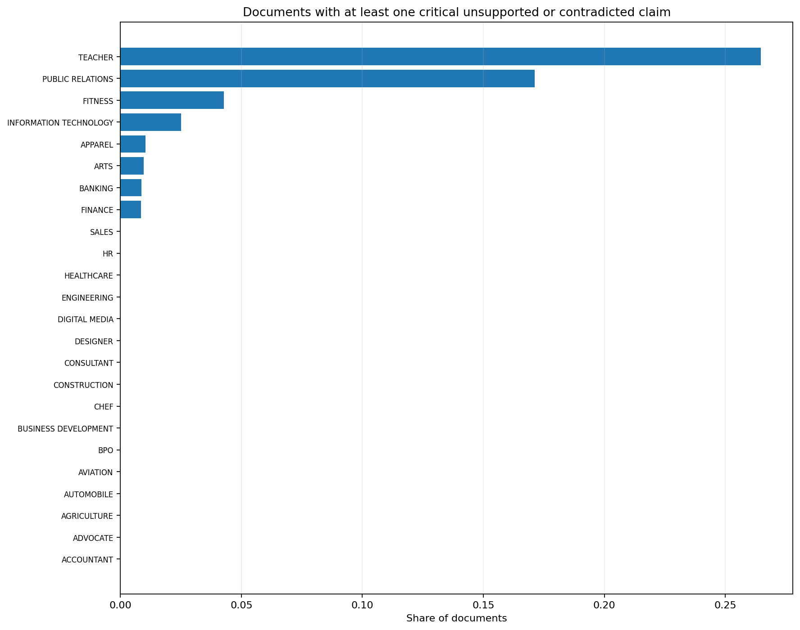
Figure 7. Critical unsupported-claim rate by dataset.
Source: pooled PDF-grounded evaluation workbooks; calculations in the combined analysis.
Interpretation. Critical unsupported claims are concentrated in a small number of datasets. Teacher has a comparatively high critical-document rate despite strong F1, demonstrating why critical-error checks must remain separate from average factual metrics.
Limitation. Critical status depends on the error taxonomy and should be independently audited for high-stakes deployment.

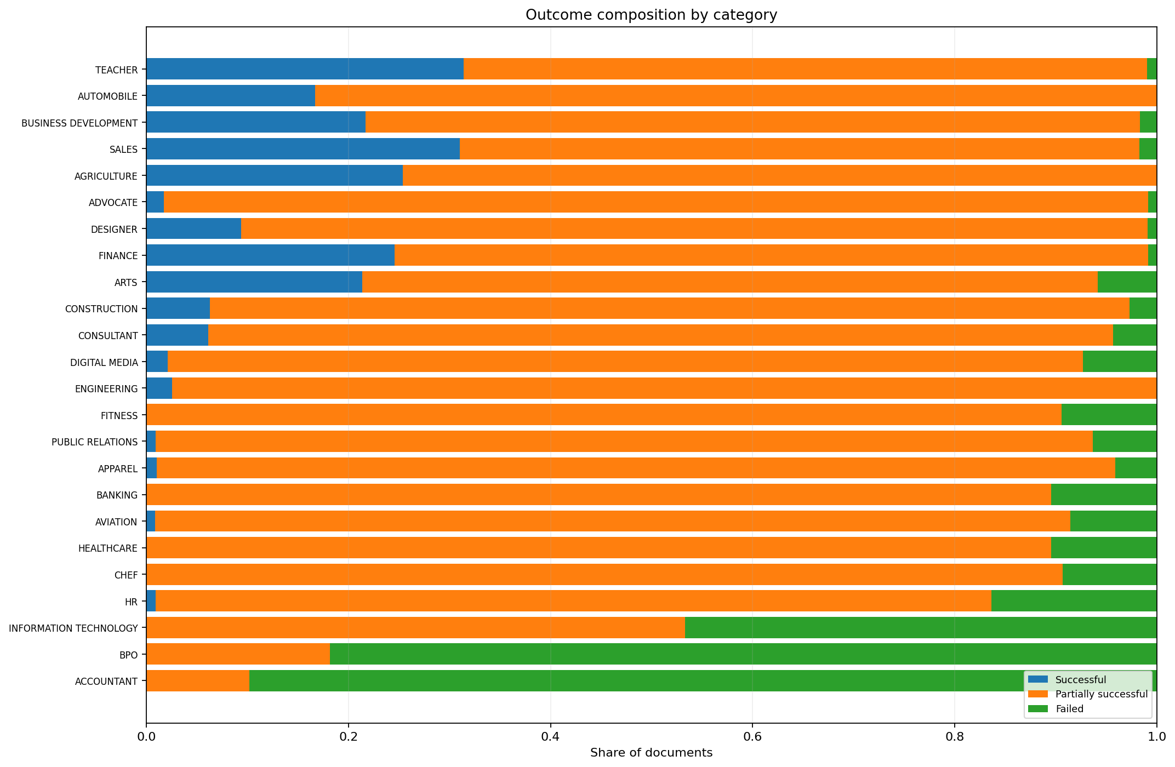
Figure 8. Outcome composition by dataset.
Source: pooled PDF-grounded evaluation workbooks; calculations in the combined analysis.
Interpretation. Dataset outcome composition reveals that some datasets contain no fully successful documents even when most documents are partially usable. Accountant and BPO have particularly high failed shares.
Limitation. The outcome categories combine technical and content conditions and are threshold-sensitive.

4.3 Segment-level performance
Table 9. Segment-level extraction performance.
Segment | Applicable | W. precision | W. recall | W. F1 | Completeness | Unsupported | Schema
Experience | 2,482 | 95.7% | 81.8% | 88.2% | 85.3% | 0.25% | 92.3%
Profile | 2,444 | 94.7% | 75.2% | 83.8% | 79.1% | 0.38% | 89.0%
Skills | 2,473 | 97.0% | 64.1% | 77.2% | 66.0% | 0.18% | 88.1%
Education | 2,462 | 93.3% | 56.7% | 70.5% | 60.5% | 0.36% | 86.6%
Certifications | 1,147 | 90.9% | 51.1% | 65.5% | 55.9% | 0.56% | 71.6%
Languages | 451 | 90.8% | 45.8% | 60.9% | 50.3% | 0.34% | 80.3%
Document metadata | 1,976 | 49.7% | 18.7% | 27.2% | 19.7% | 47.64% | 55.9%
Category classification | 2,329 | 79.9% | 7.1% | 13.1% | 8.9% | 0.18% | 27.0%
Normalized fields | 2,118 | 69.2% | 2.9% | 5.5% | 3.0% | 27.52% | 5.4%
Seniority | 2,252 | 53.9% | 2.4% | 4.6% | 3.1% | 30.46% | 22.1%
Experience is the strongest major segment, with weighted F1 of 88.2% and completeness of 85.3%. Profile and Skills are also useful, although Skills recall remains substantially below precision. Education, Certifications, and Languages show progressively lower recall. Category classification, normalized fields, seniority, and document metadata perform too poorly to be treated as authoritative fields.
Document metadata is unusual because it combines low recall with a very high unsupported-content rate. Normalized fields and seniority also contain material unsupported content. These fields should either be removed from hard filters, recomputed deterministically from source evidence, or displayed only after verification.

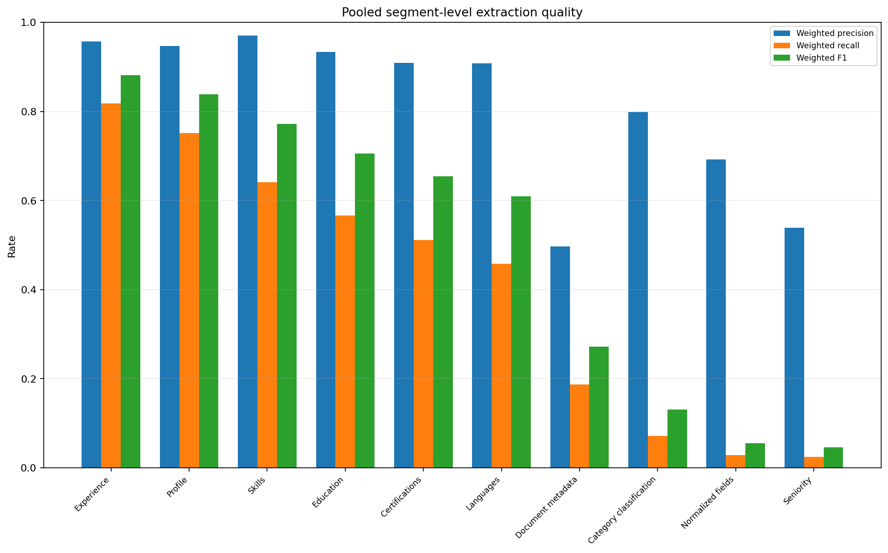
Figure 9. Segment-level weighted precision, recall, and F1.
Source: pooled PDF-grounded evaluation workbooks; calculations in the combined analysis.
Interpretation. The core narrative segments have high precision but varying recall. Derived and classification-oriented segments show extremely low recall and F1.
Limitation. Segment definitions aggregate multiple fields; performance of an individual field may differ from the segment average.

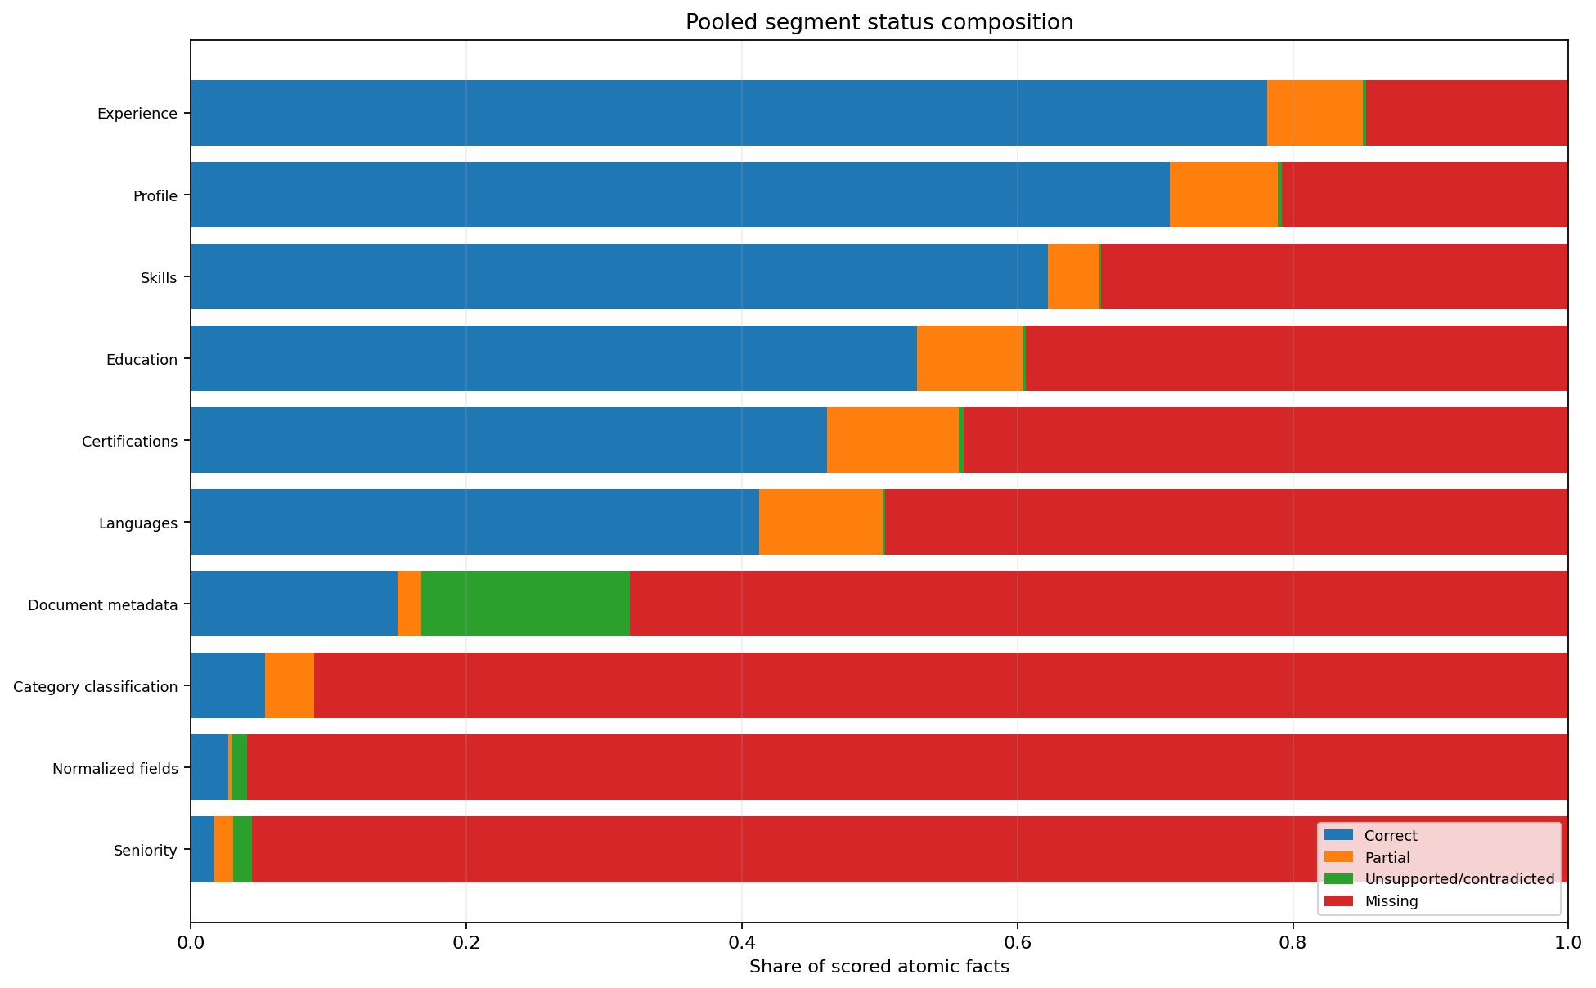
Figure 10. Segment-level fact composition.
Source: pooled PDF-grounded evaluation workbooks; calculations in the combined analysis.
Interpretation. Omitted facts dominate weak segments. Unsupported facts are less frequent overall but are concentrated in document metadata, normalized fields, and seniority.
Limitation. Counts are affected by the number of applicable facts in each segment and should not be interpreted as equal-risk denominators.

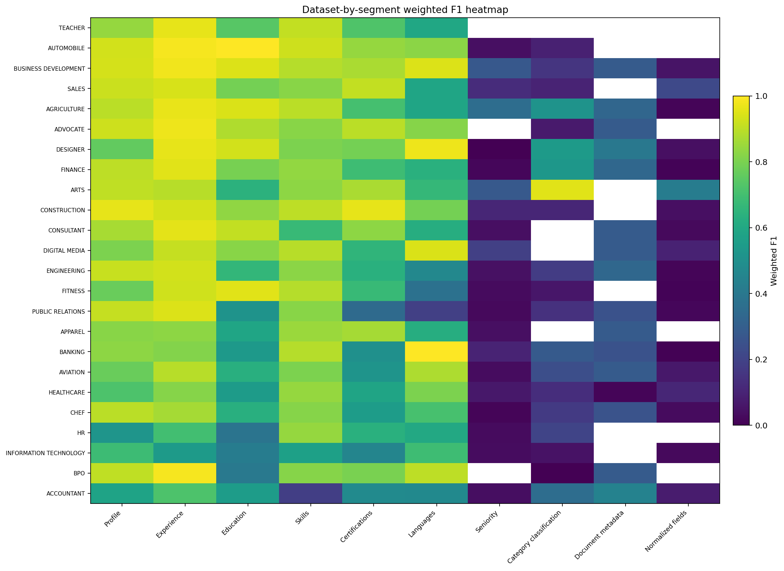
Figure 11. Dataset-by-segment weighted-F1 heatmap.
Source: pooled PDF-grounded evaluation workbooks; calculations in the combined analysis.
Interpretation. The heatmap shows occupation-specific segment failures rather than a uniform global weakness. This supports dataset-aware monitoring and targeted prompt or parser remediation.
Limitation. Cells summarize segment aggregates and do not display document-level uncertainty.

4.4 Error structure and severity
Table 10. Most frequent error categories.
Error category | Count | Share of logged errors
Omitted fact | 72,294 | 68.02%
Empty field | 11,622 | 10.94%
Partially correct fact | 10,577 | 9.95%
Segmentation error | 2,643 | 2.49%
Normalization error | 1,719 | 1.62%
Evaluation uncertainty | 1,471 | 1.38%
Missing segment | 1,420 | 1.34%
Unsupported fact | 945 | 0.89%
Incorrect seniority | 622 | 0.59%
Under-specification | 581 | 0.55%
Cross-field inconsistency | 554 | 0.52%
Contradicted fact | 457 | 0.43%
Incorrect category | 318 | 0.30%
Incorrect language | 273 | 0.26%
Over-generalization | 187 | 0.18%
Omitted fact is the dominant logged error (72,294 occurrences), followed by empty field and partially correct fact. Segmentation errors, normalization errors, evaluation uncertainty, missing segments, unsupported facts, and incorrect seniority form a second tier. The error profile is therefore structurally consistent with the aggregate precision-recall gap: the system is more likely to omit or under-specify than to invent.

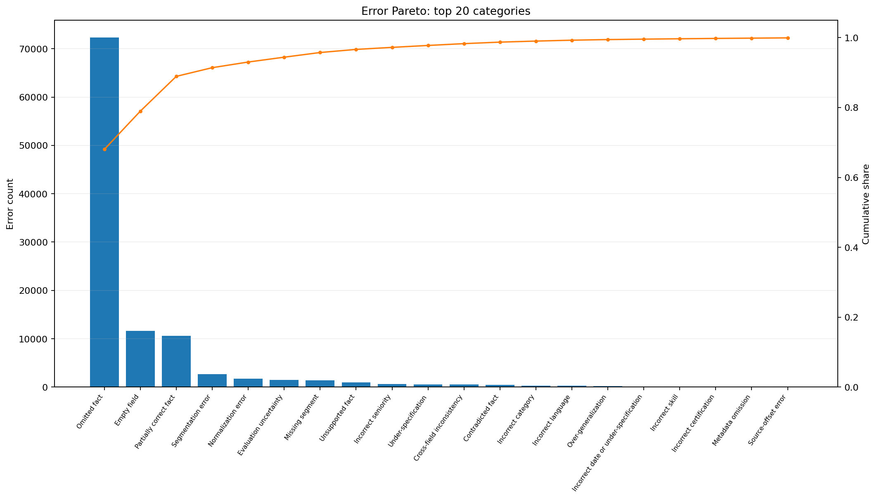
Figure 12. Error Pareto distribution.
Source: pooled PDF-grounded evaluation workbooks; calculations in the combined analysis.
Interpretation. A small number of error categories account for most logged errors. Remediation should prioritize omitted facts, empty fields, partial facts, and segmentation before less frequent normalization and classification errors.
Limitation. Frequency is not severity. A rare critical identity error may be more consequential than many minor omissions.

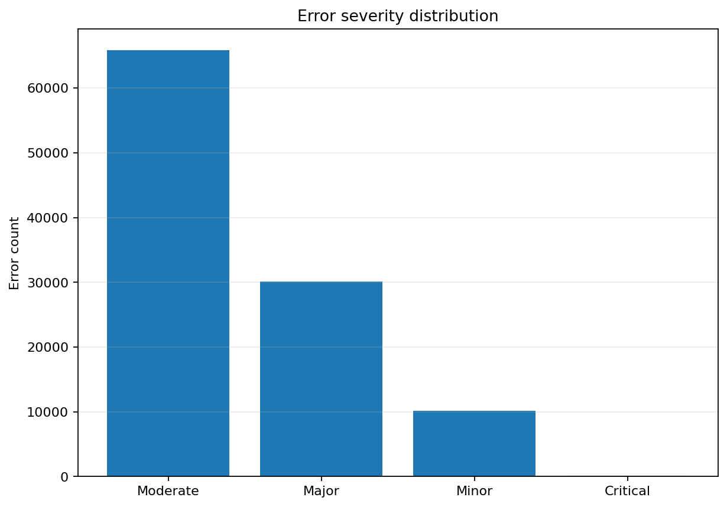
Figure 13. Error severity distribution.
Source: pooled PDF-grounded evaluation workbooks; calculations in the combined analysis.
Interpretation. Most logged errors are moderate or major; critical errors are rare in count but cannot be ignored because they can alter identity, employment, education, certification, or date evidence.
Limitation. Severity labels depend on the evaluation taxonomy and may require application-specific recalibration.

4.5 Document-level variation
Dataset averages conceal considerable document-level heterogeneity. Some CVs achieve high F1 and completeness in otherwise weak datasets, while some fail within strong datasets. Document layout, OCR quality, non-standard headings, multilingual text, tables, columns, and long employment histories can all affect extraction.

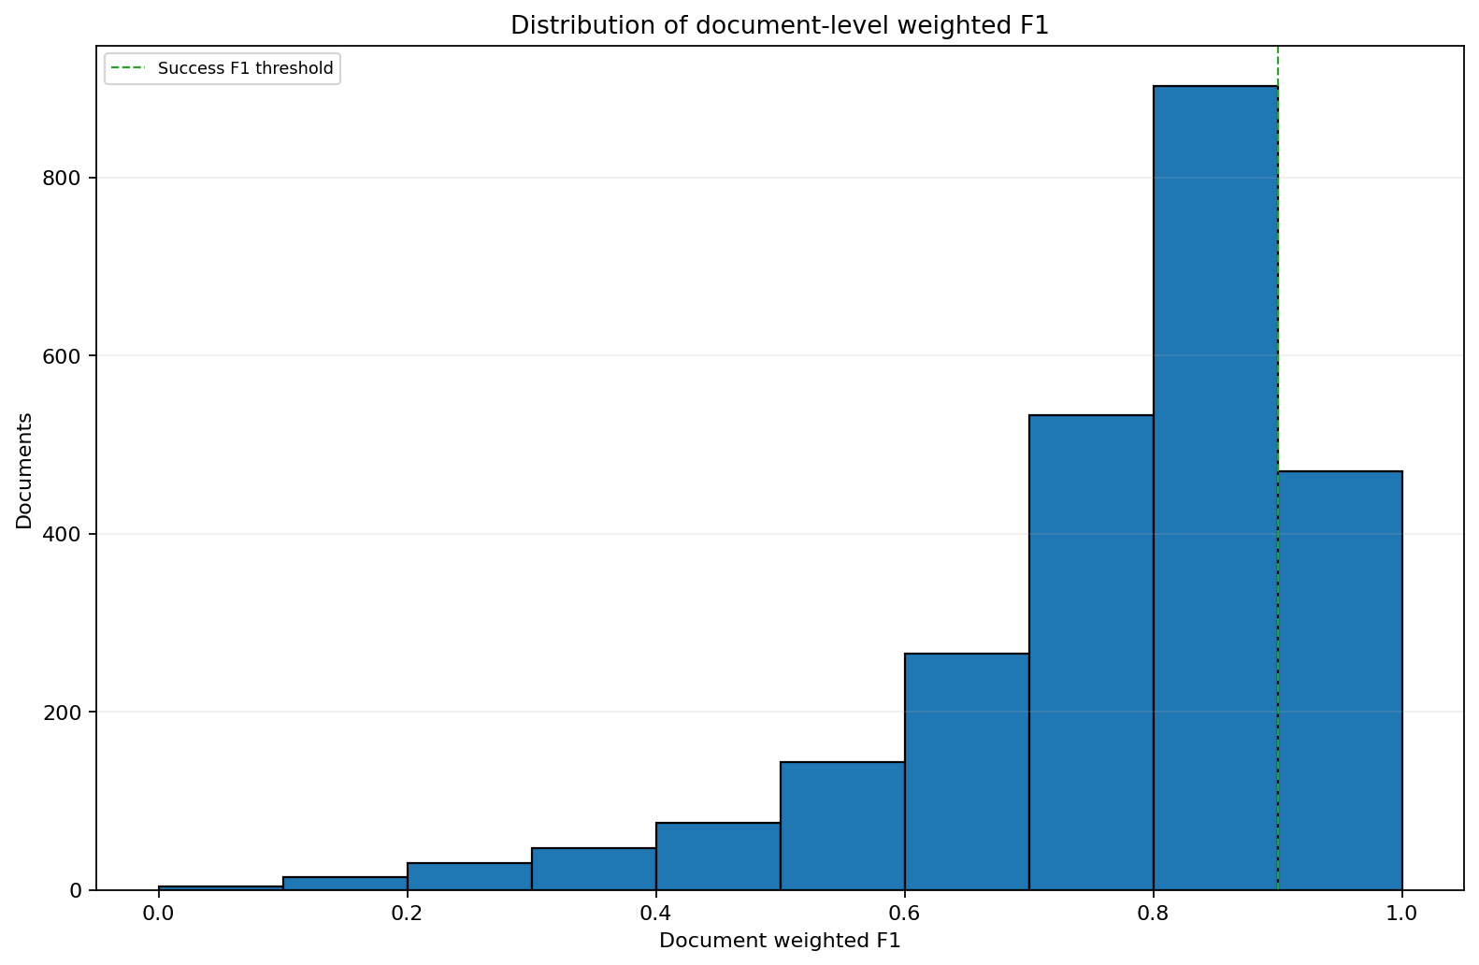
Figure 14. Distribution of document-level weighted F1.
Source: pooled PDF-grounded evaluation workbooks; calculations in the combined analysis.
Interpretation. The document-level F1 distribution is broad and is not well represented by a single mean. The mass below the success threshold explains the low fully successful share.
Limitation. The distribution does not identify the document characteristics responsible for each score.

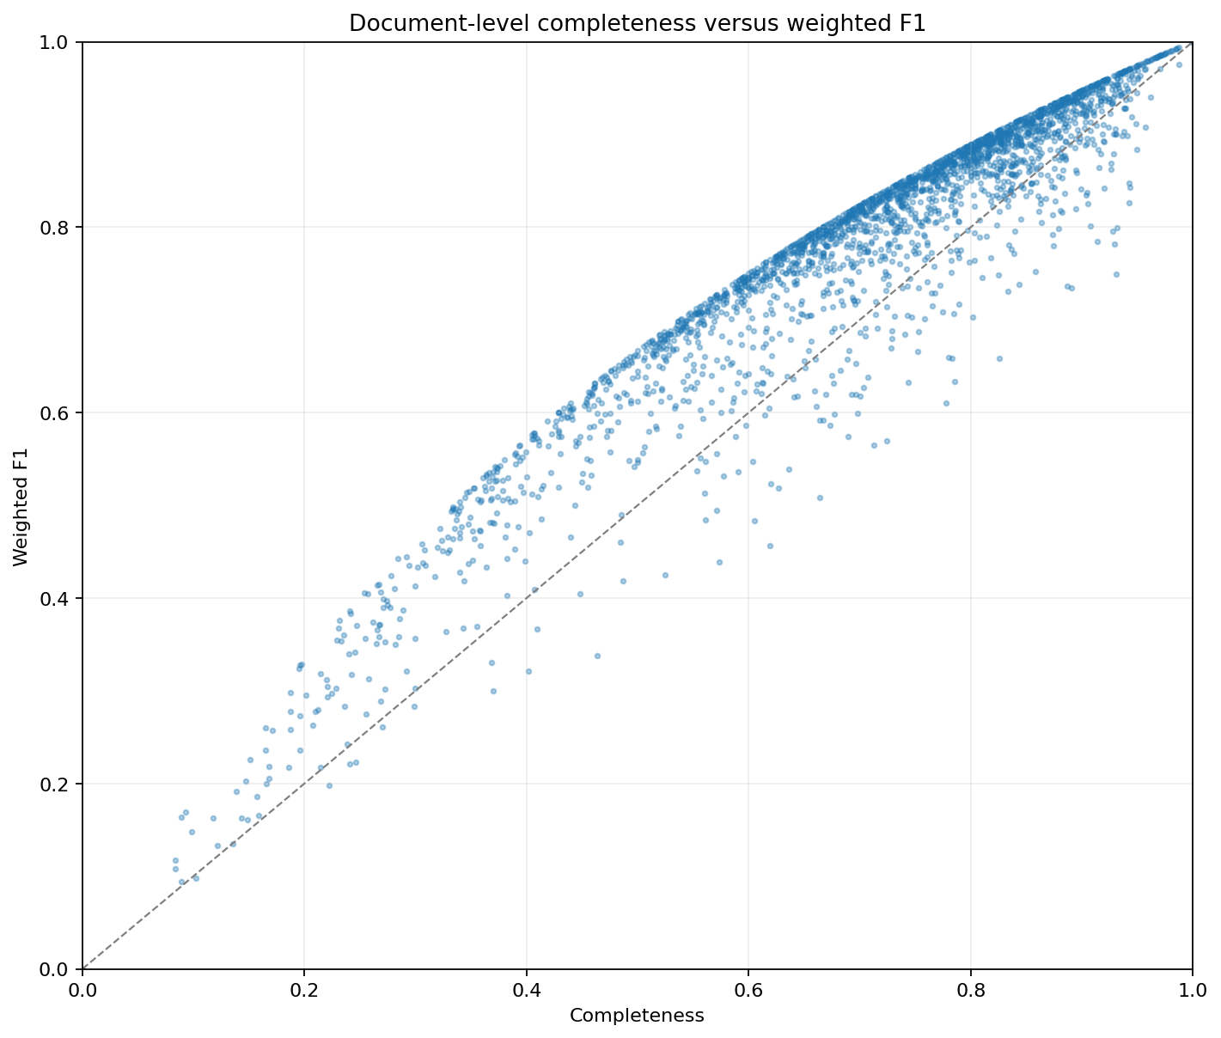
Figure 15. Document-level completeness versus weighted F1.
Source: pooled PDF-grounded evaluation workbooks; calculations in the combined analysis.
Interpretation. Documents with higher completeness generally have higher weighted F1, but the scatter shows that factual quality also depends on partial and unsupported facts.
Limitation. The axes share component counts; visual association should not be treated as an independent causal estimate.

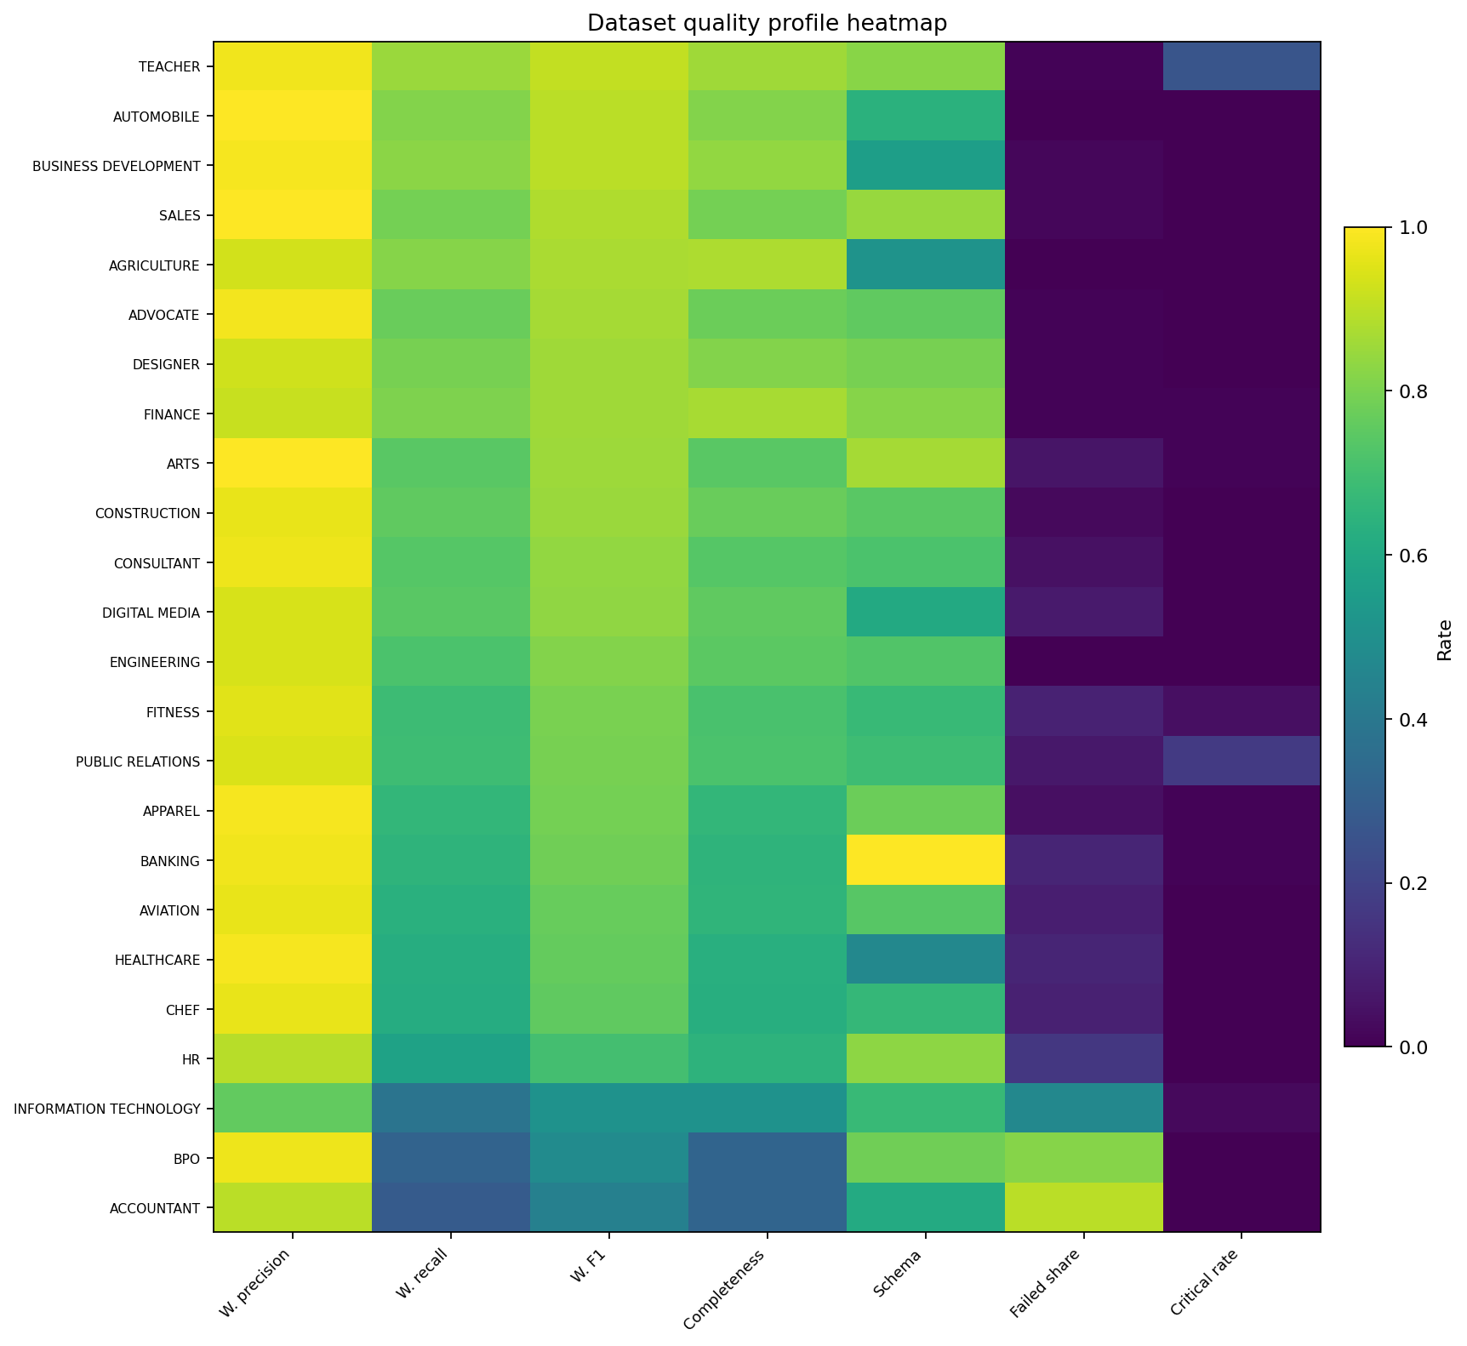
Figure 16. Multimetric dataset quality heatmap.
Source: pooled PDF-grounded evaluation workbooks; calculations in the combined analysis.
Interpretation. The multimetric heatmap highlights the difference between precision, recall, completeness, schema population, failure rate, and critical risk. No single metric is sufficient for deployment acceptance.
Limitation. Color scaling can visually amplify small differences; numerical values should be consulted for decisions.

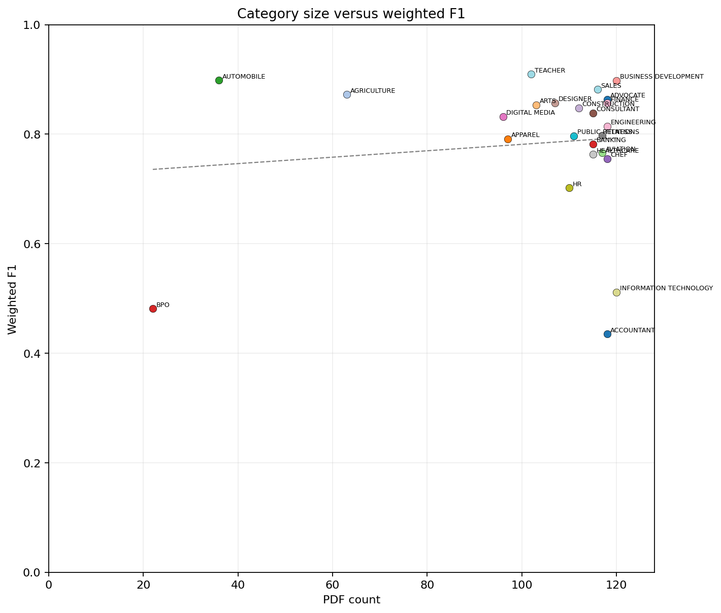
Figure 17. Dataset volume versus weighted F1.
Source: pooled PDF-grounded evaluation workbooks; calculations in the combined analysis.
Interpretation. Category size has only a weak association with weighted F1 (r = 0.118). Poor performance is not explained simply by having more CVs.
Limitation. This is an ecological dataset-level correlation and does not test document length or token count.

5. Technical Analysis

5.1 Principal strengths
The extraction system has four important strengths. First, it is operationally stable: nearly all source records can be matched and evaluated. Second, weighted precision is high across most datasets and core segments, indicating that extracted facts are generally grounded in the PDF. Third, unsupported-content rates are low for Experience, Profile, Skills, Education, Certifications, and Languages. Fourth, local execution provides data-control advantages for sensitive CV data because documents need not be transmitted to a third-party inference service.
The combination of a conservative verbatim-copying prompt, a multilingual instruction model, quantization-aware training, and explicit output formatting appears well suited to high-precision extraction. The model is also computationally attractive relative to a dense 26B model because only approximately 3.8B parameters are active per token, although all expert weights still contribute to memory requirements [4].

5.2 Principal weaknesses
The dominant weakness is information loss. Weighted recall of 65.5% and completeness of 68.2% mean that a substantial proportion of source facts is unavailable in the structured index. This is particularly serious for candidate search because false negatives can remove qualified candidates from retrieval. The weakness is not confined to optional metadata; Education, Certifications, Languages, and Skills all show material omission.
A second weakness is the unreliability of derived or classification-heavy fields. Seniority, normalized fields, category classification, and document metadata have low F1 and, in several cases, high unsupported-content rates. These fields require deterministic derivation or source validation. A third weakness is occupational heterogeneity: the same model and prompt behave very differently across datasets, so a global acceptance score cannot guarantee performance on a particular recruitment domain.

5.3 Ontological ambiguity between experience and skills
CV information is not naturally partitioned into mutually exclusive database columns. An employment bullet may simultaneously identify a role, describe a task, demonstrate a skill, name a tool, and provide evidence of seniority. A dedicated skills list is only one possible surface form of competency evidence. Treating Experience and Skills as binary alternatives therefore introduces label noise: two evaluators can agree on the source fact and still disagree on the single field to which it should belong.
For extraction evaluation, this ambiguity can produce apparent segmentation errors even when the verbatim fact has been recovered. A technically stronger representation assigns each source span a primary structural location plus zero or more semantic roles. The system can then score factual recovery separately from field-role assignment. Overlap-compatible matches should receive full or partial credit according to an explicit adjudication rule, while genuinely unrelated placements should remain errors.
For retrieval, the same-context requirement should consequently be implemented as typed compatibility rather than strict equality. A skill criterion may be satisfied by an explicit Skills entry or by an experience statement that directly demonstrates the skill. It should not be satisfied by a hobby keyword or an unrelated course title unless the application explicitly accepts those evidence types. This multi-label approach improves recall without abandoning evidentiary discipline.
The practical data model should retain the original source span once, associate it with a structural section and multiple semantic role tags, and preserve page or character provenance. Downstream search can then choose the permitted evidence roles for each job criterion instead of depending on a brittle one-field classification made during extraction.

5.4 Why high precision and low recall coexist
The observed precision-recall profile is consistent with a conservative extraction objective. The prompt forbids rewriting, normalization, correction, and translation and demands that text be copied only when it clearly belongs to a requested headline. When section boundaries are ambiguous, the lower-risk behavior is to return an empty or incomplete block. This protects precision but creates omissions. Reasoning-disabled inference may reinforce this behavior by reducing the model capacity used for cross-section reconciliation and ambiguous classification, although the present data cannot isolate that causal effect.
The XML block contract also decomposes the task by requested headline. Facts that span multiple source sections, such as a technology mentioned only inside a job responsibility, can be missed if the corresponding headline definition is narrow. Similarly, tables, sidebars, multi-column layouts, and repeated headings can make a text-only section assignment brittle even when the model understands the content.

5.5 Schema completeness is not factual completeness
The weak correlation between schema completeness and weighted F1 is a critical systems result. Schema validators verify shape, presence, and type; they do not verify that values are supported by the source. A production pipeline can therefore pass JSON schema validation while still omitting important facts or containing unsupported normalized values. Validation must be layered: syntactic validation, semantic field validation, source-evidence validation, and retrieval-behavior validation.
For RAG, this means that database completeness cannot be inferred from non-null fields. A generic value can make a field appear complete while reducing specificity. Conversely, an empty field may reflect extraction failure rather than source absence. Indexing and ranking logic must preserve this uncertainty.

5.6 Consequences for retrieval and ranking
The extracted JSON is suitable for positive-evidence retrieval but unsuitable for hard negative filtering. A query such as "must speak German" may retrieve candidates whose structured language field contains German. It must not automatically exclude all other candidates, because the language segment has only 50.3% completeness. The system should search explicit structured fields first, then search compatible evidence roles, and finally execute a raw-section or full-text fallback for candidates with missing or low-confidence fields.
Ranking should also distinguish evidence strength. A skill listed in a dedicated Skills section, repeated in recent professional experience, and supported by a source excerpt should score more highly than a single uncontextualized keyword. Derived seniority labels should not override dated employment evidence. Category classification should be treated as a navigation aid or weak feature, not a definitive occupational label.

5.7 Decomposing low coverage: source absence versus extraction failure
The term low coverage is ambiguous unless the analysis separates information that is absent from the source CV from information that is present in the PDF but not recovered by the extraction model. These mechanisms have different causes and different consequences. Source-limited coverage is a property of the corpus and should not be scored as model failure. Extraction-limited coverage is a false-negative problem and directly reduces recall in a RAG index.
At document-segment level, a CV is applicable when the PDF contains at least one fact that belongs to the segment under the evaluation taxonomy. A non-applicable segment means that the CV does not state or support that type of information. By contrast, an applicable but unpopulated segment means that the information exists in the PDF but Gemma returned no value for the segment. At atomic-fact level, an omitted PDF-supported fact is recorded as FN even when the segment contains some other extracted content.
The distinction therefore requires two denominators. The first measures how often the source corpus offers information of a given type. The second measures how much of the available information the model recovers. Let the notation below distinguish the total evaluable count, the segment-applicable count, and the count for which Gemma populated at least one value.
$$A_{s}=\frac{N_{app,s}}{N_{eval}}$$
The first ratio is source availability. It answers the corpus question: how often do the CVs provide information that can legitimately populate the segment? It does not measure extraction quality.
$$P_{s}=\frac{N_{pop,s}}{N_{app,s}}$$
The second ratio is document-level conditional population. It answers whether Gemma produced at least one value when the PDF made the segment applicable. This measure is useful but lenient because a segment can be populated while still omitting many facts.
Let Q denote the count of partially correct facts in the segment. Atomic-fact completeness is then defined as follows.
$$G_{s}=\frac{{TP}_{s}+Q_{s}}{{TP}_{s}+Q_{s}+{FN}_{s}}$$
The third ratio is atomic-fact completeness conditional on PDF-supported availability. It is the preferred measure of how well Gemma recovered available information. A stricter weighted-recall variant gives half credit to partial facts, but the same denominator is retained. Not-applicable fields and unverifiable facts are excluded from this denominator.
Table 10A. Source availability and Gemma conditional extraction coverage for principal CV-information segments.
Segment | Applicable CVs | Source availability | Gemma populated when applicable | PDF-supported facts | Gemma completeness | Weighted recall
Experience | 2,482 | 100.0% | 96.1% | 108,474 | 85.3% | 81.8%
Skills | 2,473 | 99.6% | 95.6% | 81,804 | 66.0% | 64.1%
Education | 2,462 | 99.2% | 96.0% | 12,275 | 60.5% | 56.7%
Profile | 2,444 | 98.5% | 91.3% | 15,667 | 79.1% | 75.2%
Seniority | 2,252 | 90.7% | 11.8% | 7,743 | 3.1% | 2.4%
Certifications | 1,147 | 46.2% | 83.2% | 5,088 | 55.9% | 51.1%
Languages | 451 | 18.2% | 94.7% | 1,737 | 50.3% | 45.8%
The first requested graph can therefore be calculated directly from the “Number of applicable documents” field in each 05_Segment_Results worksheet, using the 2,482 matched and evaluable CVs as the denominator. Experience is applicable in all evaluable CVs; Skills, Education, and Profile are applicable in more than 98% of records. Certifications are present in only 46.2%, and Languages in 18.2%. Low language or certification coverage is consequently partly source-limited: many CVs simply do not state those facts.
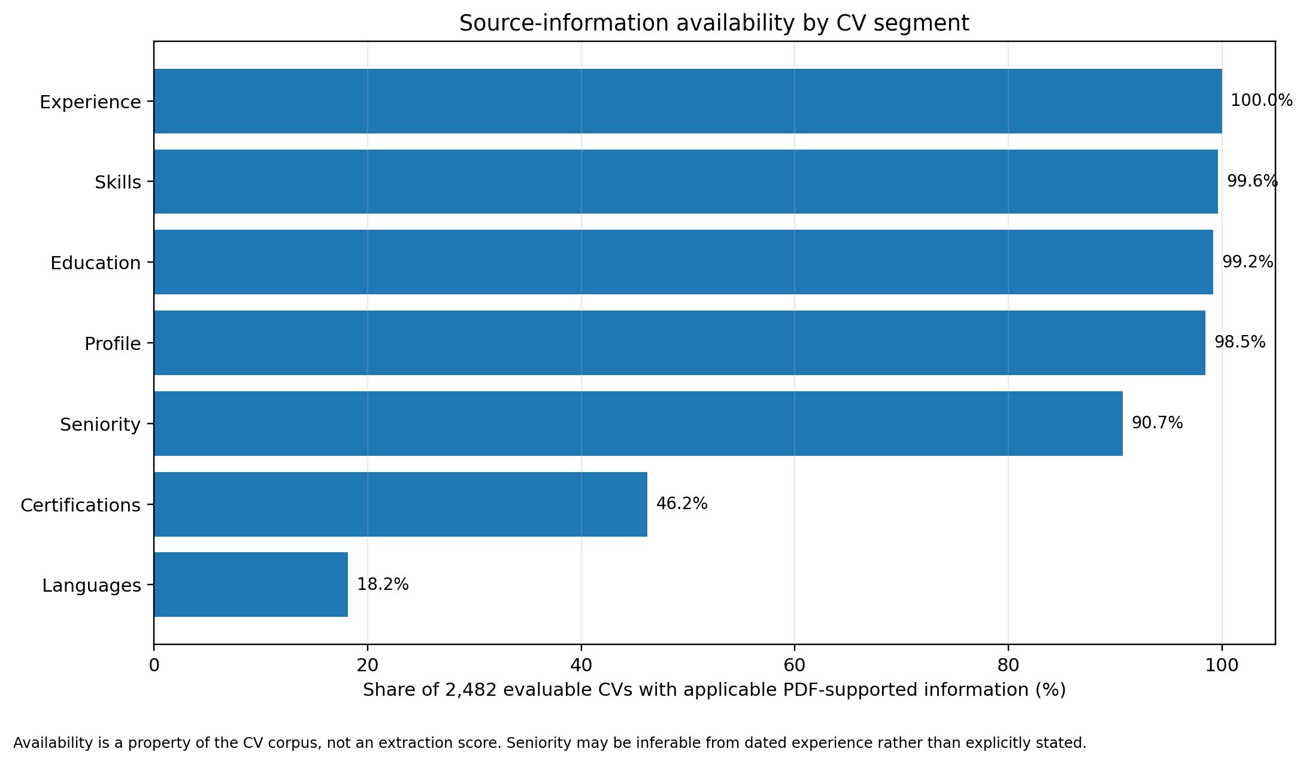
Figure 18. Source-information availability by CV segment.
Source: aggregated 05_Segment_Results worksheets from 24 category reports. Denominator: 2,482 evaluable CVs. Seniority may be inferable from dated experience rather than explicitly stated.
The second requested graph is also directly supported. Gemma’s document-level conditional population is the number of populated applicable CVs divided by the number of applicable CVs, while atomic completeness is calculated from TP, Partial, and FN. The difference between these measures is analytically important. Gemma populated a Skills segment in 95.6% of applicable CVs, but recovered only 66.0% of the available PDF-supported skill facts. Similarly, Education was populated in 96.0% of applicable CVs, yet atomic completeness was 60.5%. A non-empty JSON block must therefore not be interpreted as complete coverage.
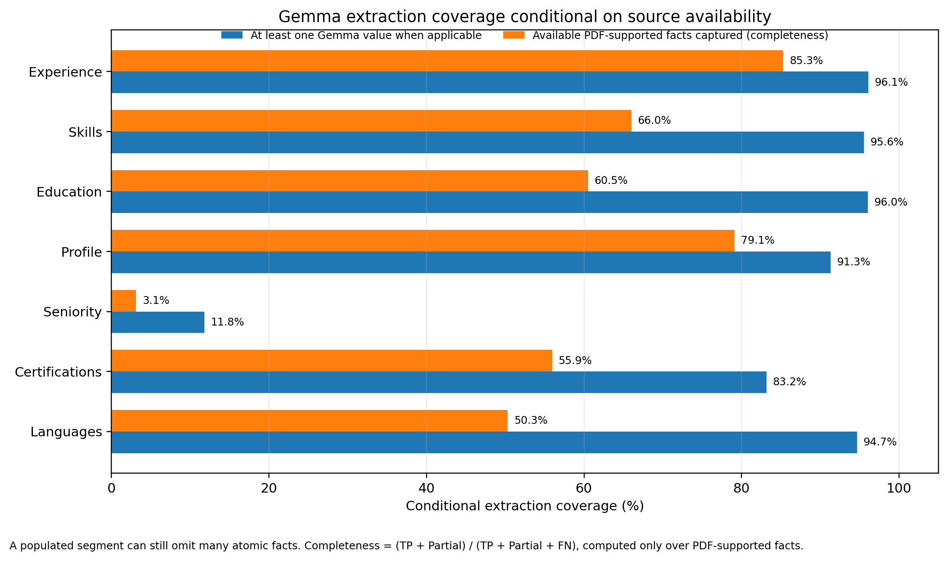
Figure 19. Gemma extraction coverage conditional on source availability.
Source: aggregated 05_Segment_Results worksheets from 24 category reports. Completeness = (TP + Partial)/(TP + Partial + FN).
The results distinguish three patterns. First, Experience and Profile are widely available and comparatively well extracted; residual low coverage is predominantly extraction loss. Second, Skills and Education are almost universally available but materially incomplete, so low coverage is clearly model- or prompt-limited rather than source-limited. Third, Certifications and Languages are both source-sparse and incompletely extracted; the end-to-end absence of a structured value cannot be attributed to either mechanism without consulting the applicability and evidence fields. Seniority is a special case: the source often contains dates or role evidence from which seniority could be inferred, but the evaluated derived field has only 3.1% completeness and should not be treated as authoritative.

5.7.1 What the PDF–ChatGPT–Gemma evidence shows
The 24 category workbooks preserve the three compared evidence layers at atomic-evidence level: the original PDF excerpt or PDF-supported fact, the ChatGPT reference extraction, and the local Gemma extraction. Across the atomic-evidence rows, ChatGPT reference values are populated in approximately 219,982 rows, compared with 157,035 populated Gemma values—about 40% more. Within the evaluation design, this supports a clear coverage conclusion: ChatGPT recovered a materially broader share of the information represented in the source CVs. The pattern is consistent with Gemma’s high false-negative counts and with the large gap between non-empty segments and complete atomic-fact recovery, particularly for skills, education, seniority, normalized fields, and document metadata.
Gemma 4 was served with --reasoning off. The model therefore had to map long, heterogeneous CV text directly into the requested structure without an explicit deliberative pass for coverage planning, cross-section reconciliation, ambiguity resolution, or final self-checking. This configuration favors speed, fewer generated tokens, and predictable structured output, but it also encourages a first-pass extraction pattern in which distributed or weakly signposted evidence is easier to omit. Linking dates to roles and employers, recognizing a skill demonstrated inside an experience bullet, deriving seniority from a career history, and revisiting an unexpectedly empty field all benefit from additional computation. The observed omission-heavy error profile and very weak seniority recovery are therefore consistent with the reasoning-disabled operating condition.
Classification of CV text is not a binary choice. A single sentence can simultaneously encode employment experience, technical or interpersonal skills, project participation, domain knowledge, seniority evidence, tools, responsibilities, and outcomes. A bullet describing leadership of an SAP migration, for example, is both experience and evidence of project-management, ERP, stakeholder, and leadership skills. Forcing that span into exactly one field creates artificial omissions even when the source fact has been recognized. ChatGPT’s broader apparent coverage may partly reflect more inclusive assignment of evidence across overlapping fields, whereas direct extraction can encourage narrower one-field decisions.
For RAG search, the appropriate representation is therefore multi-label rather than mutually exclusive: preserve the source span once, attach a primary semantic role and any compatible secondary roles, record provenance and confidence, and allow retrieval across field-compatible evidence. An experience passage may satisfy a skills query; a project passage may support domain expertise or seniority; and certification text may support both credentials and skills. The three-way evidence supports the practical conclusion that ChatGPT supplied broader candidate coverage, while Gemma’s high-precision but incomplete output should be supplemented with source-span retrieval and multi-label enrichment rather than treated as a complete binary classification of the CV.
For RAG deployment, missing values should therefore be represented with at least three states: not stated in the source, stated but not extracted, and extracted with source evidence. Collapsing these states into a single null value creates unsafe negative evidence. Each indexed field should carry source applicability, extraction status, extractor identity, source span, page reference, and confidence. Hard exclusion should be permitted only when source absence has been established, not merely when the Gemma field is empty.

6. The Need for Speed

6.1 Offline extraction versus online search latency
Speed requirements differ between the offline and online components of the system. CV extraction is normally an offline or nearline process triggered when a document is added or re-indexed. Its primary objectives are accuracy, throughput, and predictable resource use. Candidate search is interactive; it requires low query latency and should not invoke a 26B extraction model over every CV at query time. The structured and raw-text indexes should be precomputed, and the large model should be reserved for top-k reranking or evidence explanation.
The need for speed is operationally important because every prompt, model, parser, or schema change can require corpus-wide reprocessing. If extraction is slow, regression testing becomes expensive and teams are less likely to rerun quality checks. High throughput therefore supports quality governance, not merely cost reduction.

6.2 Runtime trade-offs in the supplied configuration
The supplied configuration contains several speed-oriented choices: a 4-bit quantized checkpoint, a sparse MoE architecture, automatic GPU-layer offload, Flash Attention selection, reasoning disabled, a physical micro-batch of 64, and four parallel slots. QAT is designed to reduce quality loss relative to post-training quantization [5]. MoE reduces active compute per token, while quantization reduces weight memory and memory bandwidth. Flash Attention can reduce attention-memory traffic when supported.
These settings also create trade-offs. Four parallel slots can increase aggregate throughput but may reduce per-request memory headroom and latency. A 65,536-token context increases KV-cache requirements even when typical CVs are much shorter. An upper batch of 64 may underutilize or protect memory depending on hardware and prompt lengths. Automatic layer offload and Flash Attention can vary by build and device. Therefore, the command line is not itself evidence of achieved speed.

6.3 Throughput engineering and measurement
Table 11. Speed and capacity metrics that should be measured.
Metric | Unit | Purpose
PDF parsing latency | p50, p95, p99 milliseconds/document | Separates document decoding from model inference.
Prompt tokens | tokens/document and distribution | Explains prefill cost and truncation risk.
Time to first token | milliseconds | Measures prefill and scheduling latency.
Prefill throughput | input tokens/second | Sensitive to context length, batching, and attention implementation.
Decode throughput | output tokens/second per slot and aggregate | Sensitive to quantization, memory bandwidth, and active experts.
End-to-end throughput | documents/minute | Primary offline capacity measure.
End-to-end latency | p50/p95 seconds/document | Captures queueing and validation.
Peak memory | VRAM and system RAM | Determines safe concurrency and context.
Energy | Wh/document or joules/token | Useful for sustained local deployment.
Quality-speed frontier | F1/completeness versus latency | Required for reasoning, quantization, context, and model comparisons.
The benchmark should use a stratified set by document length, layout, language, and occupation. Warm and cold runs should be separated. Concurrency should be tested at one through four slots, and the exact same documents should be evaluated to create a quality-speed frontier. Mean throughput alone is insufficient because recruitment ingestion pipelines are affected by tail latency and outlier documents.

6.4 Recommended performance architecture
A performant production design should use separate models for separate roles. PDF decoding and section segmentation should be performed once. A multilingual embedding model can index structured values and raw sections. A small cross-encoder or late-interaction reranker can score the top retrieval candidates. The larger Gemma model can then generate a concise evidence explanation for only the final shortlist. This architecture avoids repeatedly invoking the extraction model during search and preserves the ability to re-rank with source evidence.
Prompt-prefix caching can further reduce repeated system-prompt prefill where supported, but it must be measured with the exact llama.cpp build and chat template. Context size should be set to the largest value required by the observed CV distribution rather than the model maximum. Batching should group documents with similar prompt lengths to reduce padding and scheduling inefficiency.

7. Consequences of Running with Reasoning Disabled

7.1 Operational meaning of reasoning off
In current llama.cpp server documentation, --reasoning off disables reasoning or thinking in the chat interface, while reasoning on or auto can allow the model template to produce a separate thinking phase [7]. Gemma 4 officially supports thinking as an on/off feature and documents thinking mode for complex tasks [6]. In the supplied runtime, the model is therefore asked to move directly from prompt processing to the final extraction output without generating an explicit intermediate reasoning sequence.
This setting should not be confused with hiding chain-of-thought from the user. It disables the model thinking path rather than merely separating or suppressing its serialization. The exact implementation depends on the llama.cpp build and Gemma chat template, which should be versioned in the experiment manifest.

7.2 Advantages for extractive processing
Reasoning-disabled inference has several plausible advantages for this task. It reduces generated tokens and therefore decode latency. It limits the opportunity for the model to produce text outside the required XML blocks. It may improve determinism and adherence to a verbatim-copying contract. It also reduces the risk that an internal reasoning narrative containing personal data is serialized or logged. For straightforward section extraction, explicit long-form reasoning may add cost without adding value.

7.3 Risks for ambiguous and compositional extraction
The risk is that some CV extraction operations are not purely local copying. The model must often infer which section a line belongs to, reconcile multi-column order, connect a date range to a role and employer, distinguish a certification from education, identify a language from a compact proficiency list, and decide whether a technology mentioned in experience also belongs to a skills field. These are compositional classification problems. A thinking-capable mode may allocate more computation to them, potentially improving recall and consistency.
Reasoning can also help with self-checking: counting required blocks, verifying that each requested headline has been considered, detecting a contradiction between two sections, or revisiting an empty block. Conversely, unconstrained reasoning can lead to paraphrase, normalization, or unsupported inference, which would conflict with the extraction prompt. The best configuration may therefore be hidden or budgeted reasoning combined with a grammar-constrained final answer rather than unrestricted visible reasoning.

7.4 Interpretation of the present results
Table 12. Effects expected from reasoning-disabled inference.
Dimension | Expected effect | Evidence limitation
Latency and throughput | Likely improved because no reasoning tokens are decoded. | No timing logs were supplied; the magnitude is unknown.
Output-format adherence | Potentially improved by direct generation into fixed blocks. | Format errors were not isolated as a paired outcome.
Precision | May benefit from conservative, non-interpretive behavior. | High precision can also arise from the prompt and cannot be attributed to the flag.
Recall and completeness | May be reduced on ambiguous section mapping and multi-step reconciliation. | No reasoning-on control group exists.
Hallucination | May be reduced by limiting inferential expansion. | Reasoning can also improve source checking; direction is task-dependent.
Privacy and logs | Less chance of serialized reasoning containing sensitive CV details. | The final extraction still contains personal data and requires protection.
The present data support an association between the configured system and high precision with lower recall. They do not establish that reasoning-off caused this pattern. Prompt constraints, quantization, PDF text extraction, document layout, model capacity, and headline definitions are confounded. Any causal statement would exceed the evidence.

7.5 Required on-versus-off experiment
A controlled A/B experiment should sample documents across occupation, language, length, layout, and baseline outcome. The model file, llama.cpp build, context, sampling parameters, PDF text, prompts, and parser must remain fixed; only reasoning mode or reasoning budget should change. The primary endpoints should be weighted recall, weighted F1, completeness, critical rate, XML validity, output tokens, time to first token, decode time, and documents per minute. A non-inferiority margin should be defined for precision and critical errors before accepting a recall improvement.
Because reasoning output may contain sensitive personal information, any reasoning-on experiment should keep reasoning content ephemeral, access-controlled, and excluded from production logs unless there is a justified audit requirement. The final stored artifact should remain the structured extraction plus source evidence, not the chain-of-thought.

8. Discussion of the Prompting Strategy

8.1 Strengths of the extraction prompt
The extraction prompt is unusually clear about its behavioral contract. It defines a single role, specifies exact block count and order, gives an explicit empty-block representation, prohibits invention and translation, and requires source-order preservation. These properties reduce format variance and support multilingual fidelity because the model is instructed to copy the original wording rather than normalize it into English. The prompt also separates headline definitions from document text, which allows the same inference engine to be reused across schemas.
The no-rewrite and no-correction rules align with the PDF-grounded evaluation direction. They make it easier to distinguish source text from generated interpretation and likely contribute to the high precision observed in core fields. For auditability, preserving original strings is preferable to silently correcting dates, institutions, or job titles.

8.2 Prompt-induced failure modes
The same controls can produce systematic omissions. First, the prompt lacks an explicit completeness pass. Once the model has generated an empty or short block, it is not instructed to review the document for missed evidence. Second, one-block-per-headline extraction treats fields independently and may not reconcile facts spanning multiple sections. Third, the instruction to omit document section headings can remove context that is needed to interpret neighboring lines. Fourth, verbatim extraction and downstream normalization are separated, which can make normalized fields under-specified or inconsistent.
The prompt uses XML blocks rather than a schema-constrained JSON response. XML is simple, but malformed tags, extra text, or block-count errors require parser recovery. It also provides no source offsets or page identifiers. Consequently, the downstream pipeline must reconstruct provenance after extraction, increasing the risk that a correct string is assigned to the wrong field or that an unsupported normalized value is introduced later.

8.3 Relationship between prompting and observed errors
Omitted facts and empty fields are the two most frequent logged errors, which is consistent with a prompt that rewards caution but does not require coverage verification. Segmentation errors are consistent with headline-by-headline classification over flattened document text. Normalization errors and incorrect seniority are consistent with a later transformation step that is not governed by the verbatim extraction contract. Under-specification and partially correct facts can arise when the model copies only a fragment of a line or employment entry.
The weak segments are also prompt-relevant. Seniority and category classification require inference beyond verbatim copying. Normalized fields require transformation that the prompt expressly forbids. Document metadata may not be present in the CV body at all. These fields should not be expected to perform well under a pure extractive prompt unless they are handled by separate deterministic or classification stages.

8.4 Recommended prompt redesign
Table 13. Prompt failure modes and recommended controls.
Observed or potential issue | Recommended control
No completeness verification | Add a second-pass instruction: review every requested headline and revisit empty blocks before finalizing.
No provenance in output | Return verbatim evidence plus page/line/character offsets or source-span identifiers.
Cross-section facts are missed | Use a two-stage process: section/span detection followed by field extraction from selected spans.
Verbatim and normalized values conflated | Store original evidence and normalized value in separate schema fields; normalization must never overwrite evidence.
Weak derived fields | Move seniority, duration, and category derivation to deterministic or separately evaluated components.
XML parser dependence | Use JSON schema or grammar-constrained decoding with an exact array length and explicit null/empty values.
No uncertainty signal | Allow an explicit ambiguous/unverifiable status rather than forcing an empty block.
Multilingual ambiguity | Keep source language, add optional language ID, and prohibit translation in the evidence field.
Long flattened documents | Preserve page and layout boundaries or process page/section chunks with controlled overlap.
A recommended output object for each requested field contains: field name, verbatim evidence spans, source page/section, normalized value if applicable, extraction confidence or ambiguity status, and validation flags. This design preserves auditability and allows the RAG layer to select either exact evidence or normalized search terms without losing provenance.

8.5 Constrained decoding and validation
Prompt instructions alone do not guarantee valid structured output. Where supported, llama.cpp grammar or JSON-schema constrained decoding should enforce syntax and cardinality. Constrained decoding should apply only to the final answer, not to any hidden reasoning process, because constraining reasoning tokens to a JSON grammar can degrade complex task performance. The response should then pass schema validation, duplicate detection, source-span validation, and field-specific semantic checks before indexing.
Validation should be fail-closed for critical claims and fail-open for missing optional data. For example, an unsupported employer or degree should block that claim from the index, while a missing certification field should trigger raw-text fallback rather than a candidate exclusion. Prompt changes should be regression-tested using the same pooled evaluation suite.

9. Alternative Local Models

9.1 Candidate model families
Several open-weight model families can perform the same document-to-structure task. Their suitability depends on local memory, latency, multilingual coverage, instruction following, long-context behavior, and structured-output reliability. The table summarizes plausible alternatives as of July 2026; it does not claim that any alternative will outperform the evaluated Gemma configuration without a controlled benchmark.
Table 14. Alternative local model families for the same extraction task.
Model | Scale/context | Multilingual scope | Relevance to this task
Gemma 4 26B A4B IT | 25.2B total / 3.8B active; up to 256K | 140+ languages | Evaluated baseline; strong multilingual breadth, MoE efficiency, official thinking toggle and QAT variants [4-6].
Qwen3 30B A3B | 30.5B total / 3.3B active; 128K with YaRN | 100+ languages and dialects | Close architectural alternative with thinking/non-thinking modes and strong multilingual instruction following [8].
Mistral Small 3.2 24B | 24B dense; 128K | Dozens of languages; narrower than Gemma | Strong precise instruction following and robust function calling; local deployment is feasible when quantized [9,10].
Llama 4 Scout | 17B active MoE; very long context | 12 officially supported languages; pretraining includes more | Capable open-weight alternative, but official multilingual support is narrower than Gemma 4 [11].
Ministral 3 14B Instruct | 14B dense; local/edge oriented | Model-specific evaluation required | Lower memory and potentially higher throughput; may trade extraction coverage for speed [12].
Phi-4 mini instruct | 3.8B; 128K | Broad multilingual use claimed, but smaller capacity | Useful latency-oriented baseline; should be expected to require task-specific testing and possibly fine-tuning [13].

9.2 Multilingual capability as a selection constraint
CV collections often contain mixed languages, code-switching, local degree names, international employer names, and non-English section headings. Gemma 4 advertises support for more than 140 languages [4]. Qwen3 advertises more than 100 languages and dialects [8] and is therefore the closest multilingual alternative in the table. Mistral Small supports dozens of languages [10], while Llama 4 officially supports 12 languages even though its pretraining includes a broader set [11]. Smaller English-centric models may perform well on English extraction but should not be assumed to preserve equivalent multilingual recall.
Multilingual evaluation must be empirical and field-specific. Overall language support does not guarantee accurate recognition of CV abbreviations, degree nomenclature, date formats, or transliterated names. The pooled reports do not provide a language-stratified breakdown, so the current analysis cannot quantify whether multilingual documents are a major source of omission. Future evaluation should record document language and report precision, recall, and completeness by language group.

9.3 Model substitution must be empirically validated
A valid model comparison must use the same PDF text, prompt, schema, reasoning mode, context, sampling parameters, constrained-decoding settings, and evaluation protocol. It should report both quality and speed. A smaller model may be preferable if it preserves precision and materially improves throughput, but a lower recall model would amplify the principal weakness already observed. Conversely, a reasoning-oriented model may improve recall but increase latency and unsupported inference.
Task-specific fine-tuning or low-rank adaptation may outperform a generic model swap if a representative training set can be created without leaking sensitive CV data. Any fine-tuning dataset should preserve multilingual diversity and include hard negatives such as skills appearing only in hobbies, dates detached from roles, and ambiguous education/certification boundaries.

10. Integration into a RAG System for CV Search

10.1 Recommended index architecture
The recommended index has two synchronized layers. The structured layer stores validated values, normalized aliases, dates, document identifiers, field types, and source-span pointers. The source layer stores page- or section-level text chunks with layout metadata. Both layers should use the same stable document and section identifiers. Structured retrieval provides efficient filters and exact matching; source retrieval recovers information omitted by extraction and supports auditability.
A multilingual embedding model should encode job criteria and source chunks, while lexical indexing preserves exact technologies, certifications, product names, and abbreviations. Hybrid retrieval is preferable because embeddings can blur closely related but non-equivalent qualifications. A cross-encoder or late-interaction reranker can evaluate the top candidates with field type and source context [2,3].

10.2 Query decomposition and field alignment
A job description should be converted into atomic criteria with type, importance, mandatory/preferred status, temporal constraints, and acceptable equivalents. For example, "five years of Python data engineering and a relevant bachelor degree" becomes separate skill, experience-duration, role-responsibility, and education criteria. Each criterion is retrieved from corresponding fields and source sections. A hobby mention of Python cannot satisfy professional Python experience, and a course cannot satisfy a degree unless the requirement explicitly allows it.
Duration should be computed from dated employment evidence and adjusted for overlaps, open-ended periods, and ambiguity. Seniority should be inferred from titles, responsibilities, scope, and duration rather than accepted from the weak seniority field. Mandatory constraints should become hard filters only after structured and source fallback retrieval have both been executed.

10.3 Quality-aware retrieval policy
Table 15. Recommended field-specific RAG policy.
Field family | RAG use | Policy rationale
Experience | Primary structural evidence and compatible skill evidence | High segment F1; retain roles, employers, dates, responsibilities, demonstrated tools/skills, outcomes, and source spans.
Profile | Supporting relevance evidence | Useful summary, but self-description is weaker than demonstrated experience.
Skills | Positive match from explicit skills and skill-bearing experience | High precision but incomplete; use multi-role evidence and never interpret an empty explicit Skills field as skill absence.
Education | Structured filter with source verification | Moderate completeness; verify degree level, field, institution, and dates.
Certifications | Positive evidence only | Low recall; never exclude solely because the structured field is empty.
Languages | Positive evidence plus full-text fallback | Approximately half of relevant facts are represented.
Document metadata | Do not use as authoritative evidence | Low F1 and high unsupported rate.
Category classification | Weak navigation feature | Very low recall and F1; unsuitable for hard occupational filtering.
Normalized fields | Recompute deterministically | Very low completeness and material unsupported content.
Seniority | Derive from evidence | Do not use extracted label as a hard filter.
Field-level confidence should combine extraction reliability, source verification, and retrieval evidence. The system should log whether a match originated from structured data, raw fallback, or both. This enables monitoring of how often extraction omissions would otherwise have caused false negatives.

10.4 Human oversight and auditability
The RAG system should present criterion-level evidence rather than a single opaque candidate score. Reviewers should see the source excerpt, page or section, field type, retrieval method, and any uncertainty. A candidate should not be rejected solely because a structured value is missing. Critical identity, employment, education, certification, and date claims should be verified against the source PDF before use in a decision.
Monitoring should include precision at k, recall on known relevant candidates, field-level fallback rate, disagreement between structured and source retrieval, critical unsupported-claim rate, performance by occupation and language, and changes after model or prompt updates. Human overrides should be recorded with reasons so that recurrent extraction or ranking failures can be remediated.

11. Threats to Validity and Limitations
- Ground-truth limitation: the PDFs are the primary evidentiary source but are not a perfectly annotated gold standard. Ambiguous, scanned, or poorly ordered PDFs can make adjudication uncertain.
- Measurement limitation: partial credit is fixed at 0.5, and the utility of a partial fact varies by field and application.
- Dependence limitation: atomic facts within the same document are correlated; pooled counts should not be treated as independent Bernoulli trials.
- Comparability limitation: report structures are broadly standardized, but source workbooks contain localized documentation and formula inconsistencies. The corrected aggregation uses ADVOCATE-CV_Local_LLM_Extraction_Evaluation.xlsx for the Advocate category and excludes the mislabeled detailed duplicate and the outside-scope generic workbook.
- Causal limitation: no paired reasoning-on, quantization, prompt, model, or parser controls are available. Observed performance cannot be attributed to one configuration choice.
- Speed limitation: no latency, token, memory, or energy telemetry was attached. The speed analysis is analytical rather than empirical.
- Language limitation: the reports do not contain a reliable language-stratified performance table, despite multilingual model use.
- External-validity limitation: occupational datasets may not represent other CV formats, regions, languages, seniority levels, or document-generation software.
- RAG limitation: the extraction evaluation does not directly measure retrieval precision, ranking quality, or hiring outcomes. Those require a separate job-query benchmark.
- High-stakes limitation: the report evaluates data extraction and search readiness, not fairness, discrimination, legal compliance, or validity of employment selection procedures.
- Document-heterogeneity limitation: CVs differ in length, information density, layout, section naming, OCR quality, and number of applicable facts. Raw error counts and field-population rates are therefore not directly comparable without document-level denominators.
- Taxonomy limitation: Experience, Skills, Projects, and Profile are not mutually exclusive semantic classes. Binary field assignment can create measurement disagreement even when the extracted source fact is correct.
These limitations do not invalidate the central findings, but they constrain interpretation. The strongest evidence concerns the direction and distribution of extraction errors under the supplied evaluation protocol: omission is widespread, unsupported content is comparatively uncommon in core fields, and derived fields are unreliable.

12. Conclusion
The evaluated local Gemma 4 extraction pipeline is technically viable and factually conservative, but it is not a complete representation of the source CV. Across 24 predefined occupational categories and 2,484 PDF CVs, weighted precision is 94.8%, weighted recall is 65.5%, weighted F1 is 77.4%, and completeness is 68.2%. The system is more likely to omit evidence than to invent it. This makes the output useful for positive-evidence indexing but unsafe as the sole source of negative evidence or automatic exclusion. Low coverage must therefore be decomposed before interpretation: source absence is not a model error, whereas a PDF-supported omission is a false negative.
The strongest fields are Experience, Profile, and Skills, although even Skills requires source fallback. Education, Certifications, and Languages can support retrieval but cannot safely support absence-based filters. Document metadata, category classification, normalized fields, and seniority should be excluded from authoritative filtering or recomputed from source evidence.
Reasoning-disabled inference is defensible for a constrained extractive task because it can reduce latency, output variance, and leakage of internal reasoning. However, it may also reduce recall on ambiguous and compositional cases. The current data do not establish causality; a controlled on-versus-off benchmark is required. The prompt contributes to high precision through strict verbatim rules, but it needs a completeness pass, provenance-bearing output, constrained decoding, and separation of evidence from normalization.
The recommended deployment is a field-aware hybrid RAG system. It should index both validated structured data and original section-level text, decompose job descriptions into typed criteria, compare each criterion with compatible evidentiary roles rather than rigidly exclusive fields, execute raw-text fallback for missing fields, and display source excerpts for every material match. Human review must remain responsible for candidate shortlisting and decisions. Under these controls, the extracted data can materially accelerate CV search while preserving the source document as the final authority.
Deployment decision: Proceed with controlled, evidence-first RAG integration. Do not deploy the extracted JSON as a stand-alone candidate database, a complete representation of each CV, or the sole basis for candidate exclusion.

Appendix A. Dataset-Level Results
Table A1. Dataset-level outcome and quality metrics.
Dataset | PDFs | Eval. | Pipeline | W.P | W.R | W.F1 | Complete | Failed | Critical
ACCOUNTANT | 118 | 118 | 100.00% | 89.5% | 28.7% | 43.5% | 32.1% | 89.8% | 0.00%
ADVOCATE | 118 | 118 | 100.00% | 98.2% | 77.1% | 86.4% | 77.4% | 0.8% | 0.00%
AGRICULTURE | 63 | 63 | 100.00% | 93.3% | 81.9% | 87.2% | 87.7% | 0.0% | 0.00%
APPAREL | 97 | 97 | 100.00% | 98.5% | 66.1% | 79.1% | 66.1% | 4.1% | 1.03%
ARTS | 103 | 103 | 100.00% | 99.8% | 74.5% | 85.3% | 74.6% | 5.8% | 0.97%
AUTOMOBILE | 36 | 36 | 100.00% | 100.0% | 81.6% | 89.8% | 81.6% | 0.0% | 0.00%
AVIATION | 117 | 117 | 100.00% | 96.6% | 63.4% | 76.6% | 65.6% | 8.5% | 0.00%
BANKING | 115 | 114 | 99.13% | 97.9% | 65.1% | 78.2% | 65.1% | 10.4% | 0.88%
BPO | 22 | 22 | 100.00% | 97.6% | 31.9% | 48.1% | 32.2% | 81.8% | 0.00%
BUSINESS DEVELOPMENT | 120 | 119 | 99.17% | 98.5% | 82.5% | 89.8% | 83.7% | 1.7% | 0.00%
CHEF | 118 | 118 | 100.00% | 96.8% | 61.8% | 75.5% | 62.8% | 9.3% | 0.00%
CONSTRUCTION | 112 | 112 | 100.00% | 96.5% | 75.6% | 84.8% | 77.1% | 2.7% | 0.00%
CONSULTANT | 115 | 115 | 100.00% | 97.5% | 73.5% | 83.8% | 73.7% | 4.3% | 0.00%
DESIGNER | 107 | 107 | 100.00% | 93.0% | 79.5% | 85.7% | 81.4% | 0.9% | 0.00%
DIGITAL MEDIA | 96 | 96 | 100.00% | 94.1% | 74.6% | 83.2% | 75.7% | 7.3% | 0.00%
ENGINEERING | 118 | 118 | 100.00% | 94.1% | 71.8% | 81.5% | 74.9% | 0.0% | 0.00%
FINANCE | 118 | 118 | 100.00% | 91.5% | 80.5% | 85.6% | 87.0% | 0.8% | 0.85%
FITNESS | 117 | 117 | 100.00% | 95.5% | 68.4% | 79.7% | 71.3% | 9.4% | 4.27%
HEALTHCARE | 115 | 115 | 100.00% | 98.5% | 62.3% | 76.3% | 63.2% | 10.4% | 0.00%
HR | 110 | 110 | 100.00% | 89.4% | 57.8% | 70.2% | 64.5% | 16.4% | 0.00%
INFORMATION TECHNOLOGY | 120 | 120 | 100.00% | 75.9% | 38.6% | 51.1% | 50.8% | 46.7% | 2.50%
PUBLIC RELATIONS | 111 | 111 | 100.00% | 94.4% | 68.9% | 79.7% | 71.6% | 6.3% | 17.12%
SALES | 116 | 116 | 100.00% | 99.8% | 79.0% | 88.2% | 79.0% | 1.7% | 0.00%
TEACHER | 102 | 102 | 100.00% | 97.8% | 84.9% | 90.9% | 85.6% | 1.0% | 26.47%
Note. Category metrics are taken from the standardized report summaries. The Advocate row is taken from ADVOCATE-CV_Local_LLM_Extraction_Evaluation.xlsx; the mislabeled detailed duplicate is not used.

Appendix B. Report Comparability and Provenance Audit
Table B1. In-scope report provenance and aggregation status.
Expected category | Report file | Included | Audit note
ACCOUNTANT | ACCOUNTANT-CV_Local_LLM_Extraction_Evaluation(2).xlsx | Yes | Included as validated category report
ADVOCATE | ADVOCATE-CV_Local_LLM_Extraction_Evaluation.xlsx | Yes | Corrected source; replaces the mislabeled detailed duplicate
AGRICULTURE | AGRICULTURE-CV_Local_LLM_Extraction_Evaluation(1).xlsx | Yes | Included as validated category report
APPAREL | APPAREL-CV_Local_LLM_Extraction_Evaluation(3)(2).xlsx | Yes | Included as validated category report
ARTS | ARTS-CV_Local_LLM_Extraction_Evaluation(4)(1).xlsx | Yes | Included as validated category report
AUTOMOBILE | AUTOMOBILE-CV_Local_LLM_Extraction_Evaluation(1).xlsx | Yes | Included as validated category report
AVIATION | AVIATION-CV_Local_LLM_Extraction_Evaluation(1).xlsx | Yes | Included as validated category report
BANKING | BANKING-CV_Local_LLM_Extraction_Evaluation_Detailed.xlsx | Yes | Included as validated category report
BPO | BPO-CV_Local_LLM_Extraction_Evaluation_BPO(1).xlsx | Yes | Included as validated category report
BUSINESS DEVELOPMENT | BUSINESS-DEVELOPMENT-CV_Local_LLM_Extraction_Evaluation(1)(2).xlsx | Yes | Included as validated category report
CHEF | CHEF-CV_Local_LLM_Extraction_Evaluation_Detailed(1).xlsx | Yes | Included as validated category report
CONSTRUCTION | CONSTRUCTION-CV_Local_LLM_Extraction_Evaluation_CONSTRUCTION(1).xlsx | Yes | Included as validated category report
CONSULTANT | CONSULTANT-CV_Local_LLM_Extraction_Evaluation_Detailed.xlsx | Yes | Included as validated category report
DESIGNER | DESIGNER-CV_Local_LLM_Extraction_Evaluation_DESIGNER(1).xlsx | Yes | Included as validated category report
DIGITAL MEDIA | DIGITAL_MEDIA_Local_LLM_Extraction_Evaluation(1).xlsx | Yes | Included as validated category report
ENGINEERING | ENGINEERING-CV_Local_LLM_Extraction_Evaluation_Revised.xlsx | Yes | Included as validated category report
FINANCE | FINANCE-CV_Local_LLM_Extraction_Evaluation(2).xlsx | Yes | Included as validated category report
FITNESS | FITNESS-CV_Local_LLM_Extraction_Evaluation(6)(1).xlsx | Yes | Included as validated category report
HEALTHCARE | HEALTHCARE_CV_Local_LLM_Extraction_Evaluation(1).xlsx | Yes | Included as validated category report
HR | HR_CV_Local_LLM_Extraction_Evaluation.xlsx | Yes | Included as validated category report
INFORMATION TECHNOLOGY | INFORMATION-TECHNOLOGY-CV_Local_LLM_Extraction_Evaluation.xlsx | Yes | Included as validated category report
PUBLIC RELATIONS | PUBLIC-RELATIONS-CV_Local_LLM_Extraction_Evaluation(3).xlsx | Yes | Included; internal dataset-label metadata is inconsistent but result content is category-specific
SALES | SALES-CV_Local_LLM_Extraction_Evaluation.xlsx | Yes | Included as validated category report
TEACHER | TEACHER-CV_Local_LLM_Extraction_Evaluation(7).xlsx | Yes | Included as validated category report
Note. The outside-scope generic workbook and the mislabeled detailed Advocate duplicate are omitted. ADVOCATE-CV_Local_LLM_Extraction_Evaluation.xlsx is included as the validated Advocate category report.

Appendix C. Prompt and Runtime Record
Table C1. Exact supplied runtime command.
Supplied model start command
llama-server.exe -m ..\models\gemma-4-26B-A4B-it-qat-UD-Q4_K_XL.gguf --device Vulkan1 --split-mode layer -ngl auto -c 65536 -ub 64 -fa auto --reasoning off --host 127.0.0.1 --port 8080 -np 4

C.1 Extraction system prompt summary
The model is instructed to return exactly one XML block per requested headline, preserve request order, copy only text present in the document, omit headline names and unrelated text, leave unmatched blocks empty, preserve line order, and avoid rewriting, summarizing, inventing, normalizing, translating, or correcting source text.

C.2 Extraction user prompt summary
The user template supplies DOCUMENT_TEXT, REQUESTED_HEADLINES_IN_ORDER, HEADLINE_DEFINITIONS, and BLOCK_COUNT, then repeats the required XML block format and empty-block representation.

C.3 Evaluation prompt summary
prompt2(5) treats PDFs as primary evidence, local JSON as the prediction, and ChatGPT JSON as a diagnostic comparator. It fixes the evaluation direction, atomic statuses, partial-credit weight, formulas, document thresholds, evidence requirements, error taxonomy, workbook structure, and graph interpretations.

Appendix D. References
[1] P. Lewis, E. Perez, A. Piktus, et al., "Retrieval-Augmented Generation for Knowledge-Intensive NLP Tasks," Advances in Neural Information Processing Systems, vol. 33, 2020.
[2] V. Karpukhin, B. Oguz, S. Min, et al., "Dense Passage Retrieval for Open-Domain Question Answering," Proceedings of EMNLP, 2020.
[3] O. Khattab and M. Zaharia, "ColBERT: Efficient and Effective Passage Search via Contextualized Late Interaction over BERT," Proceedings of SIGIR, 2020.
[4] Google DeepMind, "Gemma 4 Model Card," Google AI for Developers, 2026. https://ai.google.dev/gemma/docs/core/model_card_4
[5] Google DeepMind, "Gemma 4 Model Overview and Quantization-Aware Training," Google AI for Developers, 2026. https://ai.google.dev/gemma/docs/core
[6] Google DeepMind, "Thinking Mode in Gemma" and "Gemma 4 Prompt Formatting," Google AI for Developers, 2026. https://ai.google.dev/gemma/docs/capabilities/thinking
[7] ggml-org, "llama.cpp Server README," 2026. https://github.com/ggml-org/llama.cpp/blob/master/tools/server/README.md
[8] Qwen Team, "Qwen3: Think Deeper, Act Faster" and Qwen3-30B-A3B Model Card, 2025. https://qwenlm.github.io/blog/qwen3/
[9] Mistral AI, "Mistral-Small-3.2-24B-Instruct-2506 Model Card," 2025. https://huggingface.co/mistralai/Mistral-Small-3.2-24B-Instruct-2506
[10] Mistral AI, "Mistral-Small-3.1-24B Model Card," 2025. https://huggingface.co/mistralai/Mistral-Small-3.1-24B-Base-2503
[11] Meta, "Llama 4 Scout Model Card," 2025. https://huggingface.co/meta-llama/Llama-4-Scout-17B-16E-Instruct
[12] Mistral AI, "Ministral-3-14B-Instruct-2512 Model Card," 2025. https://huggingface.co/mistralai/Ministral-3-14B-Instruct-2512
[13] Microsoft, "Phi-4-mini-instruct Model Card," 2025. https://huggingface.co/microsoft/Phi-4-mini-instruct
[14] Attached artifact, prompt2(5), "Master Prompt: Academic Evaluation of Local-LLM CV Extraction," supplied July 2026.
[15] Attached artifacts, aiextract.sys.prompt and aiextract.user.prompt, supplied July 2026.
[16] Attached source set, 24 category-specific local-LLM extraction evaluation reports covering 2,484 PDF CVs, associated prompts, and the combined Excel report, July 2026.

